Pete’s F16 Pit

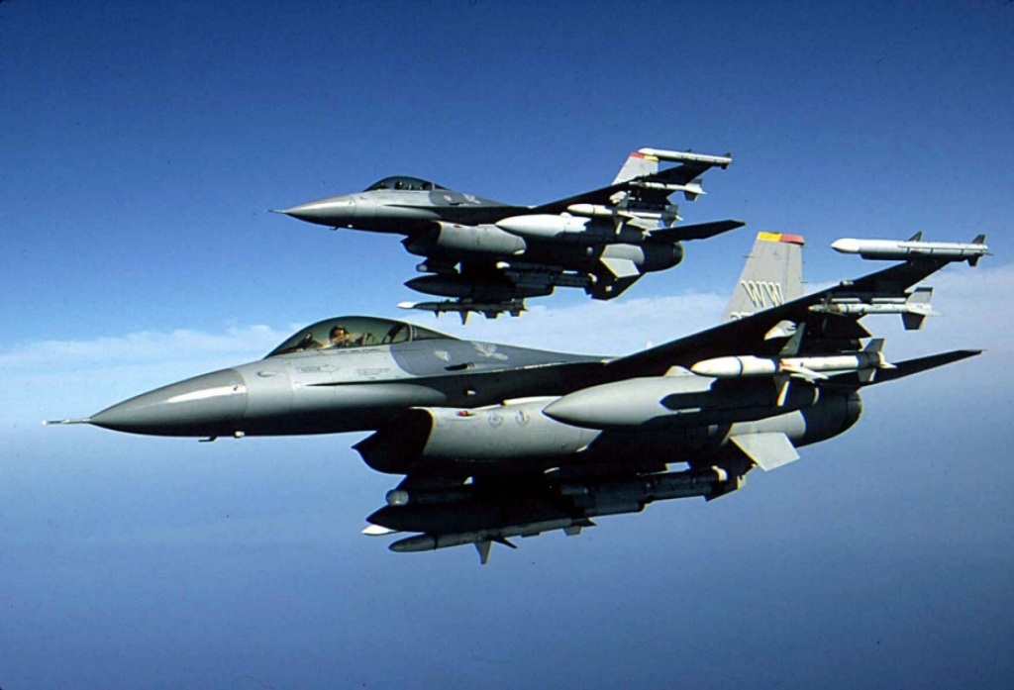

# Introduction

After building a general purpose pit, it was time to build something that looks and felt a little more like a modern fighter. Pretty much everything in the first pit was made from scratch, to a very rough plan. That gave me plenty of flexibility when it came to dimensions. I tossed up which way to go with the new pit, really make it look and smell like an F16, or a general approximation. If you are considering building a viper pit this is a very important decision point. If you start building a scale pit then you need to finish building a scale pit. A scale pit has the advantages of being able to get most things, and they’ll fit right in. The challenge is for the bits you can’t get, finding suitable alternatives that can fit in the space of the original component.

Unfortunately for the bank account this pit is a scale pit. This decision was largely driven by drooling over Jason’s Pit Kit and Mikes Panels.

This is a living document that is almost guaranteed to have errors. If you spot any please give me a ping. I’m bnepethomas on the Viperpit site.

# Acknowledgements

This document is built largely from others contributions in the Viperpit forums. The F16 layout diagram is from Martin "Pegasus" Schmitt. Pictures and details of the Beta Innovations product come from the product manuals.

# Table Of Contents

Introduction 2

Acknowledgements 2

Table Of Contents 3

Table of Figures 7

Planning the F16 Pit 8

Build/Test Issues 10

To Dos 11

The Frame 11

Backlighting 13

Parts Suppliers 14

Inputs 17

Outputs 21

Using the Optocoupler 23

Testing the Electronics. 24

Cabling the pit 28

Back of Panel PCB 29

Wiring the JAY-EL switches 30

Wiring the panels 32

Functional Testing of Panels 34

Gauge Details 36

Airspeed Indicator 37

Attitude Indicator 38

Fuel Gauge 40

Centre Console Gauges 42

The Parallax Controller 42

Testing the Gauges 42

Programming the Gauges 44

Working out the Mach-No 50

Lighting the Pit. 50

Gauge Lighting 50

LO-LED64 Led Output 52

General Panel backlighting 53

Dimming the backlights 53

Air Core Backlighting 54

EL Sheets 55

ICP 56

The Centre Console 57

Centre Pedestal 63

Caution Panel 65

Gear Panel 67

The Panels in the Pit 70

The Electronics Bays 70

Falcon Modifications 72

Solid Background for MFDs in MFD view. 72

Keystroke Modifications 75

Test 76

Anti-G 77

Flt control 78

Manual Trim 80

Fuel 83

Aux Comm 85

Ext Lighting 88

EPU 90

Elect 92

AVTR 95

ECM 97

Jet Start 98

Audio2 100

Audio 101

UHF 104

Manual Pitch 106

Threat Warn Aux 108

CMDS 110

Gear Panel 113

MISC 116

Threat Warn Prim 119

Eyebrow Lights L 121

Eyebrow Lights R 123

Indexer R 129

ICP 131

INSTR 134

HIS – Not used 136

Fuel Qty Select 137

Caution Panel 139

Sensor Power 141

HUD Control 143

Nuclear consent 145

Lighting 147

Master Zeroize 149

Air Cond 151

KY-58 153

Avionics Power 154

Anti-Ice 157

Oxy Reg 158

DTU 159

Left MFD 160

Right MFD 162

Other 164

ACES-II 165

TQS 167

SSCG 168

Switch Mapping for non-Falcon 169

Test 169

Anti-G 169

Flt control 169

Manual Trim 169

Fuel 169

Aux Comm 170

Ext Lighting 170

EPU 170

Elect 171

AVTR 171

ECM 171

Jet Start 171

Audio2 172

Audio 172

UHF 172

Manual Pitch 172

Threat Warn Aux 173

CMDS 173

Gear Panel 173

MISC 174

Threat Warn Prime 174

Eyebrow Lights L 174

Eyebrow Lights R 175

Indexer R 175

ICP 175

INSTR 176

HIS – Not used 176

Fuel Qty Select 176

Sensor Power 176

HUD Control 177

Nuclear consent 177

Lighting 177

Master Zeroize 177

Air Cond 178

KY-58 178

Avionics Power 178

Anti-Ice 178

Oxy Reg 178

DTU 179

Left MFD 179

Right MFD 179

Other 180

ACES-II 180

TQS 180

SSCG 181

Centre Console Maintenance 182

Centre Console Base Maintenance 183

PFD Console Maintenance 184

Landing Gear Console Maintenance 184

High Level Module Assembly 185

Test Server as Built Documentation 188

PC Build Instructions 192

Miscellaneous Tidbits 195

Working with PICs 204

Paint for Panels 205

Modifying a Logitech Z10 into a F16 DED. 205

Ribbstick Installation 215

Installation Considerations 215

Design Concept 216

Installation 217

Force Adjustment 218

Technical Issues 218

Realignment Of Stick 219

RWR 219

Aircore Gauges 220

Assembling the Tubes 220

Which Version of Falcon 226

MFD Export from Lighting 228

Wiring Jays MFD Adaptors 235

I/O Card Pinouts 238

ICP Layout 242

Pinouts for the PCBs 243

PCB Modifications 245

PCB Circuit Diagrams 246

PCB Connectors Alphabetically Sorted 262

PCB Connector Pinouts 265

# Table of Figures

[Figure 1 The test environment 24](#_Toc207865944)

[Figure 2 A full test run 24](#_Toc207865945)

[Figure 3 Centre Air Core Gauges 50](#_Toc207865946)

[Figure 5 RH Air Core Gauges 50](#_Toc207865947)

[Figure 6 Backlighting of Misc Panel 53](#_Toc207865948)

[Figure 7 Front Right all lit up 62](#_Toc207865949)

[Figure 8 Rear of CP 62](#_Toc207865950)

[Figure 9 Rear of CP 63](#_Toc207865951)

[Figure 10 Rear of CP with oled USB 64](#_Toc207865952)

[Figure 11 Caution Panel without gauges 65](#_Toc207865953)

[Figure 12 Back of Caution Panel 65](#_Toc207865954)

[Figure 13 Caution Panel Installed 66](#_Toc207865955)

[Figure 14 Gear Assembly before modification 66](#_Toc207865956)

[Figure 15 Additional Microswitch and backing plate 67](#_Toc207865957)

[Figure 16 After installation of microswitch 67](#_Toc207865958)

[Figure 17 Back of Gear Panel 68](#_Toc207865959)

[Figure 18 Rear of Gear Panel 68](#_Toc207865960)

[Figure 19 Gear Panel Installed 69](#_Toc207865961)

[Figure 20 Primary Input Output Module 70](#_Toc207865962)

[Figure 21 Power and Dimming Module 70](#_Toc207865963)

[Figure 22 Gammatron Input 236](#_Toc207865964)

[Figure 23 Gammatron Rotary Push Mapping 236](#_Toc207865965)

[Figure 24 GammaRay Inputs 237](#_Toc207865966)

[Figure 25 GammaRay Rotary Inputs 237](#_Toc207865967)

[Figure 26 LOLED64 Side A 238](#_Toc207865968)

[Figure 27 LOLED64 Side B Pinout 238](#_Toc207865969)

[Figure 28 Jay-EL Bulb Pinout 238](#_Toc207865970)

[Figure 29 Comport Usage 239](#_Toc207865971)

# Planning the F16 Pit

The pit is based on learnings from the pit general purpose pit and Viperpit.org, a great source of information for F16 pit builders.

I wanted to improve the documentation of the new pit by using PCBs, then there should be little doubt as to what track goes where. Designing the PCB meant careful checking and rechecking before sending the GEBER files off to the manufacturer. The PCB design program I use is WinQCard (v37), which translates the circuit diagram into a PCB layout with auto-routing. It is sold by the number of holes it supports, which meant a trade off between the cost of paying for a larger pin count version of WinQCad versus getting several boards prototyped. I opted for the 1000 pin version which still meant multiple PCBs would have to be built.

The initial run was the PCBs that sit on the back of each panel. The PCBs are double sided and silk screened. Four PCBs per sheet where specified, cost for 10 boards (including tooling and shipping) was US$101 from www.ourpcb.com

TopPrint

Bottom

Top

The larger PCBs too a little longer with the following checks:

* Compare data from the F16Callback spreadsheet on Viperpit against pictures of the F16 pit and Mike’s panels.
* Only buttons with Call backs where wired
* All panels were given provision for backlighting.
* One port on the GammaRay was left for used with rotary switches which are shared amongst all three panels.
* Output information from Oliver’s UCC Manual

Another decision point is where to split the PCBs. The drawings provided by Jason provide the answer. There needs to be three panels, with the split between the gear and misc panels.

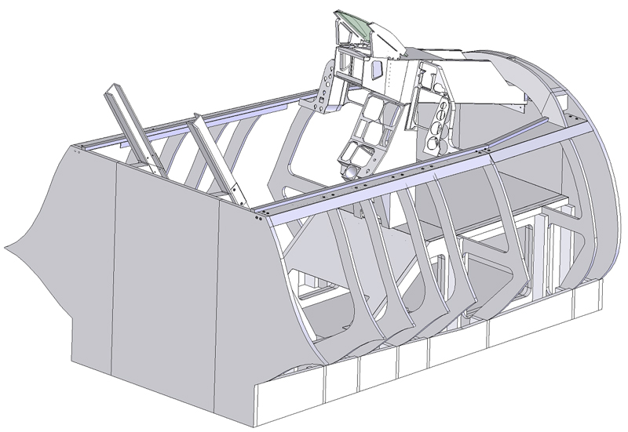

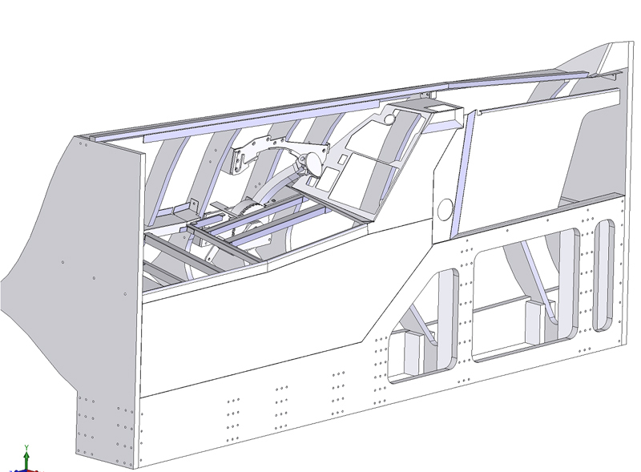

## 

# Build/Test Issues

Major

1. Caution Led loose

Minor

1. Radio Silence switches is a three position switch, only have a two position switch

# To Dos

1. 2\* speed with LMFD button 19 pressed
2. check autopilot
3. config Cougar
   1. – change radio to speedbrake
   2. zoom in and out
4. remove edges from MFDs
5. Add interfaces for touch screen
6. Install touch screen drivers
7. Paint and assembly 240V distribution block
8. Correct rudder USB interface, use PPJoy to emulate button press for both RH and LH pedals
9. Code for FI and USB gauges
10. Modify code for GPS interface to retry when no shared member and error handle. Extend support for Altitude export
11. 2M extension for platform
12. 4 Port powerboard with ears for TH2G location
13. Covering for cables on walls
14. Oriental Night for more paint
15. determine Projector mounting

# New Start-up

Power on PIT

Prim LCDs

Primary

1. F4IM – load and select config file
2. CP load
3. F4 shared mem
4. F4 MFD export (may be not looks like CPD and MFD Export fight
5. Start BMS

Secondary

1. Power on RWR and CPD lcd
2. Boot secondary
3. Disconn/recon cpd display until sync
4. Start cpd, shared mem, and MFD export
5. Start usim, load config, it no lights power off/on Electronflux via switch at front, click through Thread started errors
6. Start F4 to pit and Sim Parallex shortcut from desktop
7. Start GPSout using go.bat

# The Frame

The pit is built using Jason’s kitset.

Figure 1 The Frame after one weekend

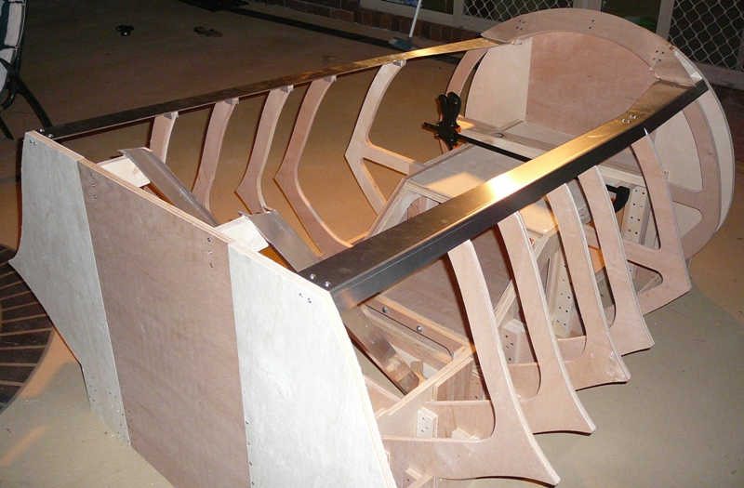

Figure 2 After a coat of paint

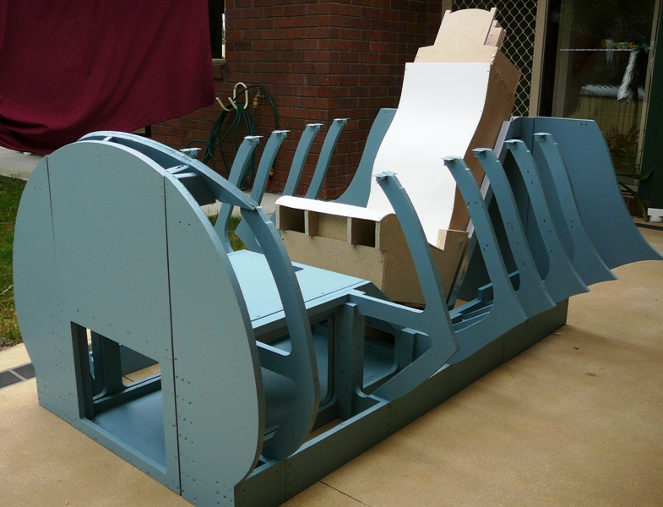

Figure 3 Add a hud tube and CP

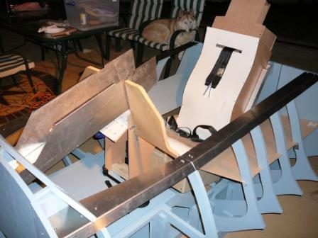

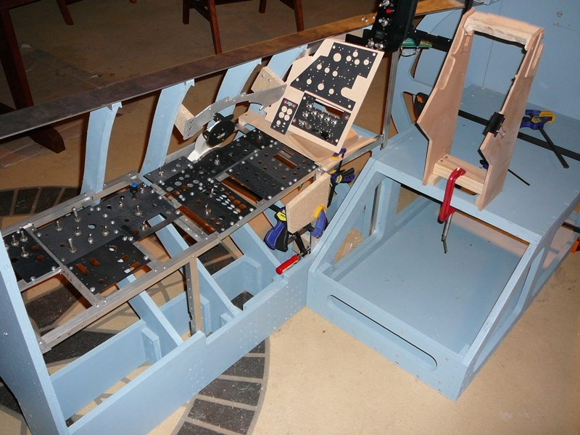

# Backlighting

Although I built a prototype using PWM, the dimmer from Flight Data Systems (<http://fdatasystems.com/LC_40.htm>) offered multiple zones, which maps nicely into what can be used inside the F16 pit. Whilst PWM is electrically noisier than a linear regulator it is much more efficient, and enables you to use different number of leds in columns without impacting on the balance of light output as the voltage is dropped when occurs when a linear regulator is used.

Something I’m still looking at is which voltage to use to drive the backlights. I have plenty of current available with an ordinary PC power supply, but that also means more current flowing to each of the boards. There are something like 539 Leds used for backlighting alone[[1]](#footnote-1). If the leds are wired in a series of three, then 180 s columns of leds need to be lit. If each column draws 20mA, then the total current draw is 3.6Amps. If a higher voltage is used, allowing 6 leds per column then the current is halved to 1.8Amps. The LC40 lighting system supports 1.5Amps per channel which gives around 16mA per column which should provide more than adequate light levels.

My thoughts is to use multiple channels to provide different light levels for

1. Backlighting NVG (Night vision Green)
2. Flood lighting NVG (to augment backlight when flying)
3. Bright Red/White to flood the pit when getting in and out

I intend to wire the lights so they are aware of voltage levels in the simulation, so lights can be managed by master battery switches. As the sim doesn’t expose Panel light status the switch will be directly used.

I also like the Bright/Dim switch on the lighting controller, which is represented on the lighting panel in the pit.

Initially I’d used LEDs to backlight the panels. Whilst this approach provides a very effective backlight, it is time consuming, and for some panels meant I’d had to cut pieces out of the support rail.

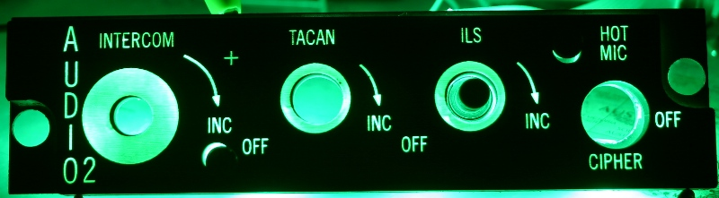

Mike then released precut EL sheets which made the backlighting thing a whole lot easier.

# Parts Suppliers

| Component | Supplier/Comments | Approx Cost |
| --- | --- | --- |
| The F16 frame itself | Penny (designed by Jason) | USD$995 |
| Throttle Arm and mechanism | Penny |  |
| Stick and Throttle Electronics | Thrustmaster Cougar | USD$193 |
| Stick | Dave’s Ribstick | USD$620 |
| Plans for Centre Console and Left and Right Instrument Panels, Hud Housing | Jason |  |
| Light Dimmers | LC40e Flight Data Systems | USD$131 |
| Backlit Panels | Mike | USD$1332 |
| Backlit Knobs | Airdance |  |
| EL Backlighting sheets | Mike | USD$550 |
| Switches – Various | E-Bay (powerguy921) |  |
| Switches – Various | art-in-part Culter Hummer Toggle |  |
| Switches – Rotary 45 Degree | FDS (Flight Data Systems) | USD$14 each |
| Switches – Jay-EL | E-Bay (in\_biz\_since\_1984) |  |
| Switches - Toggle | Allied Electronics |  |
| 676-3240 7101TZQE | 4.980 |
| 676-3265 7203TZQE | 10.010 |
| 870-0579 S1AL-RO | 11.350 |
| 870-0580 S3AL-RO | 11.690 |
| RWR | Oliver (shark.noir) | EUR 661[[2]](#footnote-2) |
| Seat Belt non-F16 | E-Bay (getnick) |  |
| Altimeter | Flight Illusions |  |
| Heading Indicator | Flight Illusions |  |
| Attitude Indicator | Flight Illusions |  |
| Airspeed indicator | Simkits |  |
| ICP | Mike and Jay (Crease Card) |  |
| EFlux | Beta Innovations |  |
| Pilot DED | Logitech Z10 Speakers | AUD$180 |
| PFD | Logitech Z10 Speakers | AUD$180 |
| Fuel Flow Indicator | Logitech G15 Keyboard | AUD$98 |
| Alternate PFD and DED LCDs | Jay (Crease Card) |  |
| Alternate PFD and DED LCDs | Topway Hong Kong (LM19264FCC TOC-0342) | USD$82 |
| Indexers | Mike | USD$350 |
| Throttle Guide | Penny or Dunk |  |
| Cabin Internal Panels | Dunk |  |
| Gear Status Indicators | Dunk |  |
| Landing Gear box and Lever | Dunk |  |
| Front Glareshields | Dunk | USD$75 |
| Toggle Switch guards | Dunk | USD$16 |
| Eject Handle | Dunk |  |
| Centre Console Leg Guards | Penny |  |
| DED Cases | Dunk | USD$30 |
| Seat Arm Lever | Mike |  |
| Aircore Gauges | Beta Innovations |  |
| Gauge Housings | Jarrod | USD$336 |
| Gauge Faceplates | Mike | USD$65 |
| Seat Stickers | aeyes@cockpits.net |  |
| Aircraft GPS | Lowrance 2000C | USD$630 + Shipping |
| Touchscreens for MFD | Ebay Hongkong |  |
| PCB Manufacture | www.ourpcb.com |  |
| PCB Design | WinQCad (with 1000 pins) | USD$300 |
| Sheet Metal Folder | www.toolman.com.au | AU$125 |
| Project Management Software | GantProject | Free |
| F16 MFDs | Real ones Jim Keane | USD$401 |
| MFD to MM2 adaptor | Jae (Crease Guard) | USD$63 |
| ICP to MM2 adaptor | Jae (Crease Card) |  |
| Warning Panel | Mike and Jae |  |
| Switch Guards | Coat Hanger | Free |
| Seat Cushions | Real Ones (HOwebman@cox.net) | USD$120 |
| Standby Attitude indicator | Real one off ebay (inop) (powerguy921) | USD$34 |
| Rudder Pedals | Simped | 244 Euro |
| Software to drive Z10 and G15 | Airdance | Free |
| Software to drive Touchscreen | Touchbuddy | Free |
| Software for LCD gauges | F4 Glass and Falcon Gauges | Free |
| Master Caution Button | Mike | USD$40 |
| Eyebrow Indicators | Mike | USD$70 |
| TWP Indicator Panel | Mike |  |
| ECM Indicator Block | Mike | USD$70 |
| Right Inside Panel | Shockwave (David) | USD$320 |
| Leds | Hong Kong |  |
| 5mm megabright warm white led | Hong Kong lvehk |  |
| Video Card | Geforce 7950GX2 1G DDR3 Dual-GPU |  |
| 8” Touch Screen | stivaskam | AU$225 |
| Plasma-MM2 | Beta Innovations (\*2) | USD$59 |
| LO-LED64 | Beta Innovations – 64 Port Latched Led | USD$49 |
| LBC-PWM | Beta Innovations – 12V PWM Dimmer | USD$29 |
| LO-HV64 | Beta Innovations – High Voltage Latched | USD$79 |
| EFlux | Beta Innovations - |  |
| GammaRay V2 | Beta Innovations - GammaRay | USD$275 |

Mike Panel Details

Air Cond 30.00 30.00

Air Cond Backplate 10.00 10.00

Anti-G 25.00 25.00

ANTI-G Backplate 10.00 10.00

ANTI-ICE 25.00 25.00

Anti Ice Backplate 8.00 8.00

Audio1 30.00 30.00

Audio 1 Bakplate 10.00 10.00

Audio2 25.00 25.00

Audio 2 Backplate 8.00 8.00

Aux Comm 35.00 35.00

Aux Comm Backplate 12.00 12.00

2 part bezel cover for Glass Gauges $70

the ACES safety lever $35

8 indicators @ $10 ea. = $80

Leo

1) Oil (AC360A)

2) Noz Pos (AC360B)

3) RPM (AC360C)

4) FTIT (AC360C)

5) EPU FUEL (AC360C)

1) HYD PRESS 1 & 2 (AC360A)

2) Cabin Pressure (AC360C)

Qty Price($) Product ID : Product Name

===========================================================================

3 $115.00 AC360AG : 1in 360 Deg Air-Core Movement Green

3 $130.00 AC360CG : 2in 360 Deg Air-Core Movement Green

AC360CG 2" 360 Deg Air-Core Movement Green 1 $130.00/ea

BKB-32 32 point breakout board 1 $26.00/ea

AC360BG 1.5" 360 Deg Air-Core Movement Green 1 $119.00/ea

NITRO NITRO - Expansion Card 1 $119.00/ea

The gauges I’ve purchased are the analog units, which work Dx10 8 Bit cards

# Inputs

The directional inputs are based on the Cougar stick. Whilst the core of its electronics are used, there are a couple of mods for the inputs:

The stick itself has been replaced by Dave (Ribbs) Ribstick. The throttle mechanism will drive a mod kit from Cubby, and the pedals are from Simped Detier.

1. GammaRay for bulk input
2. Gammatron for Rotary Inputs (to get support for push Rotaries)
3. Beta Innovations MM2. One for ICP and one for MFD, both using Jay’s adapters. I had originally allocated ports on the GammaRay, but the MM2 with Matrix scanning is a much better fit for Real MFDs, and also for the ICP.

Gammatron pinout

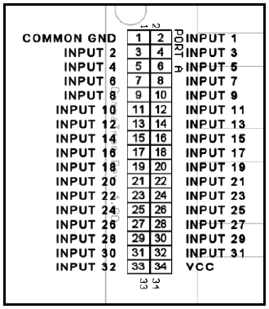

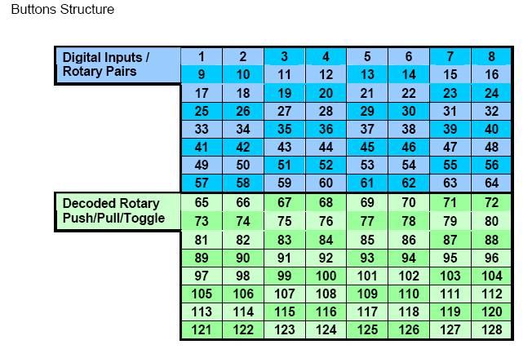

Gammaray Pinout

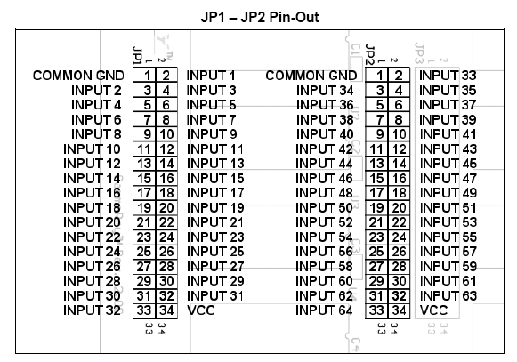

Gammaray Rotary Input mode

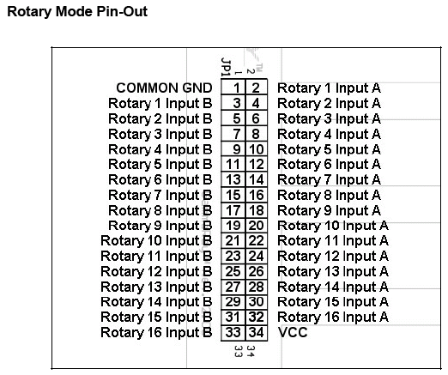



Jay added some new capabilities to the ICP in April 08, working thumbwheels:

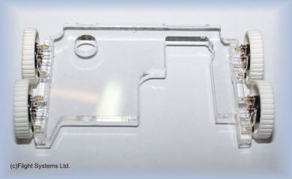

The MM2 has 8 analog inputs, so it can be used as an input for the thumbwheels, as the MM2 sits in the ICP housing there is no long analog runs that need to be supported. Will need to modify the ICP housing to fit the thumbwheel modification as it slightly widens the ICP assembly.

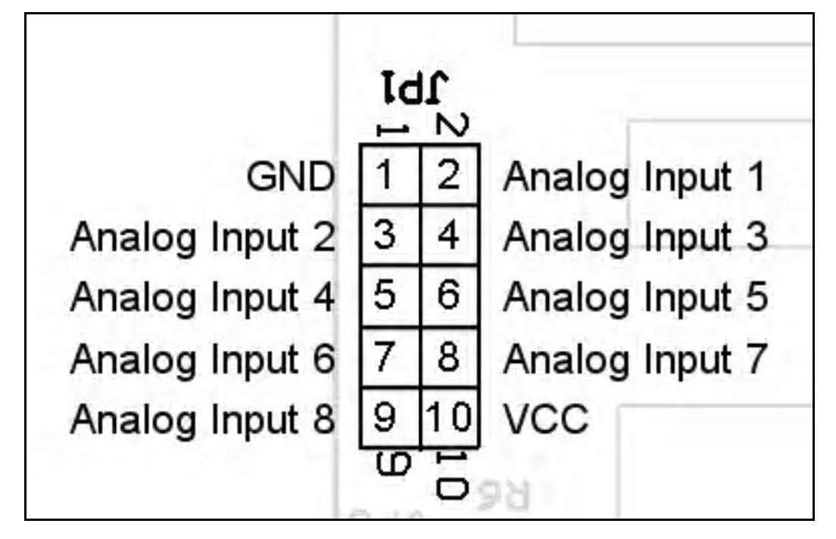.

# Outputs

There are a number of outputs in the pit that can be driven from the simulator. Such needs can be addressed using products from a range of Simulator Suppliers. My first general purpose pit used a mix of cards Phidgets, custom LCDs, Parallax, Simkits, Flight Illusions. As none of these had native drivers for Falcon 4 there was plenty of custom code to be cut.



1. The UCC for RWR and PFD

2. Beta Innovations EFlux for Caution Panel and DAC outputs

3. EFlux using LOLED64 for driving leds. For larger current devices use opto-isolator.

4. Flight Illusions altimeter, attitude indicator, and gyro compass

5. The LC\_40 dimmer from flight data systems

6. The Parallax 16 port servo card

7. The air core gauge driver from Beta Innovations

I’m attempting to use fewer suppliers for the new pit.

| Output | Instance | Card | Comments |
| --- | --- | --- | --- |
|  |  |  |  |
| Leds |  | Beta Innovations via EFlux |  |
| Servos | Airspeed | Parallax or Beta Innovations via EFlux |  |
| Mach No |
| Jet Fuel |
| Magnetic Switches | Jet Starter | Beta Innovations High Voltage card via EFlux |  |
| Park Brake |
| Flood Lights/Leds | Floor Flood | LC40 PWM Dimmer |  |
| Panel Flood |
| Altimeter | Altimeter | Flight Illusions |  |
| Heading Indicator | Heading Indicator | Flight Illusions |  |
| RWR Indicator |  | Custom LCD driving by PHCC |  |
| MFD Backlight |  | LC40 PWM | 5V bulbs |
| Panel Backlighting | General Panels | EL Sheets via Beta Innovations PWM via Eflux |  |
| Aircore Guages | Nozzle Position |  | Cases by Jarrod, backlighting by Leo, Aircore by Leo |
| Engine RPM |
| Cabin Pressure |
| Oil Pressure |
| Hyd Press – A |
| Hyd Press - B |
| EPU Fuel |
| FTIT |

The LO-LED64 can directly drive LEDS. For testing I used the patch/breakout board. Currently the brightness control option doesn’t work (May 2008)

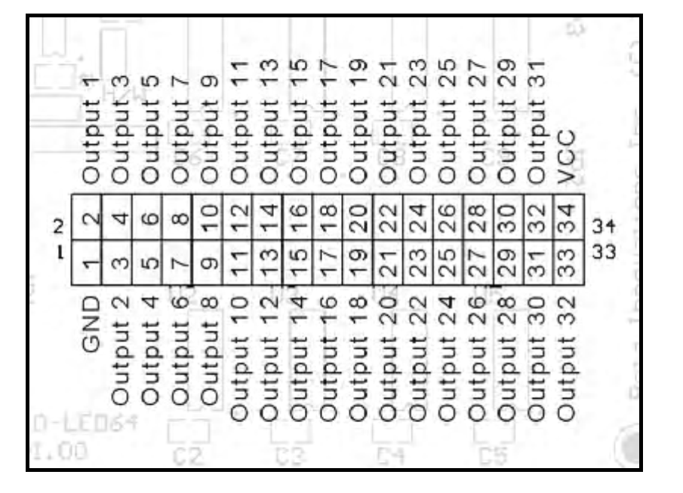

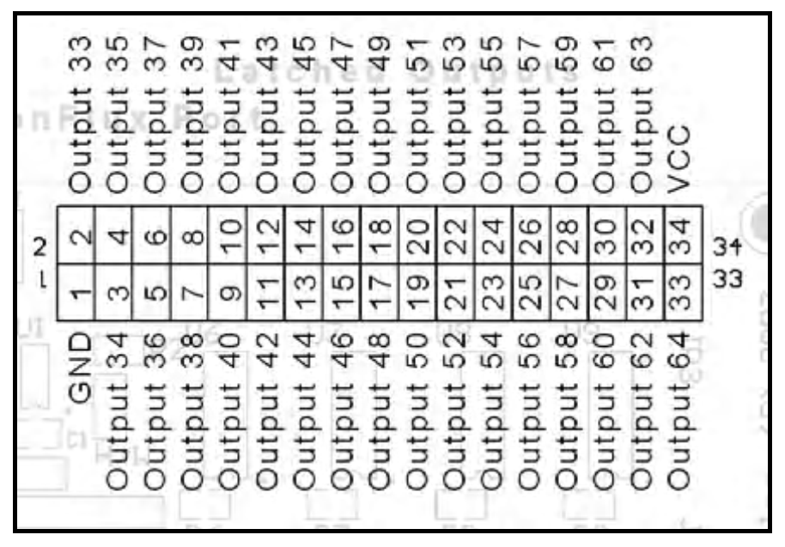

# Using the Optocoupler

To reduce the likelihood of higher voltages finding their way back to other input or output devices I’m used a small optocoupler circuit to isolate the outputs of the LoLed64 from the 12V supplies driving the dimmers or Honeywell switches.

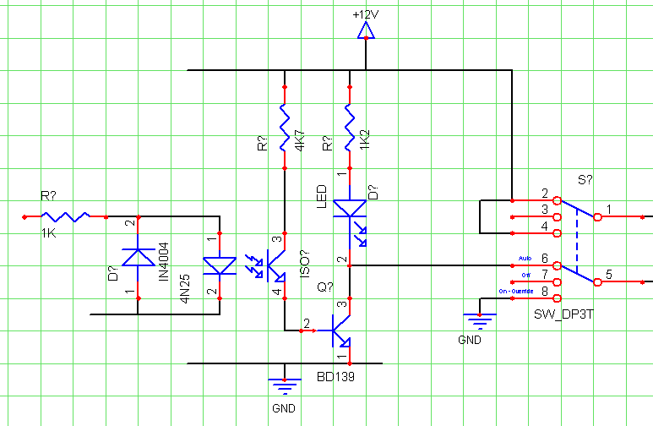

# Testing the Electronics.

I’d built a jig to hold the front assembly so I could test the Centre Assembly out of the pit.

Figure 4 The test environment

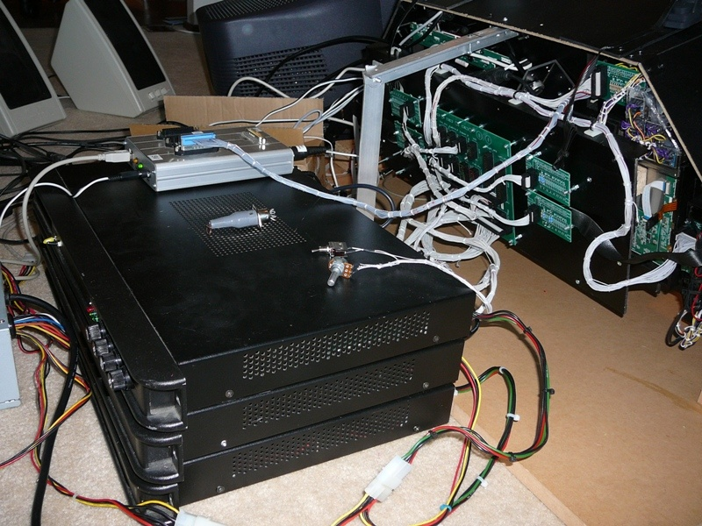

Figure 5 A full test run

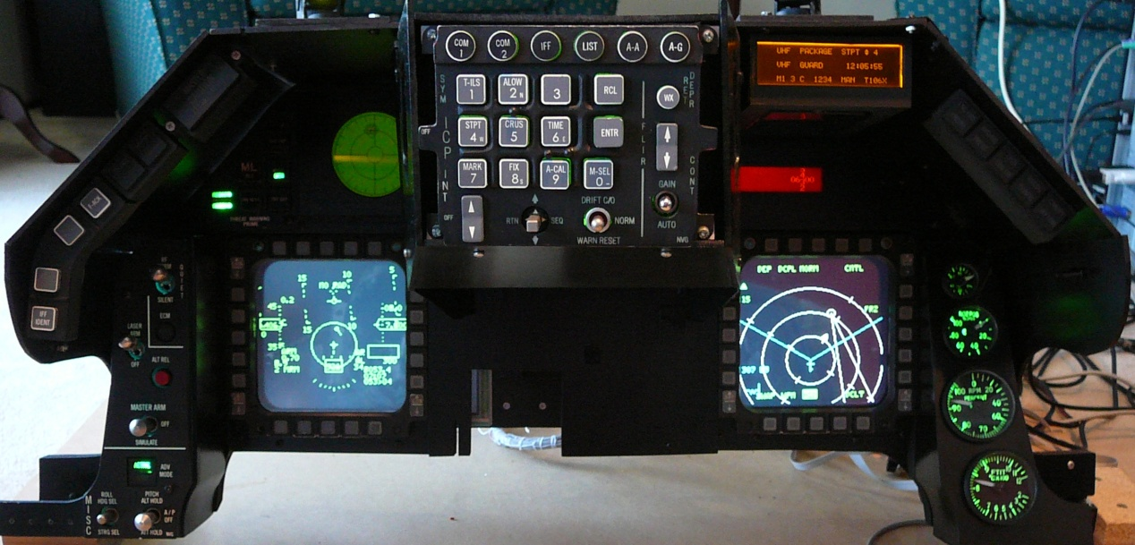

When powering up the ElectronFlux, initially the node LEDs will go yellow. Nothing happens until the USB is connected to the computer, and then LEDS and Relays start clicking.

You may need to update the firmware. Download from Beta Innovations site, this will normally require a username/password.

Upgrading ElectronFlux Firmware (from Readme file)

\*\*\*\*\*\*\*\*\*\*\*\*\*\*\*\*\*\*\*\*\*\*\*\* I M P O R T A N T \*\*\*\*\*\*\*\*\*\*\*\*\*\*\*\*\*\*\*\*\*\*\*\*\*\*\*

DO NOT RESTART THE MODULE UNTIL ALL NODE PROCESSORS

HAVE BEEN UPDATED WITH THE LATEST FLASH.

\*\*\*\*\*\*\*\*\*\*\*\*\*\*\*\*\*\*\*\*\* I N S T R U C T I O N S \*\*\*\*\*\*\*\*\*\*\*\*\*\*\*\*\*\*\*\*\*\*\*\*

1) Unzip contents into a temp directory.

2) download and install the latest Device Manager if you haven't already done so.

3) Start Device Manager and restart the ElectronFlux module in Flash Mode.

Updating the Nodes flash memory.

4) Click on the "Node Configuration" tab.

5) Click on "Load..." button, locate and select the EFND\_R###.bix file included in this zip file.

6) Click on the "Program" button. Flash update will begin.

Updating the Core flash memory.

7) Click on the "Device Configuration" tab.

8) Click on "Load..." button, locate and select the EF\_R###.bix file included in this zip file.

9) Click on the "Program" button. Flash update will begin.

10) Click on "Execute" button once the update is complete. Device is now ready to use.

Configuring the EF Ports

Port F

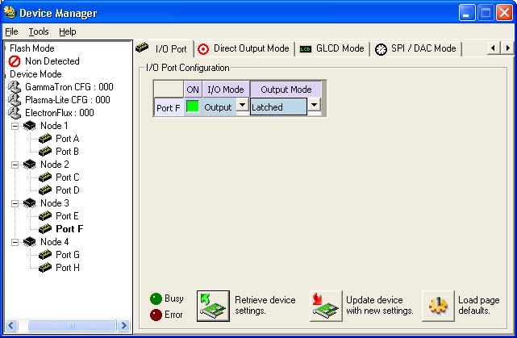

Port G

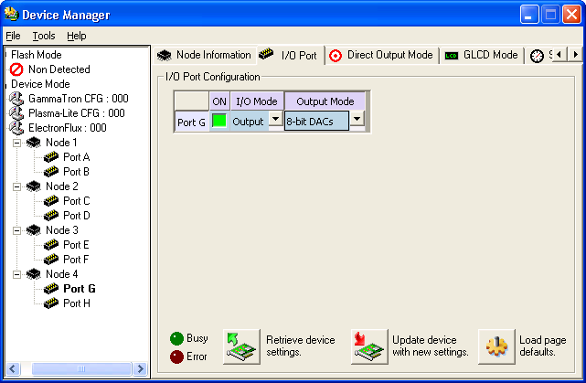

Port H

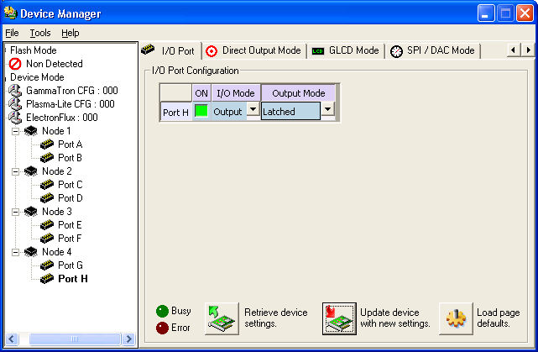

Testing the Ports

Use the Beta Innovations USB Toolkit

Select the Latched Outputs Toolkit, and then Port F. Now select the individual ports to test. With a supply voltage of 5.07Vs ,the port was rising to 5.06V.

With a Flatop White LED the following results were obtained:

|  |  |  |
| --- | --- | --- |
| Series R | mA | Offered V |
|  |  |  |
| 10K | 0.23 |  |
| 1.5K | 1.34 |  |
| 820 | 2.30 |  |
| 330 | 4.96 |  |
| 220 | 6.82 |  |
| 150 | 9.08 – 9.43 |  |
| 100 | 12.26 | 4.67 |
| 56 | 17.12 | 4.5 |

With 4 Leds in a JAY-EL no resistor gives a total load of 41.2mA.

|  |  |
| --- | --- |
| Series R (4 Leds) | mA |
| 100 | 14.85 |
| 56 | 20.87 |
| 33 | 26.43 |
|  |  |

# Cabling the pit

A quick count of switches, leds, and lamps shows that the pit has well over two hundred connections, and at least ten major electronic modules. Now given anyone of these modules may meet an untimely end, I didn’t want to throw a soldering iron into the middle of a mass of cables whenever a module needed replacing or testing.

With the F16 Pit I put together some PCBs using WinQCad (hopefully will be of use to others someday). As the pit breaks down into three blocks, left middle and right there are three distribution panels which connect back to the electronics.

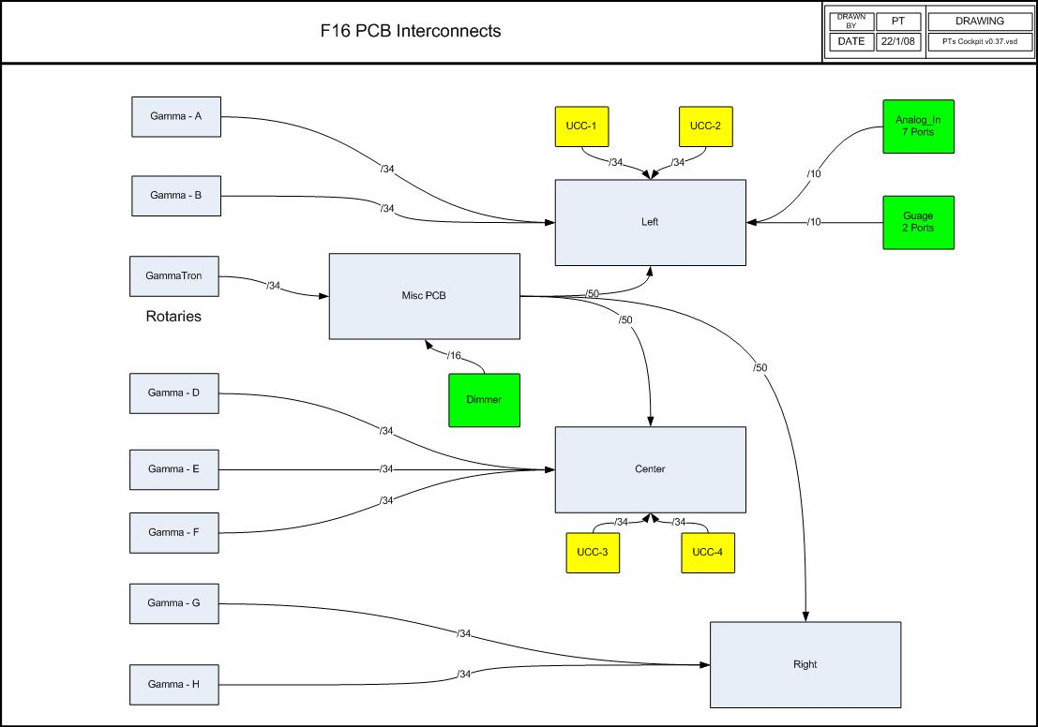

The Misc PCB provides a distribution point for the dimmer and rotary interface on the Gammatron.

Each Panel in the pit has a common PCB which provides connectivity to the GammaRay and UCC/ElectronFlux. The idea behind this is that only a single cable connects to the panel to the distribution PCB which in turn only has the minimal number of connectors back to the electronics. I’m planning to put all of the electronics in a single PC box/power supply simplifying the layout of the electronics and power supplies.

### Back of Panel PCB

This is the building block of the pit, and has been designed to cover all of the panels aside from the MFDs which have a large number of connectors.

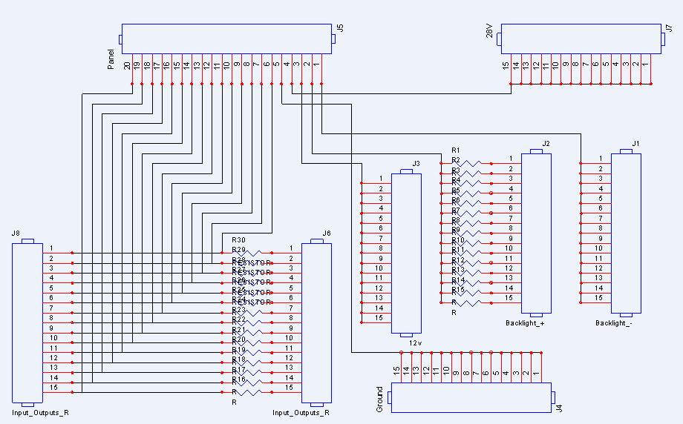

The PCB has 4 pins which 5 ports which are dedicated to the Backlight and power requirements. The remaining pins can either be inputs or outputs. The outputs can be driven via a resistor.

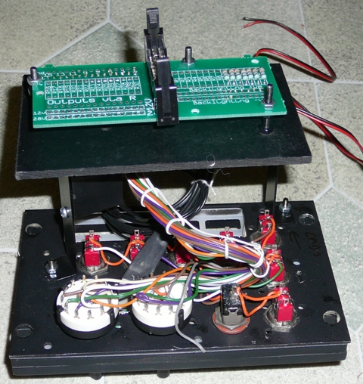

The distribution PCB is connected directly to the lighting controller, which has multiple channels. The first channel is for panel backlighting, the second for NVG lighting of the front of the panels, the third for while flood lighting of the pit in general.

|  |  |
| --- | --- |
| Wire Colour | Wire Role |
|  |  |
| Light Blue | Backlight +ve |
| Dark Blue | Backlight -ve |
| Black | Ground |
| Yellow | Variable Voltages 28 to 12V for Lights and Leds |
| Purple | Return from lights –ve side going to output |
| Red | +12V |
| Green, crème, Brown, Orange, Gray, White | GammaRay Inputs |

The PCBs have thicker tracks for the Gnd, Fixed voltages, and the Dimmer rails. The dimmer rails are separated from the general inputs/outs by Gnd and general rails which should provide additional noise isolation.

## Wiring the JAY-EL switches

The Jay-EL switches I scored were from an F4 simulator. To change the bulbs simply put your finger nails around the front legend and pull it out.

Photo Disassembled switch

Each Switch holds 4 bulbs rated at 28Volts, 2 across the top and two across the bottom. Current draw at 28 is 40mA, 30mA at 16V. At 28V one bulb effectively lights the top or bottom of the switch. All four bulbs draw 160mA. At lower voltages if becomes more clearly apparent that two bulbs are in each row. Using a modification described in the appendix, I replaced modified the bulbs replacing the bulb with white leds. While I haven’t checked it out myself, a modeling company does offer bulbs with led inserts (http://www.trainaidsa.com/shop-leds.html)

Looking from the top of the switch the are pins labeled 4, 3, C, 2, 1 (from back, left to right)

|  |  |
| --- | --- |
| Pin | Bulb Position |
|  |  |
| C | Common |
| 1 | Bottom Left |
| 2 | Top Left |
| 3 | Top Right |
| 4 | Bottom Right |

What I also noticed is the case casing does get a little warm when the lights are on. I briefly did think about trying to series the bulbs to reduce current draw and brightness a little and then realised they all anchor to a single common.

The switches from the F4 Simulator have the following legends

|  |  |  |  |  |
| --- | --- | --- | --- | --- |
| White Front Legend | F-16 Equiv | Top Lighted Text | Bottom Lighted Text | Lens Colour |
|  |  |  |  |  |
| SYS TEST | Yes | TEST (Green) | TEST (Green) | Clear |
| Diamond Shape |  |  |  | Black |
| ML RST | Yes |  |  | Red |
| SEARCH |  | SEARCH (Yellow) | SEARCH (Yellow) | Clear |
| MODE | Yes | PRIORITY (Yellow) | OPEN (Green) | Clear |
| POWER |  | PWR (Green) | PWR (Green) | Clear |
| RECORD |  | RECORD (Green) | RECORD (Green) | Clear |
| AAA DEF |  | AAA (Yellow) | DEFEAT (Yellow) | Clear |
| TGT SEP | YES | TARGET (Green) | SEPARATE(Green) | Clear |

The F16 TWP Stack looks like

|  |  |  |
| --- | --- | --- |
|  |  | HAND OFF (Record) |
|  | LAUNCH | MODE PRIORITY |
| Unknown/ Naval (AAA Def) | SYS TEST | TGT SEP |

The Green Highlighted text have a direct match to the F4 Legends, the Yellow will have to wait until someone makes some matching lenses. As of mid 2008 Mike now makes inserts for the switches.

The switch has six contact connectors at the back. Basically a left and right side.

The top connector is common, middle is Normally Open, and bottom is normally closed.

Changing the lenses.

1. Remove the bulb assembly
2. There is a metal collar around the front with a couple of dimples, remove from front.
3. Underneath this should be a clear lens, the coloured lens, and another clear lens.
4. If the lens don’t simply dropout, remove a bulb and push them out fro the back.

The non-soldered switches

A few of the switches don’t have solder lugs, thought this was going to represent some challenges, but has it turns out all is good. Used the following lugs (from Dick Smith Electronics)

* + 5.3mm Ring Terminal Red
  + 3.2mm Spade Terminal Red
  + 4.3mm Spade Terminal Blue

# Wiring the panels

As each panel has a connection back to the distribution panel, one of the challenges was how mount the connection on the back of the panel. I explored a couple options; making box frames like the real thing had promise until I discovered it didn’t fit into some of the locations as it hit the rails. Getting threaded pillars was also a bit of challenge. Ended up make simple brackets.

Start by setting up a document or spreadsheet to keep track of what you’ve purchased. There are a lot of panels in the F16 and it’ll probably take a while to get all the needed bits.

Here’s a suggested order to assemble panels:

* I highly recommend Mike Panels and Back-plates as they are to scale and back-light nicely
* Determine how the panels are going to be backlit. This is a major decision point as it impacts how much free space you’ll have on each panel. I originally used LEDs which provided a very bright light, but there were a few challenges. When the EL sheets appeared from Mike Williams, I changed tracked. See the panel backlighting section for more information.
* Determine how the cables are going to be terminated, for example I’m using distribution panels in the left, centre and right sides of the pit so it can be ‘easily’ disassembled. I also made the decision to use independent wiring for each panel so they can be individually removed. Another option would have been to wire the panels after they had been bolted in. Whilst this simplifies cabling it makes future modifications more challenging.
* As I discovered building a scale pit means that pretty much every needs to be correctly scaled, so build the shell of the pit first as it’s the thing you’ve got to squeeze things into
* Roughly mount the stick and throttle, as these can get in the way of bits protruding out of the back of the panel.
* Install the switches, rotaries and indicators (if possible) onto the panels. Check the switches are able to fit through the EL Sheet.
* Install the EL sheets.
* I also painted the heads of the bolts and the tops and sides of the nylon washers to give the pit a more polished look.
* Mount the panels and face plates
* Build the frames to support the panels and the Center Console. Whilst building the frame check that the panels with components can be mounted. You’ll probably find it’ll be time for some additional filing
* At this point you should have all the panels and faceplates mounted in the pit.
* Now its time to build the brackets to hold the connector of each of the PCBs.
* I used S shaped brackets, held where possible by the bolts that support the front faceplate. If the bolts are not in a suitable location 5 minute epoxy resin is used to attach the bracket to the base plate. Before gluing double check the bracket and PCBs are not going to collide with anything on the frame.
* Given I was using EL sheets I also mounted the inverter on the bracket; again ensuring it doesn’t hit anything on the panel or in the pit.
* Now mount the board the will sit between the bracket and PCB. This basically is an adaptor to deal with the different possible bracket positions and the relatively fixed holes on the PCB. Again check, that the back board doesn’t hit anything in the pit. Nylon washers should be used to provide insulation between anything metal and the PCB.
* A slot should be cut into the board that supports the PCB to allow wiring through (including the input to the EL inverter)
* The panel assembly can now be disassembled and given a coat of black satin paint.
* Partially assembly the panel and the wire up the switches and indicators.
* Test switches. Initially test switches with no power applied, all positions of all switches should be tested. Meter all switch inputs to check there are no crossed connections to indicator outputs.
* Test indicators
* Remount the EL sheet.
* Test backlighting
* If modifications are required to the panels, they can be touched up using the paint recommended in the painting section of this document. Once you’ve double checked all is good spray a couple of coats of sealant over the front panel.
* Cable-tie the EL sheet cabling and use hot melt glue to support the EL sheet connector.
* Run a final functional test before mounting the panel.
* And now move onto the next panel.



## Functional Testing of Panels

Disconnect all Power and USB devices

Manually check continuity for LEDS on both signal and ground sides

Check rails are not shorted (note +28Rail on extension PCBs is now ground rail for Leds)

Check rails connect to connect rails on aggregation PCB

Connect on Led driving USB devices

Test Leds devices

Only if all led tests successful proceed

Shutdown power

Remove USB driving devices

Connect GammaRay ports

Test inputs.

Power off

Connect USB Driving devices

Check all inputs and outputs using USB toolkit.

The Centre Console Assembly

|  |  |  |  |
| --- | --- | --- | --- |
|  |  |  |  |
|  | Left AOA Indicator (on top of front glareshield) | 3 LEDS |  |
|  | Right NWS, RDY Indicator (on top of front glareshield) | 3 LEDS |  |
|  | Misc Panel | Header PCB and EL Inverter |  |
|  | Left MFD | MM DB15 and 5V for back lighting |  |
|  | Right MFD | MM DB15 and 5V for back lighting |  |
|  | TWP | Header PCB |  |
|  | RWR | Connection to Aluminum Tube |  |
|  | Master Caution | Switch plus 3 Led |  |
| TF Fail |  |  |
| FACK |  |  |
|  | DED | 12 USB |  |
|  | Fuel Flow |  |  |
|  | Eyebrow warnings |  |  |
|  | Gauges |  |  |
|  | Left Display | 12 VGA USB |  |
|  | Right Display | 12 VGA |  |
|  | CP Flood |  |  |
|  | ICP |  |  |

# Gauge Details

|  |  |
| --- | --- |
|  |  |
|  |  |
|  |  |
|  |  |
|  |  |
|  |  |
|  | IMG_0238 |
| Airspeed Indicator | p1010205  Simkit’s General Purpose Gauge with F16 Faceplate.  Airspeed indicator, the Simkit’s F16 indicator is pretty darn tidy, even the Mach-No dial works! |
|  | Copy of P1040450  Not my first choice, as it isn't a close replica, but again the Simkit’s altimeter doesn't keep up with a nut at the stick of a viper, so the Flight Illusions one wins. I'd prefer to have white displays and be able to dim them, but I guess I'll have to wait until something comes out of Leo’s factory :). So for medium term Flight Illusions. |
|  | Copy of P1040450  The AOA and VVI will be simple servos using RedDog's recently released templates. |
| Attitude Indicator | Copy of P1040450  Attitude Indicator, Flight Illusions for this one as the Simkit’s Attitude indicator does not do full rolls. |
|  | Copy of P1040450 |
|  | P1040459a |
|  | Copy of P1040119 |
|  |  |
|  | Copy (2) of P1040119 |
|  |  |
|  |  |
|  |  |
|  |  |
| Fuel Gauge | P1010206  Simkit’s General Purpose Gauge with F16 Fuel Faceplate.  The Simkit’s gauges have dual needles and don't look to0 bad. (http://i198.photobucket.com/albums/aa273/bnepethomas/P1010206.jpg) |
|  |  |
|  |  |
|  |  |
|  |  |
|  |  |
|  | P1040348a |

# Centre Console Gauges

|  |  |
| --- | --- |
| P1040538 | P1040458 |

Both Flight Illusions and Parallax are interfaced using a Virtual Serial Port.

|  |  |
| --- | --- |
| Controller | Com Port |
|  |  |
| GPS | Com1 |
| Flight Illusions | Com6 |
| Parallax | Com2 |

Parallax port manually set using the advanced settings

## The Parallax Controller

The Parallax Controller is a 16 Port USB Servo Controller (first Port is Port 0). It needs an external 5V supply to drive the servos. You can configure and test the controller without the external supply, but the servos will not respond until power is applied.

## Testing the Gauges

Flight Illusions driver includes test capabilities, current version in July 08 is G-Step 3.51.

Parallax supplies PSCI, which can also manage the speed at which servos move.

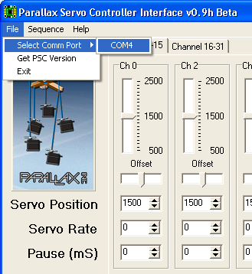

To open the Parallax controller you first need to select the Com Port (virtual) the device is attached to. Once the port is open the status box will change from blank to Comm Port Open.

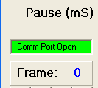

A number of devices use the FTDI USB to serial converters. PSCI will scan looking for the Parallax device. Another way to check which port the Parallax is attached to is to open Device Manager and check serial ports. Sometimes the board goes a little silly, i.e. it opens but doesn’t respond. Check sanity by requesting version, if it returns v1.4 its ok, if it returns ‘…’ then communications have been lost.

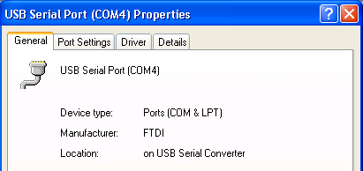

PSCI is a sequencer which can be used to exercise the gauges. Given you usually will want to slow or dampen the gauge movements, the servo rate should be set to a non-zero number. I’ve found 30 to be good for heavily dampened devices and 10 for more active gauges such as AOA and VSI.

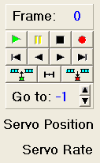

Once the servo rates have been set, position the gauges using the sliders, and then press the Record (red dot) button. The sequence can then be saved (Sequence – Save) Programming the Gauges

# Programming the Gauges

Whilst the pit will primarily be driven by Falcon4, it’s desirable that it can be driven by other Sims.

Given Leo has already done the hard yards with F4IM, all devices driven by F4IM will continue to use the F4 shared memory. For the Parallax and flight Illusions gauges they’ll be driven by a separate shared memory file, this makes it easier to move between different devices in the future as the code to drive the device is abstracted from the code to read values from the simulator.

|  |  |  |
| --- | --- | --- |
| Simulator Value | Gauge | Gauge Item |
|  |  |  |
| Airspeed | Simkit’s Airspeed |  |
| Mach No | Simkit’s Airspeed |  |
| Altitude | FI Altitude |  |
| Air Pressure | FI Altitude |  |
| Air Pressure Adjust | FI Altitude |  |
| AOA | AOA |  |
| Roll | FI Attitude |  |
| Pitch | FI Attitude |  |
| VSI | VSI |  |
| Heading | FI Heading |  |
| Desired Heading | FI Heading |  |
| Fuel Internal | Simkit’s F16 Fuel (Fwd) |  |
| Fuel External | Simkit’s F16 Fuel (Aft) |  |

Data Types for the Shared Memory File

*Public Type Type\_Parallax\_Servo\_F16*

*'Angle Of Attack -25 to +25*

*AOA As Single*

*'Vertical Speed -6000 to +6000*

*VSI As Single*

*'Internal Fuel -99 to 100, -99 Indicates Power off*

*Internal\_Fuel As Single*

*'External Right Fuel -99 to 100, -99 Indicates Power off*

*External\_Fuel As Single*

*Airspeed As Single*

*'MachNo multiplied by 100*

*MachNo As Single*

*PowerAvailable As Boolean*

*End Type*

*Public Type Type\_FI\_F16*

*'Common Backlight Control for FI Gauges*

*Backlight As Single*

*'Altitude 0 to 100000*

*Altitude As Single*

*'AirPressure 0 to 2000, 1013 normal*

*AirPressure As Single*

*'Roll*

*Roll As Single*

*'Pitch*

*Pitch As Single*

*'Heading*

*Heading As Single*

*'Drives HeadingBug*

*DesiredHeading As Single*

*PowerAvailable As Boolean*

*End Type*

**Falcon 4 Data Path’s**

F4 Glass

2nd PC

1st PC

*Shared Memory File*

*“PTLomacSharedMemoryArea”*

*Shared Memory File*

*“FalconSharedMemoryArea”*

GPS

*RS232 from COM5*

*"19200,N,8,1"*

*NEMA*

*UDP Data Link for Dual Engine Stack*

*(to 8081)*

PTTRC

\_Link

*TCP Link to Simkits TRC Custom Link*

*(to 1972)*

*Shared Memory File*

*“TRCSharedMemoryArea”*

*Shared Memory File*

*“PTDualEngineSharedMemoryArea”*

*Shared Memory File*

*“FalconSharedMemoryArea”*

Falcon4

Flight Illusion Gauges

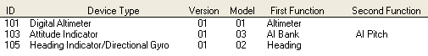

Note – when using GStep 3.5 – even if gauges are configured and responding the connection status can be reported as unknown.

I used the SysInternals (now owned by Microsoft) PortMon in hex mode to decode what is being sent to the gauges.

Using the Decoder Ring

00 Start of frame

65 Device ID 101 – 65 Hex

Data

0 01 02 = 0

3 f5 13 = 5109

2 31 4e = 20016

4 Set Attitude Command

FF End of Frame

0 01 02 = 0

3 f5 13 = 5109 – 13F5

2 31 4e = 20016 – 20017

MSB is +ve negative bit.

Commands for Flight Illusion Gauges

Byte 1: Flag byte:&h00

Byte 2: Address: 1-255; address zero forbidden!

Byte 3: Command byte: Bit 3 always "1": CCCC.1SHL

H & L are the data bits to "repair" the "forced to one bits" in

byte 4 & 5), S= sign bit of the integer value)

CCCC is the 4 bits command(0001-1111, so 1-15)

Byte 4: Data Low; &h00-&hFF; bit0 always 1 : XXXX.XXX1 -> XXXX.XXXL

Byte 5: Data Hight:&h00-&hFF: bit1 always 1 : XXXX.XX1X -> XXXX.XXHX

Byte 6: End byte:&hFF

Altimeter

Commands:

0= noop

1= Initialize

2= Set Instrument Address; Value 0-&hff (odd addr. only),second byte:&HAA

3= Set Scan frequency (Needle Speed)

4= Set Altitude (-9999 to + 50000)

5= Set AirPresure mode (byte1: 0= Inches HG, 1= Milibar), byte2:0=no connection, 1=connected to altitude)

6= Set Needle zero displacement; Number of steps between sensor and needle

7= Send info about instrument; Reply &h00, Address, Type, Model, Version, Airpressure

8= Switch lights: Low byte= DL00.0000; D=display on/off, L=light on/off

9= Set Instrument Model &Version, Low Byte=Model, High Byte=Version

10= Write an EEPROM byte (Blocked; is for debug only)

11= Direct Needle Control (0 to 1079); Sets needle independent from altitude

12= Set Airpressure value

Command 4 is the one you'll need mostly. Rest better using our ControlProgram.

Attitude Indicator

Commands:

0= noop

1= Initialize

2= Set Instrument Address; Value 0-&hff,second byte:&HAA

3= Set Instrument speed: If positive: Bank; If negative: Pitch

4= Set Bank position (0-3839)

5= Set Pitch position (0-1200)

6= not used

7= Send info about instrument; Reply &h00, Address, Type, Model, Version

8= Switch lights: Low byte= DL00.0000; D=display on/off, L=light on/off

9= Set Instrument Model &Version, Low Byte=Model, High Byte=Version

10= Move bank directly; used for calibration

11= Move pitch directly; used for calibration

12= Set calibration values for pitch and bank centres

13= Clear calibration values for pitch and bank

14= Set/Reset test mode: 0=off, 1=on, turn right, 2=on, turn left

'----------------------------------------------------------------

I advise just to use commands 4, 5 and 8 only. Calibration can best be done using our G-Step control program. It has to be done only once.

Engine Cluster

The engine cluster is connected to a virtual com port via 40 bytes long messages.

Port settings: 38400 bps, 8 bits, no parity, 2 stopbits

First byte is the command. Engine cluster will recognize more commands, but for gauge setting this must be character "F". Other commands are for diagnostics and program update, so use the "F" only!!

After the "F"a string of characters will set the needle. High and Low byte make an integer from 0-3800. Take care of gauge limits. In Visual Basic the characters to set ITT gauge are (as an example):

int1 = GaugeIttLeft

If GaugeIttLeft > 3800 Then GaugeIttLeft = 3800

If GaugeIttLeft < 0 Then GaugeIttLeft = 0

int2 = Int(int1 / 256)

Mid$(ComBufferXmit, 2, 1) = Chr$(int2 And &HFF)

Mid$(ComBufferXmit, 3, 1) = Chr$(int1 And &HFF)

Displays are driven using 4 bits per digit. Example for torque display:

If TorqueLeft < 100 Then

byte1 = Mid$(bTorqueLeft, 4, 1) And &HF

byte1 = (byte1 + 1) \* 16

byte1 = byte1 Or &HB 'code for dot

Mid$(ComBufferXmit, 36, 1) = Chr$(byte1)

byte1 = Mid$(TorqueLeft, 2, 1) And &HF

Byte2 = Mid$(TorqueLeft, 1, 1) And &HF

byte1 = ((byte1 + 1) \* 16) + Byte2 + 1

Mid$(ComBufferXmit, 37, 1) = Chr$(byte1)

Else

byte1 = Mid$(TorqueLeft, 1, 1) And &HF

Byte2 = Mid$(TorqueLeft, 2, 1) And &HF

byte1 = ((Byte2 + 1) \* 16) + byte1 + 1

Mid$(ComBufferXmit, 37, 1) = Chr$(byte1)

byte1 = Mid$(TorqueLeft, 3, 1) And &HF

byte1 = byte1 + 1

byte1 = byte1 Or &HB0 'first digit = blank/space

Mid$(ComBufferXmit, 36, 1) = Chr$(byte1)

End If

The displays is capable to display the following characters:

&h0=character "0"

'

'

&h9=character "9"

&hA = "." 'dot

&hB = " " 'space

&hC = "+" 'plus

&HD = "-" 'minus

&HE = ':" 'semicolumn

&HF = '=" 'equal sign

Backlight and displays are switched on/off using bits in byte 38.

Last two bytes are checkbytes: &hAA.

Message layout:

Byte 1: command:F=update values

Byte 2: ITT Left Hight

Byte 3: ITT Left Low

Byte 4: Torque Left High

Byte 5: Torque Left Low

Byte 6: PropRPM Left High

Byte 7: PropRPM Left Low

Byte 8: Turbine Left High

Byte 9: Turbine Left Low

Byte10: FuelFlow Left High

Byte11: FuelFlow Left Low

Byte12: OilTemp Left High

Byte13: OilTemp Left Low

Byte14: OilPress Left High

Byte15: OilPress Left Low

Byte16: ITT Right Hight

Byte17: ITT Right Low

Byte18: Torque Right High

Byte19: Torque Right Low

Byte20: PropRPM Right High

Byte21: PropRPM Right Low

Byte22: Turbine Right High

Byte23: Turbine Right Low

Byte24: FuelFlow Right High

Byte25: FuelFlow Right Low

Byte26: OilTemp Right High

Byte27: OilTemp Right Low

Byte28: OilPress Right High

Byte29: OilPress Right Low

Byte30: Display1 Left High

Byte31: Display1 Left Low

Byte34: Display1 Right High

Byte35: Display1 Right Low

Byte32: Display2 Left High

Byte33: Display2 Left Low

Byte36: Display2 Right High

Byte37: Display2 Right Low

Byte38: Control byte

bit 7: Light control 0=off 1=on

bit 6: Blanking Diplays 0=off 1=on

Byte39: &hAA

Byte40: &hAA

After each message the Engine Cluster will send back a 16 byte message with first character &HFF. Rest of the message can be neglected. Contains status and some internal readings.

## Working out the Mach-No

I’d initially tried to calculate the position of the Mach No relative to the position of the airspeed meter. Turns out that’s the hard way to do it. The Mach-No is proportional to the altitude, so find the Mach 1.0 speed for each of the altitudes and store that is a table.

|  |  |
| --- | --- |
| Altitude | Mach 1.0 kts |
|  |  |
| 0 | 661.4 |
| 5,000 | 649.9 |
| 10,000 | 638.2 |
| 15,000 | 626.3 |
| 20,000 | 614.2 |
| 25,000 | 601.8 |
| 30,000 | 589.2 |
| 35,000 | 576.3 |
| 40,000 | 573.2 |
| 45,000 | 573.5 |
| 50,000 | 573.5 |

# Lighting the Pit.

## Gauge Lighting

Beta Innovation Air Core

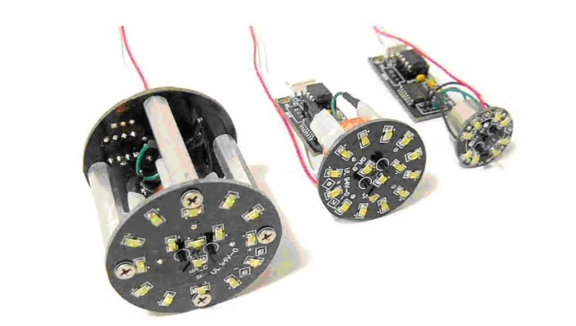

The Beta Innovation Air Core gauges are driven off a Digital to Analog Converter. The faceplates and needles are built by Mike Williams; the Gauge Tubes are built by Jarrod (Jarrod66 on Viperpit).

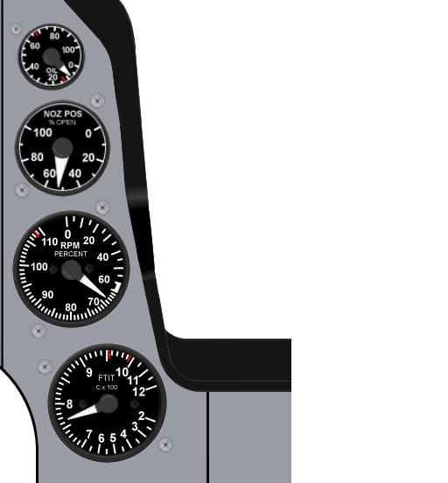

Figure 6 Centre Air Core Gauges

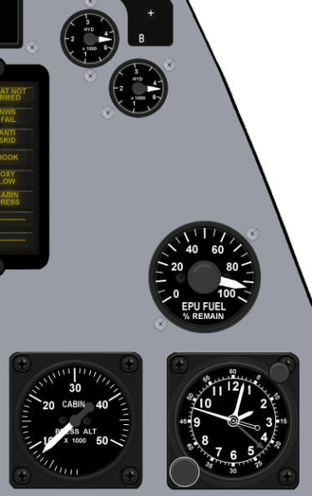

Figure 7 RH Air Core Gauges

These gauges come supplied with Led backlighting. A total of 520mA at 12V is needed to drive the backlighting for the eight gauges.

|  |  |  |  |
| --- | --- | --- | --- |
| Guage Type | Backlight Current | Qty | Total |
| AC360A | 40 mA | 3 | 120mA |
| AC360B | 80 mA | 1 | 80mA |
| AC360C | 80 mA | 4 | 320mA |
|  |  |  | 520mA |

## LO-LED64 Led Output

The LO-LED64 is driven by the E-Flux. As the name suggests it can drive 64 Led outputs. As it is a passive device, F4IM must be manually configured to use this module. Each of the 64 channels can source 35mA at 5V. It supports PWM with a duty cycle range of 25% to 100% via software control.

Outputs using positive logic should be configured like

Figure 8 LOLED-64 driving a led

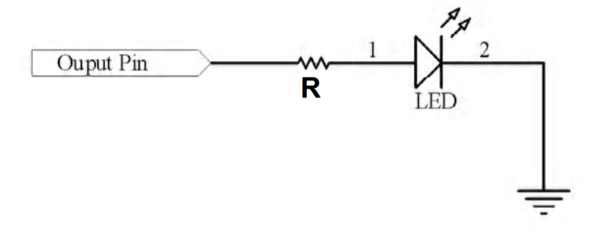

The card has the following connectors

Figure 9 LOLED-64 Ports

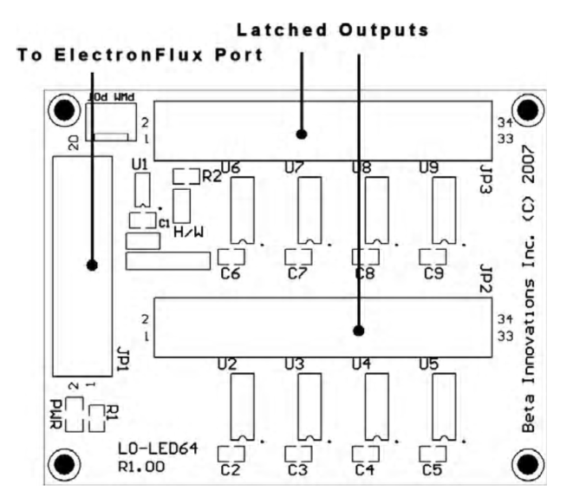

Figure 10 LOLED64 Port A

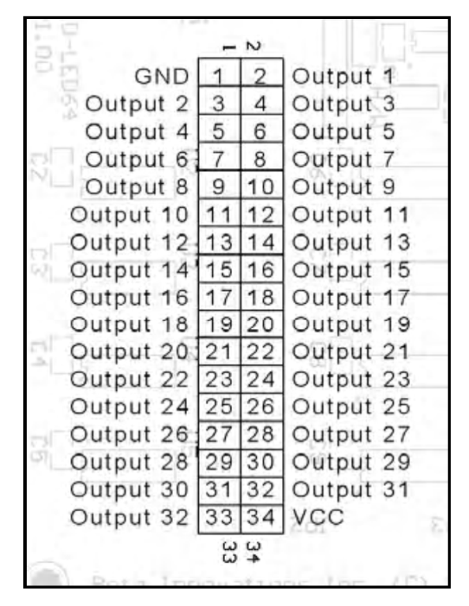

Figure 11 LOLED64 Port B

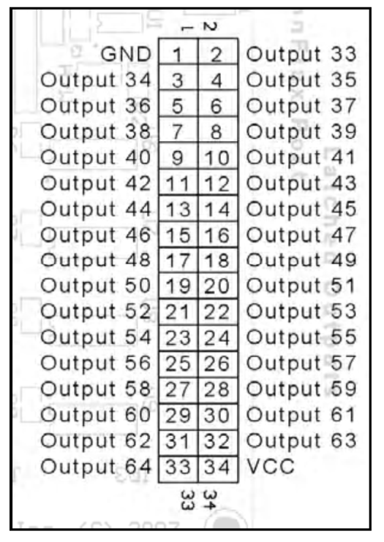

There is a PWM Pot port on the card but this is not functional. The datasheet specifies that the unit can also be S/W controlled, currently this is not configured in F4IM (plan is initially to have a slider in F4IM). The dimming setting applies to all ports. The ultimate plan is to allow you to dim with a pot connected to one of the BI input devices.

# General Panel backlighting

## Dimming the backlights

The Beta Innovation’s LBC-PWM will drive both the Air Core gauges and the General Panel EL Sheets. Consideration will also be given to driving the Simkit’s backlights. The Flight Illusions gauges cannot be dimmed, only supporting off/on for backlighting.

As each of the ten channels is capable of driving 500mA several channels have be used. Given the pit has three wiring zones, Left, Centre, and Right, the EL sheets will also be driven across three channels.

The Air Core gauges sit across the centre and right side of the pit. They will use different channels to the EL sheets to reduce the likelihood of interference and reduce the size of fault domains.

Figure 12 Backlighting of Misc Panel

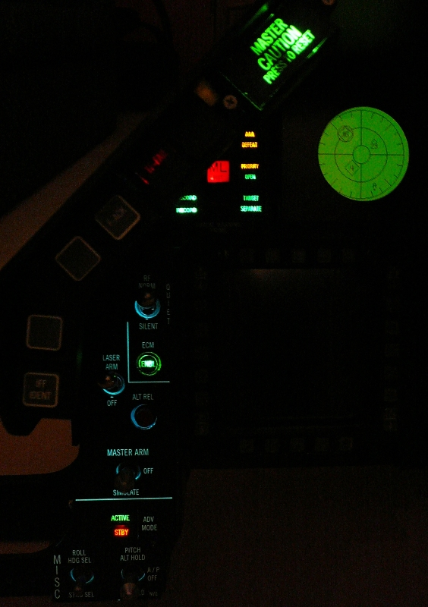

## Air Core Backlighting

|  |  |  |
| --- | --- | --- |
| Centre | Gauge Size (inches) | Current Draw (mA) |
| Oil Pressure | 1 | 40 |
| Nozzle Position | 1.5 | 80 |
| RPM | 2 | 80 |
| FTIT | 2 | 80 |
|  |  | 280mA Total |

|  |  |  |
| --- | --- | --- |
| Right | Gauge Size (inches) | Current Draw |
| Hyd Pressure A | 1 | 40 |
| Hyd Pressure B | 1 | 40 |
| EPU Fuel | 2 | 80 |
| Cabin Pressure | 2 | 80 |
|  |  | 240mA Total |

## EL Sheets

| Left Hand Side EL | |
| --- | --- |
| 1 | Test |
| 2 | Anti-G |
| 3 | Flt control |
| 4 | Manual Trim |
| 5 | Fuel |
| 6 | Aux Comm |
| 7 | Ext Lighting |
| 8 | EPU |
| 9 | Elect |
| 10 | AVTR |
| 11 | ECM |
| 12 | Jet Start |
| 13 | Audio2 |
| 14 | Audio |
| 15 | UHF |
| 16 | Manual Pitch |
| 17 | Threat Warn Aux |
| 18 | CMDS |
| 19 | Gear Panel |
| 20 | MISC |

Total Current Draw 20\*25mA = 500mA

Right Hand Side EL

|  |  |
| --- | --- |
| Right Hand Side EL | |
| 1 | Caution Panel |
| 2 | Sensor Power |
| 3 | HUD Control |
| 4 | Nuclear consent |
| 5 | Lighting |
| 6 | Master Zeroize |
| 7 | Air Cond |
| 8 | Oxy Reg |
| 9 | KY-58 |
| 10 | Avionics Power |
| 11 | Anti-Ice |
| 12 | DTU |
| 13 | OBOGS Monitor |

Total Current Draw 13\*25mA = 325mA

## ICP

Mike (Kabar03) and Jay (Crease-Guard) from Viperpit have put together a very nice ICP.

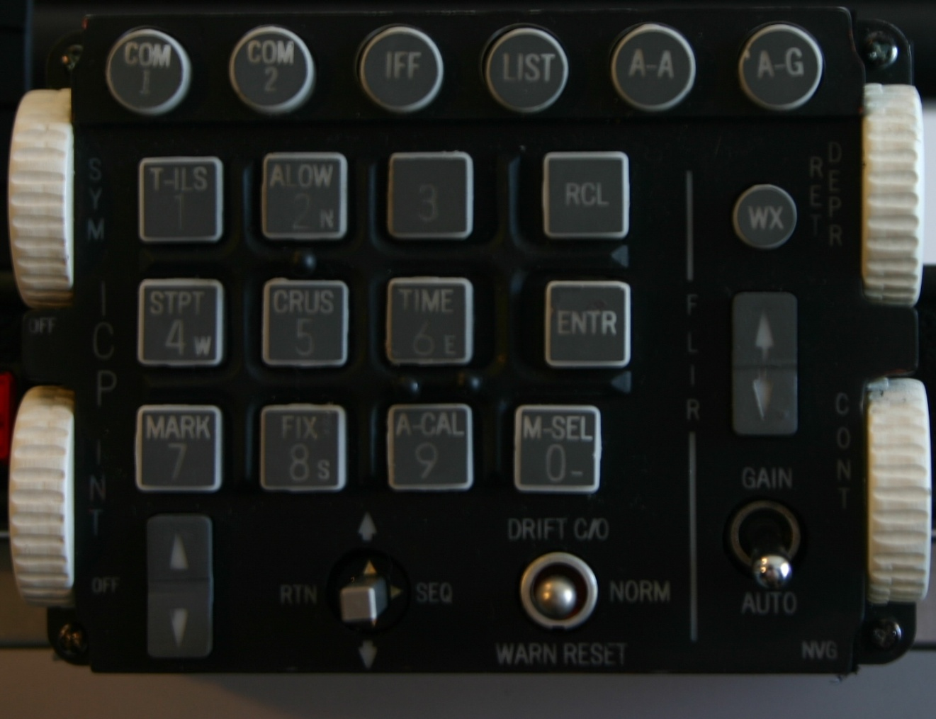

It also is backlit, does require 24V (later models use 12V), so I added an adjustable plug-pack from Dick Smith Electronics.

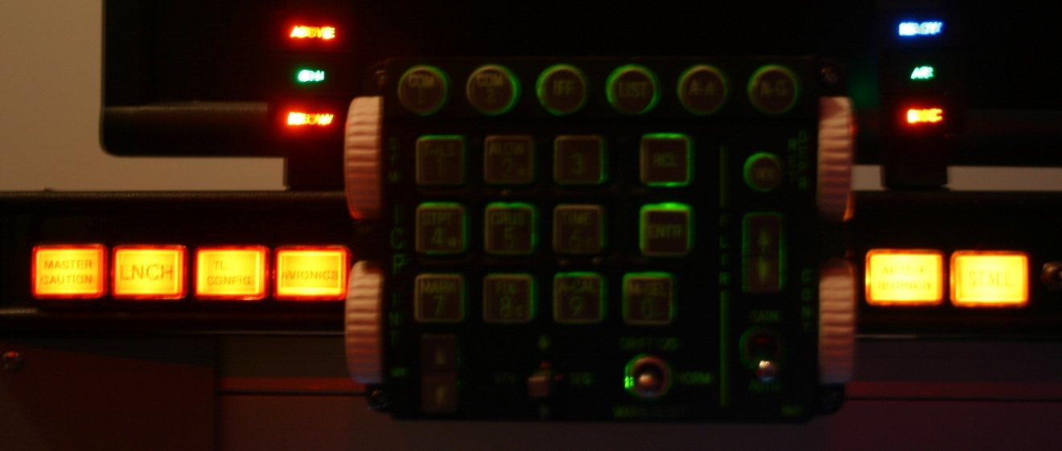

I had been searching for some toggle switches that didn’t look or feel cheap. These can be found at Allied Electronics ([www.AlliedElec.com](http://www.AlliedElec.com)). The switch models I’m using include:

* 676-3240 7101TZQE
* 676-3245 7103TZQE
* 676-3250 7105TZQE

# The Centre Console

The Centre console is the most complex part of the pit, largely due to the number of devices that are mounted in a small area.

Here’s an overview of the pieces that make up the centre console

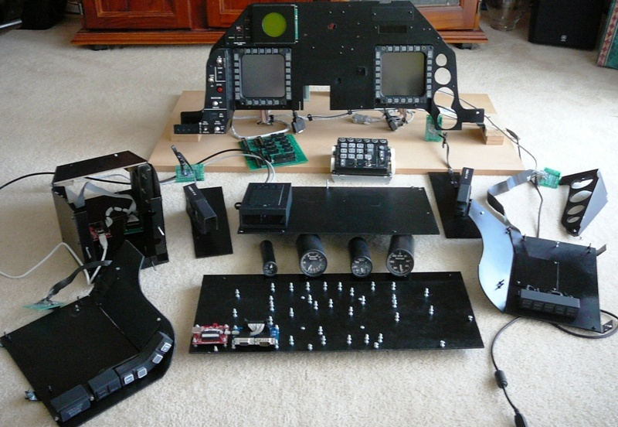

The MM2 and the adaptor PCB are now mounted on the inside of the back panel due to the connectors from the adaptor card intruding into the leg room area in the leg well.

On the back side of the panel we find the G15 display along with its USB interface mounted on the top right, above the MFD display and its electronics. The DB15 (VGA) connectors attached to ribbon cables are from the MFDs. The two stubs of wood in the centre hold the Centre distribution board. The MFD displays are driven off a 12V PC Power Connector.

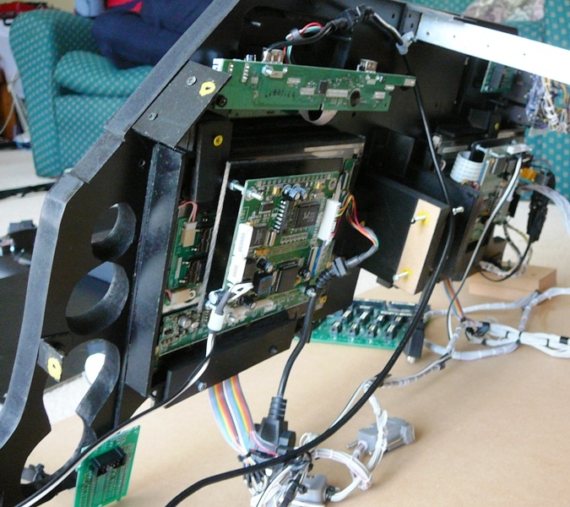

From the back right of the panel we find the PCBs for the MISC Panel, TWP. The white connector next to the TWP PCB is for the RWR.

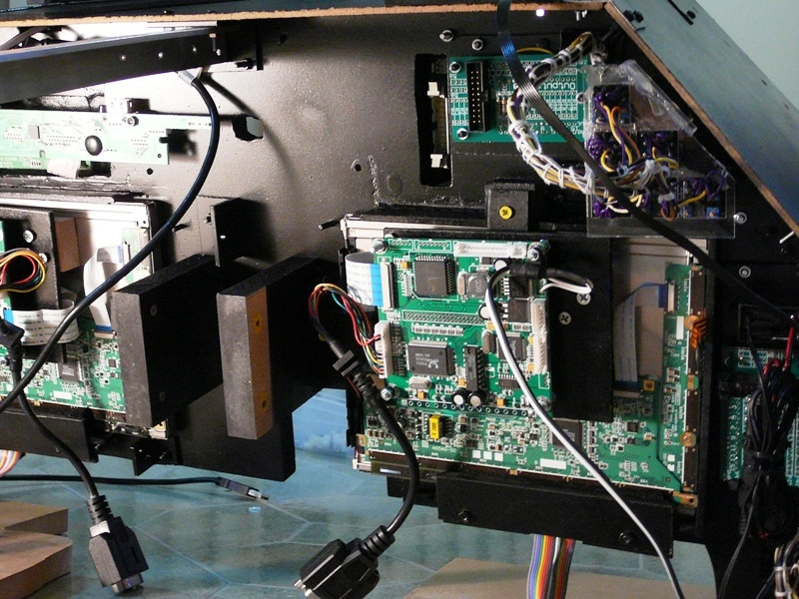

The electronics panel for the MFD display had to be relocated, so it is mounted on a board. The MFDs are touch screen aware, the flat brown cable connects to the touch controller, which is currently not installed. The Misc PCB is not directly connected to the Misc panel because of space challenges.

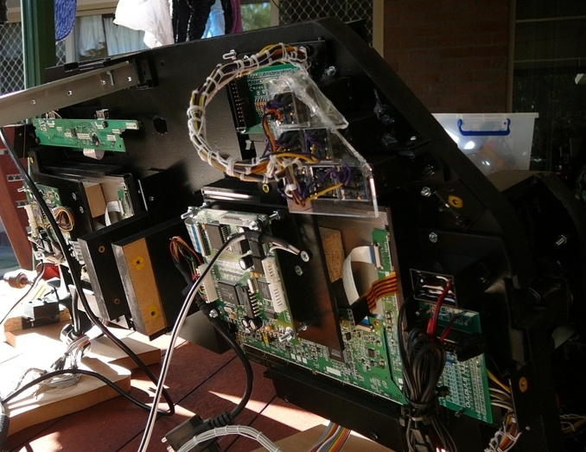

The MM2 and its adaptor card for the ICP are mounted in the ICP itself. I currently don’t have plans to build an HUD.

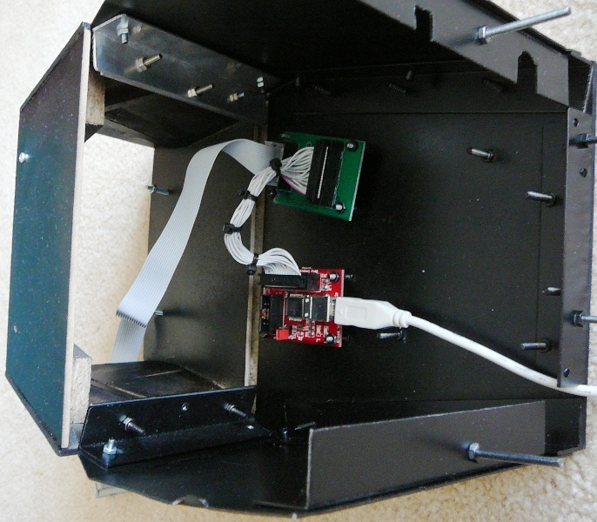

The Front right Eyebrow panel has its cables and holt melt glue (which holds the leds in place) painted black to stop light bleed through. The piece if sheet metal holds the cables up against the frame.

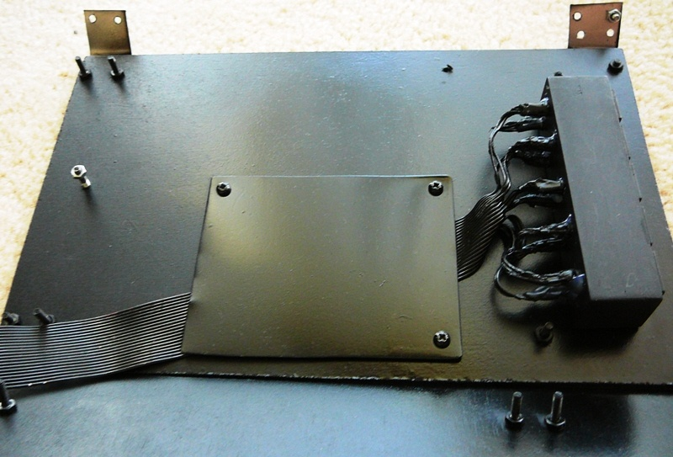

A similar thing is done with the front left Eyebrow panel.

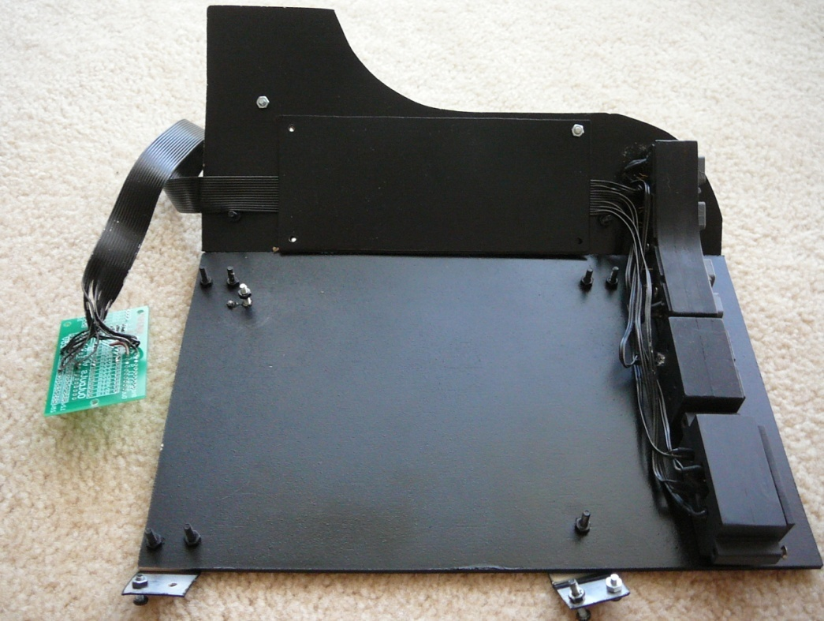

Here’s the back of the panel with the Centre distribution board mounted (note the MM2 and MFD adaptor card now sit on the inside of the distribution board).

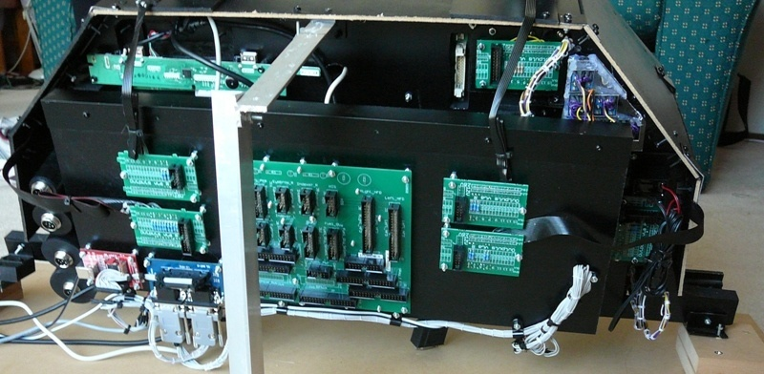

And from the front

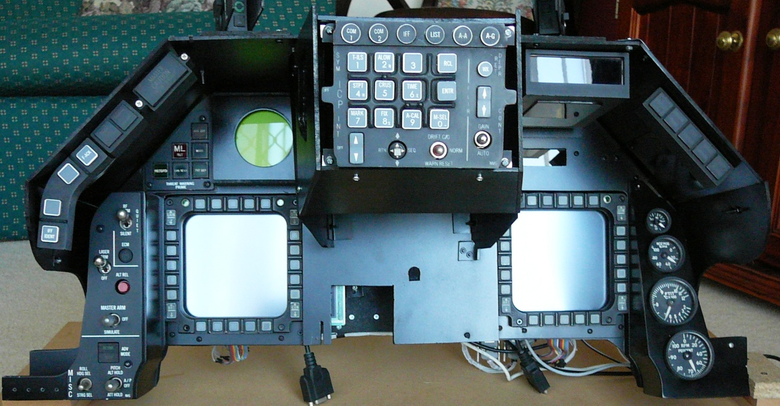

And from the side. The hole in the centre of the front board it to provide clearance for the top gauge in the CP.

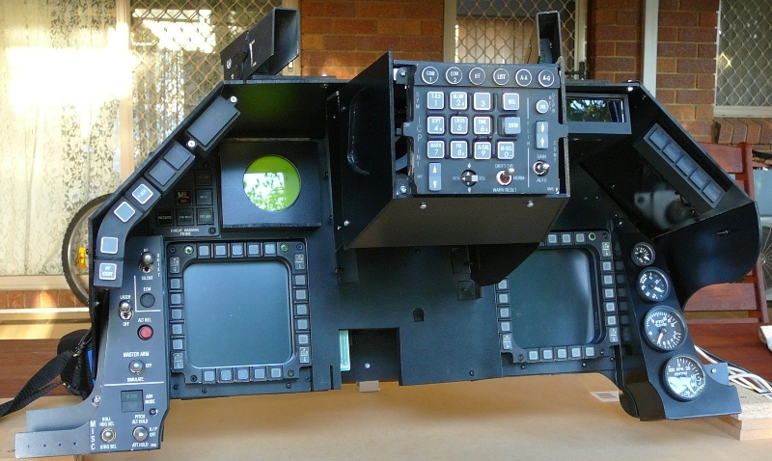

Figure 13 Front Right all lit up

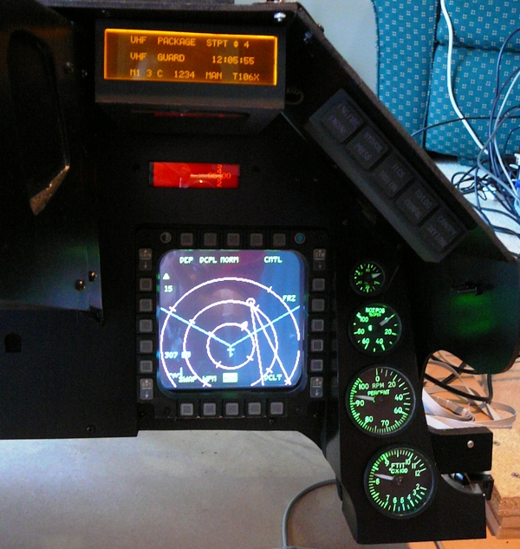

## Centre Pedestal

Figure 14 Rear of CP

Figure 15 Rear of CP

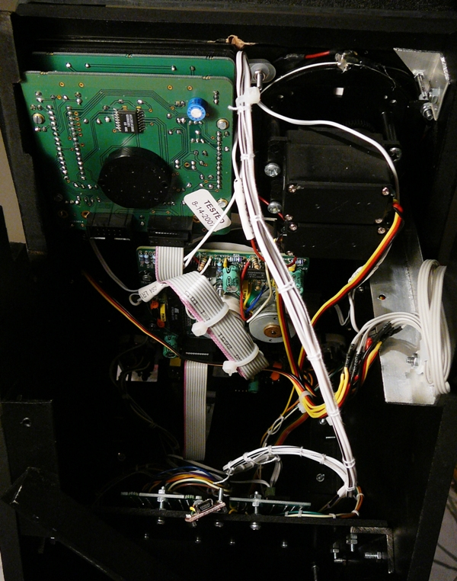

The Flight Illusions gauges are daisy-chained.

Figure 16 Rear of CP with oled USB

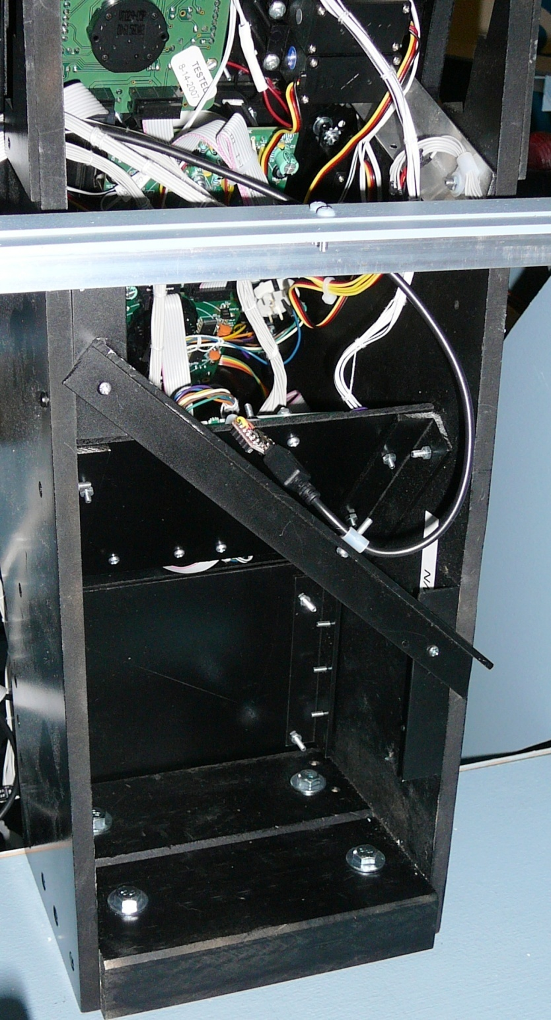

The OLED display has a small USB to serial converter, it is held in place by the USB lead. The four bolts in the bottom hold the CP in place.

## Caution Panel

Figure 17 Caution Panel without gauges

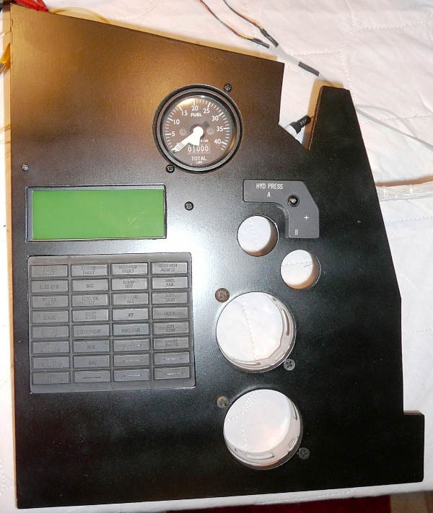

Figure 18 Back of Caution Panel

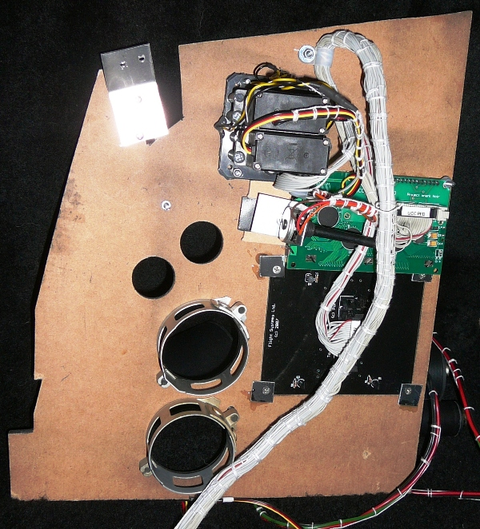

The potentiometer adjusts the contrast of the PFD LCD.

Figure 19 Caution Panel Installed

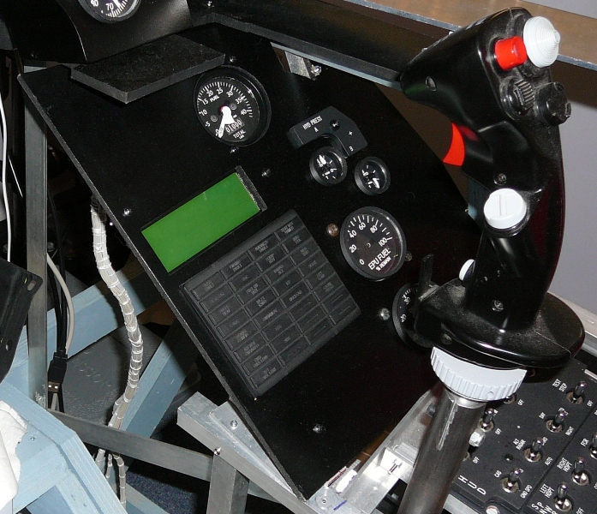

## Gear Panel

The gear panel contains Dunk’s gear assembly. It has been slightly modified so that it now reports Gear lever position, as opposed to just transition.

Figure 20 Gear Assembly before modification

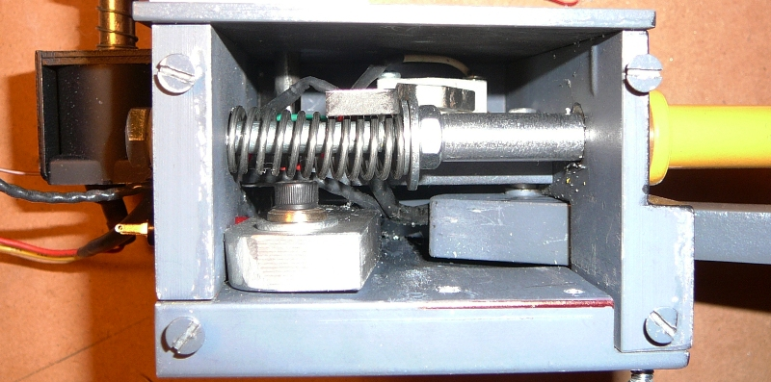

Figure 21 Additional Microswitch and backing plate

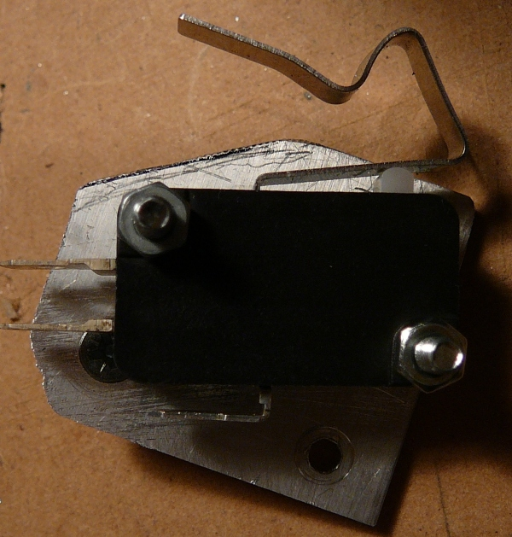

Figure 22 After installation of microswitch

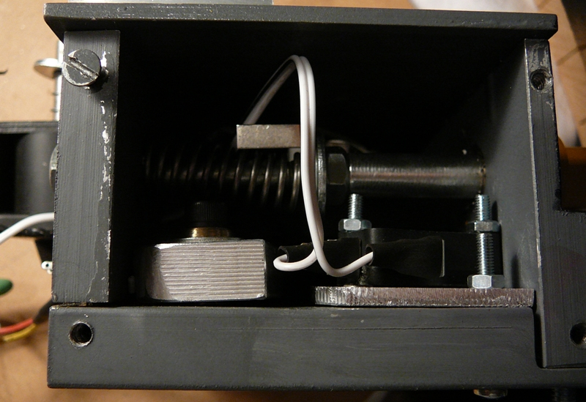

Figure 23 Back of Gear Panel

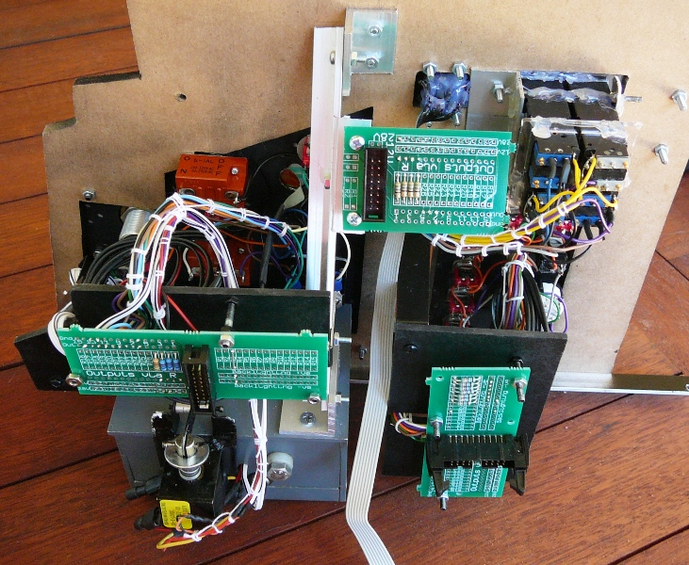

A right angle bracket is just to hold the gear assembly in place. It is also bolted directly to the bracket which supports the inner wall.

Figure 24 Rear of Gear Panel

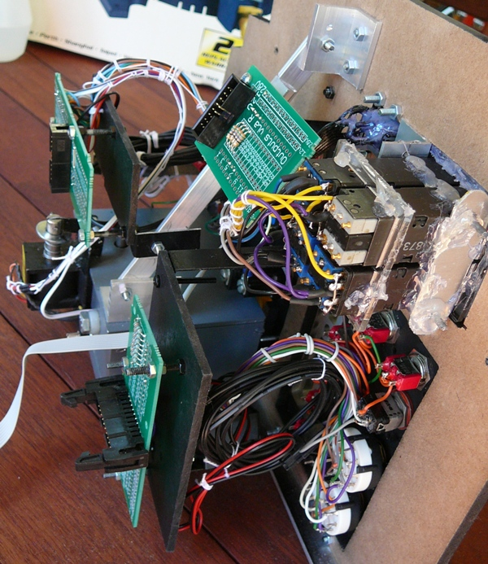

Figure 25 Gear Panel Installed

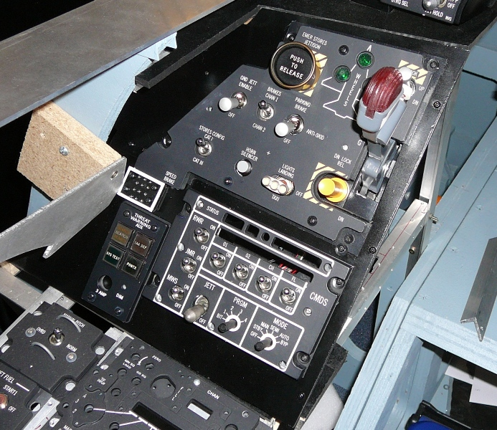

# The Panels in the Pit

The section summarises the panels in the pit. It includes references to Mark Doran’s Callback worksheet and uses pictures cut from Martins F16 pit picture. The panels are in order from the back left of the pit in a clockwise direction.

An empty space in the callbacks section means that at the time of spreadsheet creation the switch was not function in Falcon4. Variants of Falon4 such as Open Falcon probably have callbacks not recorded in this document.

The callbacks are copied from the spreadsheet and pasted as a RTF object, which results in a word table. The font is reduced to 10 points. Macros where used pretty heavily when creating this document. Something I found useful was creating a new toolbar and then Assigning the Macro to the toolbar by Tools -> Customize -> Commands -> Selecting Macros in the left hand column and dragging the macros I needed to the new toolbar.

## The Electronics Bays

There are three electronics ‘bays’. I’ve used some old terminal server boxes.

The three bays are:

1. Primary Input output module
2. Power Distribution, dimming
3. Servo, Flight Illusion

Figure 26 Primary Input Output Module

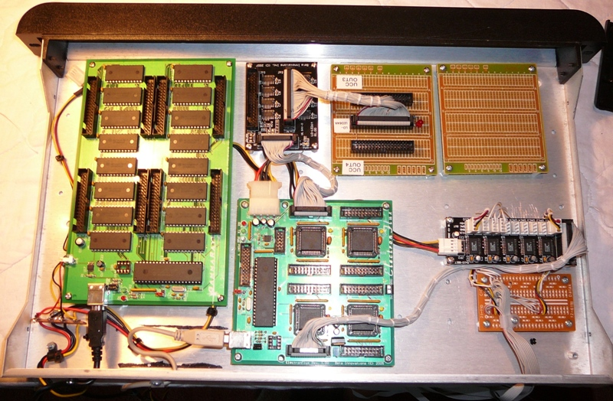

Figure 27 Power and Dimming Module

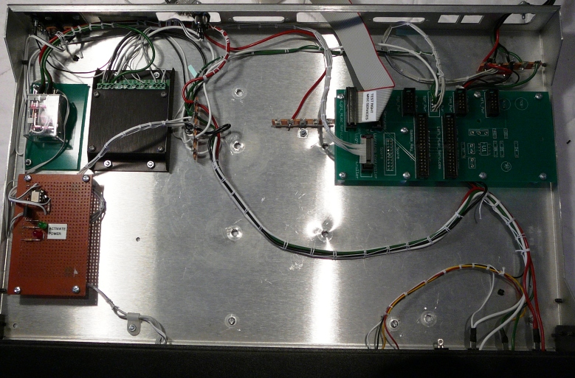

# Falcon Modifications

## Solid Background for MFDs in MFD view.

Useful gem from Lightning

For F4AF, you have to create a text file in your C:\Program Files\Lead Pursuit\Battlefield Operations folder called "BFops.cfg".  In that file, make sure you have a **line** that reads as follows:

Code:

set g\_f**Mfd**Transparency 100

For OpenFalcon, the file is called "falconbms.cfg".    
For RedViper, the file is called "redviper.cfg".

|  |  |
| --- | --- |
| Build Status | |
| Panel Purchased |  |
| Back Panel Purchased |  |
| Mounted in Pit |  |
| Backlighting | Ordered |
| Wired |  |
| Knobs mounted |  |
| Inputs Tested |  |
| Outputs Tested |  |
| Protective Coat Applied |  |

Panel Summary

|  |  |
| --- | --- |
| Test |  |
| Anti-G |  |
| Flt control |  |
| Manual Trim |  |
| Fuel |  |
| Aux Comm |  |
| Ext Lighting |  |
| EPU |  |
| Elect |  |
| AVTR |  |
| ECM |  |
| Jet Start |  |
| Audio2 |  |
| Audio |  |
| UHF |  |
| Manual Pitch |  |
| Threat Warn Aux |  |
| CMDS |  |
| Gear Panel |  |
| MISC |  |
| Threat Warn Prim | Complete |
| Eyebrow Lights L | Complete |
| Eyebrow Lights R | Complete |
| Indexer L | Complete |
| Indexer R | Complete |
| ICP | Complete |
| INSTR |  |
| HIS |  |
| Fuel Qty Select |  |
| Caution Panel |  |
| Sensor Power |  |
| HUD Control |  |
| Nuclear consent |  |
| Lighting |  |
| Master Zeroize |  |
| Air Cond |  |
| KY-58 |  |
| Avionics Power |  |
| Anti-Ice |  |
| Oxy Reg |  |
| DTU 2 |  |
| Left MFD |  |
| Right MFD |  |
| Other |  |
| ACES-II |  |
| TQS |  |
| SSCG |  |
|  |  |

## Keystroke Modifications

F4AF – Using pt\_cockpitbuilders key file (based on cockpitbuilders). Thought I’d be able to do some moving around of keystrokes, using direct DX assignments, but discovered the F4AF doesn’t understand multiple instances of the same controllers (Plasa-MM2s), so keystrokes have to continue to be used for the bulk of the functions.

|  |  |  |
| --- | --- | --- |
| Panel | Switch | Comments |
|  |  |  |
| MISC | RF Inhibit | RF Inhibit Shift-Alt-R SimRFSwitch. The default steps through the RF Quiet settings. Want absolute steps. There are three callbacks RF Norm – RF Quiet, and RF silent. The current toggle is to position so only RF Norm and RF silent are used.  Shift-Control N RF Norm  Shift-Control S RF Silent |
| MISC | Laser Arm | Shift-Control u Laser Arm On  Shift-Control y Laser Arm Off |
| MISC | Autopilot | Default is simply AP off/on. Need to map Shift-Alt-A Left AP Switch Up  Shift-Alt-S Left AP Switch Middle  Shift-Alt-D Left AP Switch Down  Shift-Alt-Z Right AP Switch Up  Shift-Alt-X Right AP Switch Middle  Shigt-Alt-C Right AP Switch Down |
|  |  |  |
| MISC | AVD Mode | Use Invert of TFR-Stdby for Active (BMS) |
| TWP | Priority | Use invert on Open led for Priority. |
|  |  |  |
|  |  |  |

## Test

|  |  |
| --- | --- |
| Build Status | |
| Panel Purchased |  |
| Back Panel Purchased |  |
| Mounted in Pit |  |
| Backlighting | Ordered |
| Wired |  |
| Knobs mounted |  |
| Inputs Tested |  |
| Outputs Tested |  |
| Protective Coat Applied |  |

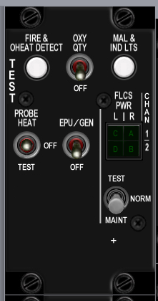

|  |  |  |  |  |  |  |
| --- | --- | --- | --- | --- | --- | --- |
|  | **Poles** | **Switch type** | **Positions** | **Postion names** | **Notes** | **Callback** |
|  |  |  |  |  |  |  |
| EPU gen | 2 | toggle | off-on | off-epu gen |  |  |
| PROBE HEAT | 3 | toggle | on-off-on | test-off-probe heat |  |  |
| FIRE & OHEAT DETECT | 2 | push | off-(on) | n/a |  |  |
| OXY | 2 | toggle | off-on | off-QTY |  |  |
| MAL & IND LTS | 2 |  |  | n/a |  |  |
| A B C D | 0 | indicator light | none | C A D B quartered markings on legend tile | | |
| test maint | 3 | locking toggle | on-off-on | h |  |  |

Notes:

Consider hard wiring indicators to on when power is available.

## Anti-G

|  |  |
| --- | --- |
| Build Status | |
| Panel Purchased |  |
| Back Panel Purchased |  |
| Mounted in Pit |  |
| Wired |  |
| Knobs mounted |  |
| Inputs Tested |  |
| Outputs Tested |  |

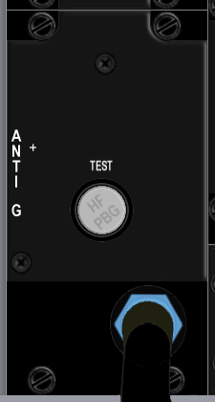

|  |  |  |  |  |  |  |
| --- | --- | --- | --- | --- | --- | --- |
| **Switch Name** | **Poles** | **Switch type** | **Positions** | **Postion names** | **Notes** | **Callback** |
|  |  |  |  |  |  |  |
| test | 2 | push | off-(on) | Test |  |  |

## Flt control

|  |  |
| --- | --- |
| Build Status | |
| Panel Purchased |  |
| Back Panel Purchased |  |
| Mounted in Pit |  |
| Wired |  |
| Knobs mounted |  |
| Inputs Tested |  |
| Outputs Tested |  |

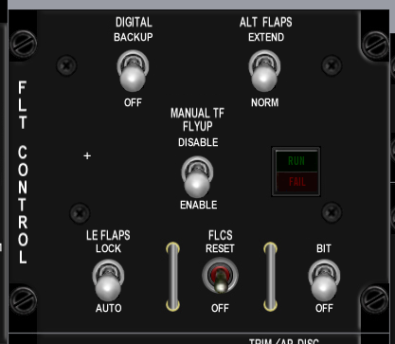

|  |  |  |  |  |  |  |  |  |
| --- | --- | --- | --- | --- | --- | --- | --- | --- |
| **Switch Name** | **Poles** | **Call Back** | **Pole Totals** | **Switch type** | **Positions** | **Postion names** | **Notes** | **Callback** |
|  |  |  | **2** |  |  |  |  |  |
| DIGITAL | 2 | 0 | 0 | locking toggle | [off]-[on] | off-backup |  |  |
| ALT FALPS | 2 | 0 | 1 | locking toggle | [off]-[on] | norm-extend |  | SimAltFlapsNorm, SimAltFlapsExtend |
| MANUAL TF FLYUP | 2 | 0 | 0 | locking toggle | [off]-[on] | disable-enable |  |  |
| LE FLAPS | 2 | 0 | 1 | locking toggle | [off]-[on] | auto-lock |  | SimLEFAuto?, SimLEFLock |
| FLCS | 2 | 0 | 0 | momentary toggle | (on)-off | reset-off |  |  |
| BIT / OFF | 2 | 0 | 0 | locking toggle | [off]-[on] | OFF, BIT |  |  |
| RUN FAIL | 0 | 0 | 0 | indicator light | none | n/a, RUN FAIL legend lights when pressed | | |

|  |  |
| --- | --- |
|  | J4 |
| 1 | BKLGT-V |
| 2 | BKLGT+V |
| 3 | +12V LEFT |
| 4 | +28V LEFT |
| 5 | GND LEFT |
| 6 | L\_FLT |
| 7 | FLP\_EXT |
| 8 | LEF\_LCK |
| 9 | 9 OPEN |
| 10 | 10 OPEN |

## Manual Trim

|  |  |
| --- | --- |
| Build Status | |
| Panel Purchased |  |
| Back Panel Purchased |  |
| Mounted in Pit |  |
| Wired |  |
| Knobs mounted |  |
| Inputs Tested |  |
| Outputs Tested |  |

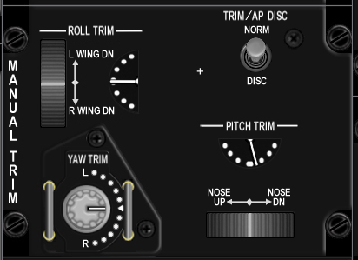

|  |  |  |  |  |  |  |  |  |
| --- | --- | --- | --- | --- | --- | --- | --- | --- |
| **Switch Name** | **Poles** | **Call Back** | **Pole Totals** | **Switch type** | **Positions** | **Position names** | **Notes** | **Callback** |
|  |  |  | **1** |  |  |  |  |  |
| Pitch Trim | 1 | 0 | 0 | encoder with center detent | thumbwheel |  | light stripe showing position | BMS analog axis or SimTrimNoseUp, SimTrimNoseDown |
| Roll Trim | 1 | 0 | 0 | encoder with center detent | thumbwheel |  | light stripe showing position | BMS analog axis or SimTrimRollLeft, SimTrimRollRight |
| Yaw Trim | 1 | 0 | 0 | encoder with center detent | thumbwheel |  | light stripe showing position | BMS analog axis or SimTrimYawLeft, SimTrimYawRight |
| Trim /AP DISC | 2 | 1 | 1 | locking toggle | [off]-[on] | norm, disc |  | SimTrimAPNORM, SimTrimAPDISC |

|  |  |
| --- | --- |
|  | J30 |
| 1 | BKLGT-V |
| 2 | BKLGT+V |
| 3 | +12V LEFT |
| 4 | +28V LEFT |
| 5 | GND LEFT |
| 6 | ROLL |
| 7 | PITCH |
| 8 | 8 OPEN, |
| 9 | ANA\_PWR |
| 10 | ANA\_GND |
| 11 | APITCH |
| 12 | AROLL |
| 13 | AYAW |
| 14 | YLEFT |
| 15 | YRGHT |
| 16 | RLEFT |
| 17 | RRIGHT |
| 18 | NSEUP |
| 19 | NSEDWN |
| 20 | AP\_DISC |

## Fuel

|  |  |
| --- | --- |
| Build Status | |
| Panel Purchased |  |
| Back Panel Purchased |  |
| Mounted in Pit |  |
| Wired |  |
| Knobs mounted |  |
| Inputs Tested |  |
| Outputs Tested |  |

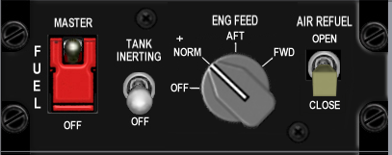

|  |  |  |  |  |  |  |
| --- | --- | --- | --- | --- | --- | --- |
| **Switch Name** | **Poles** | **Switch type** | **Positions** | **Position names** | **Notes** | **Callback** |
|  |  |  |  |  |  |  |
| MASTER | 2 | guarded toggle | off-on | OFF, MASTER | Guarded in MASTER | SimMasterFuelOff, SimMasterFuelOn |
| TANK INERTING | 2 | toggle | off-on | OFF-TANK INERTING ?????? |  |  |
| ENG FEED | 4 | rotary knob | on-on-on-on | OFF, NORM, AFT, FWD | (4x45 deg) | SimFuelPumpOff, SimFuelPumpNorm, SimFuelPumpAft, SimFuelPumpFwd |
| AIR REFUEL | 2 | toggle | off-on | CLOSE, OPEN |  | SimFuelDoorOpen, SimFuelDoorClose? |

|  |  |
| --- | --- |
|  | J6 |
| 1 | BKLGT-V |
| 2 | BKLGT+V |
| 3 | +12V LEFT |
| 4 | +28V LEFT |
| 5 | GND LEFT |
| 6 | FUEL\_ON |
| 7 | PMP\_OFF |
| 8 | PMP\_NRM |
| 9 | PMP\_AFT |
| 10 | PMP\_FWD |
| 11 | FUL\_DOR |
| 12 | 12 OPEN, |
| 13 | 13 OPEN, |
| 14 | 14 OPEN, |
| 15 | 15 OPEN, |
| 16 | 16 OPEN |

## Aux Comm

|  |  |
| --- | --- |
| Build Status | |
| Panel Purchased |  |
| Back Panel Purchased |  |
| Mounted in Pit |  |
| Wired |  |
| Knobs mounted |  |
| Inputs Tested |  |
| Outputs Tested |  |

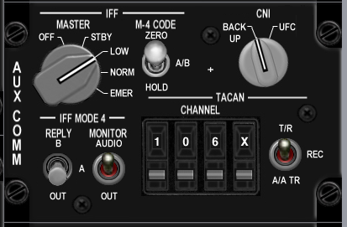

|  |  |  |  |  |  |  |
| --- | --- | --- | --- | --- | --- | --- |
| **Switch Name** | **Poles** | **Switch type** | **Positions** | **Position names** | **Notes** | **Callback** |
|  |  |  |  |  |  |  |
| MASTER | 5 | Rotary knob | on-on-on-on-on | off, STBY, LOW, NORM, EMER | (5x36 deg) | SimToggleAuxComMaster |
| M-4 CODE | 3 | locking toggle | [on]-[off]-[on] | hold, a/b, zero |  |  |
| CNI | 2 | Rotary knob | on-off | BACK UP, UFC | (2x36 deg) | SimAuxComBackup, SimAuxComUFC |
| REPLY | 3 | locking toggle | [off]-[on]-[on] | OUT, A, B |  |  |
| MONITOR | 2 | toggle | off-on | OUT, AUDIO |  |  |
| TACAN | 3 | toggle | on-off-on | A/A TR-REC-T/R |  | SimTACANAATR, SimTACANTR |
| CHANNEL 100's | 10 | encoder | cw/ccw | 0-9 inclusive |  | SimCycleLeftAuxComDigit, SimDecLeftAuxComDigit |
| CHANNEL 10's | 10 | encoder | cw/ccw | 0-9 inclusive |  | SimCycleCenterAuxComDigit, SimDecCenterAuxComDigit |
| CHANNEL 1's | 10 | encoder | cw/ccw | 0-9 inclusive |  | SimCycleRightAuxComDigit, SimDecRightAuxComDigit |
| channel x/y | 2 | encoder | cw/ccw | x, y |  | SimCycleBandAuxComDigit |

|  |  |
| --- | --- |
|  | J7 |
| 1 | BKLGT-V |
| 2 | BKLGT+V |
| 3 | +12V LEFT |
| 4 | +28V LEFT |
| 5 | GND LEFT |
| 6 | COM\_OFF |
| 7 | COM\_STB |
| 8 | COM\_LOW |
| 9 | COM\_NO |
| 10 | COM\_BCK |
| 11 | COM\_UFC |
| 12 | TCN\_ATR |
| 13 | TCN\_NTR |
| 14 | 14 OPEN, |
| 15 | 15 OPEN, |
| 16 | 16 OPEN |

|  |  |
| --- | --- |
|  | J8 |
| 1 | BKLGT-V |
| 2 | BKLGT+V |
| 3 | +12V LEFT |
| 4 | +28V LEFT |
| 5 | GND LEFT |
| 6 | R\_GND |
| 7 | INC\_LFT |
| 8 | DEC\_LFT |
| 9 | INC\_CEN |
| 10 | DEC\_CEN |
| 11 | INC\_RGHT |
| 12 | DEC\_RGHT |
| 13 | INC\_BND |
| 14 | DEC\_BND |
| 15 | 15 OPEN, |
| 16 | 16 OPEN |

## Ext Lighting

|  |  |
| --- | --- |
| Build Status | |
| Panel Purchased |  |
| Back Panel Purchased |  |
| Mounted in Pit |  |
| Wired |  |
| Knobs mounted |  |
| Inputs Tested |  |
| Outputs Tested |  |

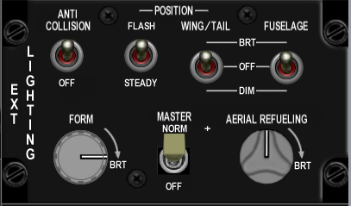

|  |  |  |  |  |  |
| --- | --- | --- | --- | --- | --- |
| **Switch Name** | **Poles** | **Switch type** | **Positions** | **Position names** | **Notes** |
|  |  |  |  |  |  |
| Form | 0 | potentiometer | increase clockwise | |  |
| Master | 2 | toggle | [off]-[on] | off, norm | SimExtlMasterOff, SimExtlMasterNorm |
| Aerial Refueling | 0 | potentiometer | increase clockwise |  |  |
| Anti Collision | 2 | toggle | off-on | off, anti collision | SimAntiCollOff, SimAntiCollOn |
| Flash Steady | 2 | toggle | on-off | flash, steady | SimLightsFlash, SimLightsSteady |
| Wing Trail | 3 | toggle | on-off-on | dim, off, brt | SimWingLightOff, SimWingLightBrt |
| Fuselage | 3 | toggle | on-off-on | dim, off, brt |  |

|  |  |
| --- | --- |
|  | J9 |
| 1 | BKLGT-V |
| 2 | BKLGT+V |
| 3 | +12V LEFT |
| 4 | +28V LEFT |
| 5 | GND LEFT |
| 6 | EXTM\_ON |
| 7 | ACOL\_ON |
| 8 | FLSH\_ON |
| 9 | WNG\_DM |
| 10 | WNG\_BRT |
| 11 | P\_MSTR |
| 12 | P\_DIM |
| 13 | P\_CMN |
| 14 | 14 OPEN, |
| 15 | 15 OPEN, |
| 16 | 16 OPEN |

## EPU

|  |  |
| --- | --- |
| Build Status | |
| Panel Purchased |  |
| Back Panel Purchased |  |
| Mounted in Pit |  |
| Wired |  |
| Knobs mounted |  |
| Inputs Tested |  |
| Outputs Tested |  |

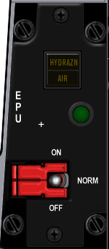

|  |  |  |  |  |  |  |  |  |
| --- | --- | --- | --- | --- | --- | --- | --- | --- |
| **Switch Name** | **Poles** | **Switch type** | **Positions** | **Position names** | **Notes** | **Callback** | **Lightbits1** | **Lightbits2** |
|  |  |  |  |  |  |  |  |  |
| EPU | 3 | guarded toggle | off-on-on | OFF-NORMAL-ON | Center guard on NORMAL | SimEpuOff,SimEpuAuto,SimEpuOn | | |
| RUN light | 0 | indicator light | none | green light |  |  |  | EPUOn = $100000 |
| HYDRAZN-AIR | 0 | indicator light | none | HYDRAZN-AIR |  |  |  | Hydrazine = $100,Air = $200 |

|  |  |
| --- | --- |
|  | J10 |
| 1 | BKLGT-V |
| 2 | BKLGT+V |
| 3 | +12V LEFT |
| 4 | +28V LEFT |
| 5 | GND LEFT |
| 6 | EPU\_ON |
| 7 | HYDRA |
| 8 | AIR |
| 9 | EPU\_OF |
| 10 | EPU\_ON |

## Elect

|  |  |
| --- | --- |
| Build Status | |
| Panel Purchased |  |
| Back Panel Purchased |  |
| Mounted in Pit |  |
| Wired |  |
| Knobs mounted |  |
| Inputs Tested |  |
| Outputs Tested |  |

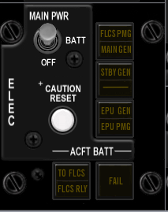

|  |  |  |  |  |  |  |  |  |
| --- | --- | --- | --- | --- | --- | --- | --- | --- |
| **Switch Name** | **Poles** | **Switch type** | **Positions** | **Position names** | **Notes** | **Callback** | **Lightbits1** | **Lightbits2** |
|  |  |  |  |  |  |  |  |  |
| MAIN PWR | 3 | Locking toggle | [off]-[on]-[on] | OFF, BAT, MAIN PWR | | SimMainPowerOff,SimMainPowerBatt,SimMainPowerMain | | |
| CAUTION RESET | 2 | push | off-(on) |  |  | SimWarnReset? | |  |
| FLCS PMG-MAIN GEN | 0 | indicator light | none | FLCS PMG-MAIN GEN |  |  |  | FlcsPmg = $1,MainGen = $2 |
| STBY GEN | 0 | indicator light | none | STBY GEN |  |  |  | StbyGen = $4 |
| EPU GEN-EPU / PMG | 0 | indicator light | none | EPU GEN-EPU / PMG |  |  |  | EpuGen = $8,EpuPmg = $10 |
| FAIL | 0 | indicator light | none | FAIL |  |  |  | BatFail = $80 |
| TO FLCS-FLCS RLY | 0 | indicator light | none | TO FLCS-FLCS RLY |  |  |  | ToFlcs = $20,FlcsRly = $40 |
|  |  |  |  |  |  |  |  |  |

|  |  |
| --- | --- |
|  | J17 |
| 1 | BKLGT-V |
| 2 | BKLGT+V |
| 3 | +12V LEFT |
| 4 | +28V LEFT |
| 5 | GND LEFT |
| 6 | FLCSPMG |
| 7 | MAINGEN |
| 8 | STBYGEN |
| 9 | EPUGEN |
| 10 | EPUPMG |
| 11 | BATFAIL |
| 12 | TOFLCS |
| 13 | FLCSRLY |
| 14 | PWR\_OFF |
| 15 | PWRMAIN |
| 16 | WRN\_RST |

## AVTR

|  |  |
| --- | --- |
| Build Status | |
| Panel Purchased |  |
| Back Panel Purchased |  |
| Mounted in Pit |  |
| Wired |  |
| Knobs mounted |  |
| Inputs Tested |  |
| Outputs Tested |  |

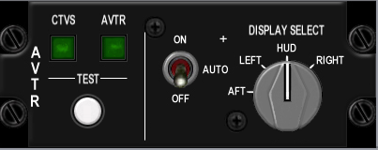

|  |  |  |  |  |  |  |  |  |  |  |
| --- | --- | --- | --- | --- | --- | --- | --- | --- | --- | --- |
| **Switch Name** | **Poles** | **Switch type** | **Positions** | **Position names** | **Notes** | **Callback** | **Lightbits1** | **Lightbits2** | **Lightbits3** | **HSIbits** |
|  |  |  |  |  |  |  |  |  |  |  |
| AVTR | 3 | toggle | on-off-on | on, auto, off |  | SimAVTRSwitchOff, SimAVTRSwitchAuto, SimAVTRSwitchOn | | | | |
|  |  |  |  |  | (4x45 deg) | |  |  |  | AVTR = $2000 |

|  |  |
| --- | --- |
|  | J16 |
| 1 | BKLGT-V |
| 2 | BKLGT+V |
| 3 | +12V LEFT |
| 4 | +28V LEFT |
| 5 | GND LEFT |
| 6 | AVTR |
| 7 | AVT\_OFF |
| 8 | AVT\_ON |
| 9 | 9 OPEN |
| 10 | 10 OPEN |

## ECM

|  |  |
| --- | --- |
| Build Status | |
| Panel Purchased |  |
| Back Panel Purchased |  |
| Mounted in Pit |  |
| Wired |  |
| Knobs mounted |  |
| Inputs Tested |  |
| Outputs Tested |  |

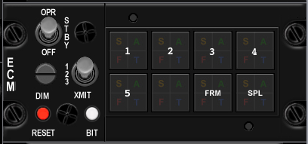

|  |  |  |  |  |
| --- | --- | --- | --- | --- |
| **Switch Name** | **Poles** | **Switch type** | **Positions** | **Position names** |
|  |  |  |  |  |
| OPR | 3 | toggle | off-on-on | OFF-STBY-OPR |
| DIM | 3 | rotary | on-on-on | 1, 2, 3 |
| XMIT | 2 | locking toggle | [on]-[off] | xmit, blank |
| RESET | 2 | toggle | (on)-off | reset, blank |
| BIT | 2 | toggle | (on)-off | bit, blank |
| 1 | 0 | indicator light | none | S, A, F, T light in corners |
| 2 | 0 | indicator light | none | S, A, F, T light in corners |
| 3 | 0 | indicator light | none | S, A, F, T light in corners |
| 4 | 0 | indicator light | none | S, A, F, T light in corners |
| 5 | 0 | indicator light | none | S, A, F, T light in corners |
| ALT | 0 | indicator light | none | S, A, F, T light in corners |
| FRM | 0 | indicator light | none | S, A, F, T light in corners |
| SPL | 0 | indicator light | none | S, A, F, T light in corners |

## Jet Start

|  |  |
| --- | --- |
| Build Status | |
| Panel Purchased |  |
| Back Panel Purchased |  |
| Mounted in Pit |  |
| Wired |  |
| Knobs mounted |  |
| Inputs Tested |  |
| Outputs Tested |  |

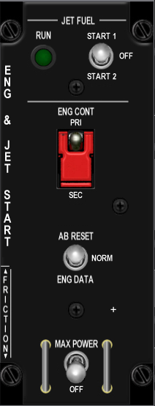

|  |  |  |  |  |  |  |  |
| --- | --- | --- | --- | --- | --- | --- | --- |
| **Switch Name** | **Poles** | **Switch type** | **Positions** | **Position names** | **Callback** | **Notes** | **Lightbits2** |
|  |  |  |  |  |  |  |  |
| JET FUEL | 3 | locking toggle | [on]-[off]-[on] | START2-OFF-START1 | SimJFSStart | solenoid pulls to center after start ?? |
| ENG CONT | 2 | guarded toggle | off-on | SEC-PRI |  | guarded up to PRI |  |
| AB RESET | 3 | toggle | (on)-off-(on) | ENG DATA-NORM-AB DATA | |  |  |
| MAX POWER | 2 | locking toggle | [off]-(on) | OFF-MAX POWER |  |  |
| RUN | 0 | indicator light | none | green light |  |  | JFSOn = $200000 |

|  |  |
| --- | --- |
|  | J13 |
| 1 | BKLGT-V |
| 2 | BKLGT+V |
| 3 | +12V LEFT |
| 4 | +28V LEFT |
| 5 | GND LEFT |
| 6 | JFS\_ON\_LGHT |
| 7 | JFS\_ON\_SOL |
| 8 | JFS\_ST |
| 9 | 9 OPEN, |
| 10 | 10 OPEN |

## Audio2

|  |  |
| --- | --- |
| Build Status | |
| Panel Purchased |  |
| Back Panel Purchased |  |
| Mounted in Pit |  |
| Wired |  |
| Knobs mounted |  |
| Inputs Tested |  |
| Outputs Tested |  |

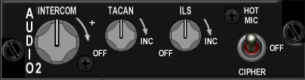

|  |  |  |  |  |  |
| --- | --- | --- | --- | --- | --- |
| **Switch Name** | **Poles** | **Switch type** | **Positions** | **Position names** | **Notes** |
|  |  |  |  |  |  |
| INTERCOM | 0 | potentiometer | increase clockwise |  |  |
| TACAN | 2 | potentiometer 10k log | [off]-increase clockwise |  | rotary pot with off switch |
| ILS | 2 | potentiometer 10k log | [off]-increase clockwise |  | rotary pot with off switch |
| HOT MIC | 3 | toggle | on-off-on | CIPHER, OFF, HOT MIC | |

## Audio

|  |  |
| --- | --- |
| Build Status | |
| Panel Purchased |  |
| Back Panel Purchased |  |
| Mounted in Pit |  |
| Wired |  |
| Knobs mounted |  |
| Inputs Tested |  |
| Outputs Tested |  |

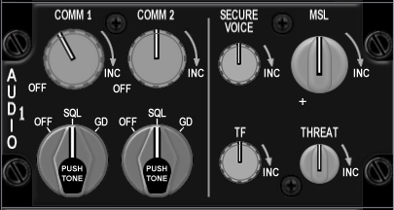

|  |  |  |  |  |  |  |
| --- | --- | --- | --- | --- | --- | --- |
| **Switch Name** | **Poles** | **Switch type** | **Positions** | **Position names** | **Notes** | **Callback** |
|  |  |  |  |  |  |  |
| COMM 1 volume | 2 | potetiometer | off-increase clockwise | | rotary pot with off switch | BMS analog axis or SimStepComm1VolumeDown, SimStepComm1VolumeUp |
| COMM 1 selector | 3 | rotary knob | on-on-on | OFF-SQL-GD | PUSH FOR TONE,(3x45 deg) | |
| COMM 2 volume | 2 | potetiometer | off-increase clockwise |  | rotary pot with off switch | BMS analog axis or SimStepComm2VolumeDown, SimStepComm2VolumeUp |
| COMM 2 selector | 3 | rotary knob | on-on-on | OFF-SQL-GD | PUSH FOR TONE,(3x45 deg) | |
| SECURE VOICE | 0 | potetiometer | increase clockwise |  |  |  |
| TF | 0 | potetiometer | increase clockwise |  |  |  |
| MSL | 0 | potetiometer | increase clockwise |  |  | BMS analog axis or SimStepMissileVolumeDown, SimStepMissileVolumeUp |
| THREAT | 0 | potetiometer | increase clockwise |  |  | BMS analog axis or SimStepThreatVolumeDown, SimStepThreatVolumeUp |

|  |  |
| --- | --- |
|  | J31 |
| 1 | BKLGT-V |
| 2 | BKLGT+V |
| 3 | +12V LEFT |
| 4 | +28V LEFT |
| 5 | GND LEFT |
| 6 | ANA\_PWR |
| 7 | ANA\_GND |
| 8 | ACM1\_V |
| 9 | ACM2\_V |
| 0 | AMSL\_V |
| 1 | ATHRT\_V |
| 2 | CM1\_UP |
| 3 | CM1\_DWN |
| 4 | CM2\_UP |
| 5 | CM2\_DWN |
| 6 | MSL\_UP |
| 7 | MSL\_DWN |
| 8 | THRT\_UP |
| 9 | THRT\_DWN |
| 20 | R\_GND |

## UHF

|  |  |
| --- | --- |
| Build Status | |
| Panel Purchased |  |
| Back Panel Purchased |  |
| Mounted in Pit |  |
| Wired |  |
| Knobs mounted |  |
| Inputs Tested |  |
| Outputs Tested |  |

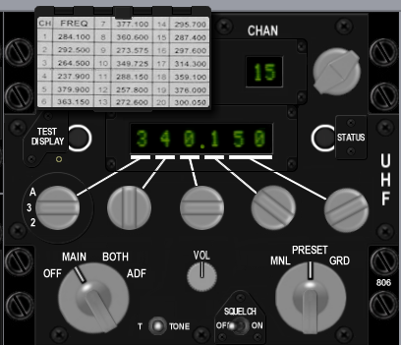

|  |  |  |  |  |  |  |
| --- | --- | --- | --- | --- | --- | --- |
| **Switch Name** | **Poles** | **Switch type** | **Positions** | **Position names** | **Notes** | **Callback** |
|  |  |  |  |  |  |  |
| UHF | 4 | rotary | on-on-on-on | OFF-MAIN-BOTH-ADF | |  |
| TONE | 2 | push | off-(on) | tone |  |  |
| VOL | 0 | potentiometer | clockwise to increase | |  |  |
| SQUELCH | 2 | toggle | off-on | OFF-ON |  |  |
| MANUAL | 3 | rotary | on-on-on | MANUAL-PRESET-GUARD |  |  |
| Freq 100's | 4 | encoder | cw-ccw | A, 3, 2, T |  |  |
| Freq 10's | 10 | encoder | cw-ccw | 0-9 inclusive |  |  |
| Freq 1's | 10 | encoder | cw-ccw | 0-9 inclusive |  |  |
| Freq 1/10's | 10 | encoder | cw-ccw | 0-9 inclusive |  |  |
| Freq 1/1000's | 4 | encoder | cw-ccw | 00, 25, 50, 75 |  |  |
| CHAN | 20 | encoder | cw-ccw | 1-19 inclusive |  | SimCycleRadioChannel, SimDecRadioChannel |
| EMB | 2 | push | off-(on) | ?? |  |  |

## Manual Pitch

|  |  |
| --- | --- |
| Build Status | |
| Panel Purchased |  |
| Back Panel Purchased |  |
| Mounted in Pit |  |
| Wired |  |
| Knobs mounted |  |
| Inputs Tested |  |
| Outputs Tested |  |

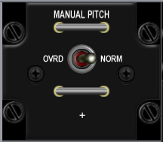

|  |  |  |  |  |  |  |
| --- | --- | --- | --- | --- | --- | --- |
| **Switch Name** | **Poles** | **Switch type** | **Positions** | **Position names** | **Notes** | **Callback** |
|  |  |  |  |  |  |  |
| MANUAL PITCH | 2 | toggle | off-on | OVRD-NORM | Horizontal wire guard loops above and below toggle | SimMPO |

|  |  |
| --- | --- |
|  | J3 |
| 1 | BKLGT-V |
| 2 | BKLGT+V |
| 3 | +12V LEFT |
| 4 | +28V LEFT, |
| 5 | GND LEFT |
| 6 | MPTCHO NET49\_1, |
| 7 | 7 OPEN, |
| 8 | 8 OPEN, |
| 9 | 9 OPEN, |
| 10 | 10 OPEN |

## Threat Warn Aux

|  |  |
| --- | --- |
| Build Status | |
| Panel Purchased |  |
| Back Panel Purchased |  |
| Mounted in Pit |  |
| Wired |  |
| Knobs mounted |  |
| Inputs Tested |  |
| Outputs Tested |  |

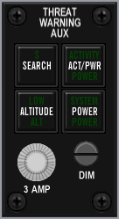

|  |  |  |  |  |  |  |  |  |
| --- | --- | --- | --- | --- | --- | --- | --- | --- |
| **Switch Name** | **Poles** | **Switch type** | **Positions** | **Position names** | **Notes** | **Callback** | **Lightbits1** | **Lightbits2** |
|  |  |  |  |  |  |  |  |  |
| Search | 2 | on/off lighted push | off-on | search |  | SimRWRSetSearch | | AuxSrch = $1000 |
| activity power | 2 | on/off lighted push | off-on | activity power |  |  |  | AuxAct = $2000 |
| Low priority | 2 | on/off lighted push | off-on | low |  | SimRWRSetGroundPriority? | | AuxLow = $4000 |
| system power | 2 | on/off lighted push | off-on | power |  | SimRwrPower | | AuxPwr = $8000 |
| fuse | 0 | fuse holder | none | n/a |  |  |  |  |
| Dimmer | 0 | potentiometer | rotary | n/a | no EPIC connection |  |  |  |

|  |  |
| --- | --- |
|  | J22 |
| 1 | BKLGT-V |
| 2 | BKLGT+V |
| 3 | +12V LEFT |
| 4 | +28V LEFT |
| 5 | GND LEFT |
| 6 | AXSCH |
| 7 | AXACT |
| 8 | AXLOW |
| 9 | AXPWR |
| 10 | R\_SRCH |
| 11 | R\_GND |
| 12 | R\_PWR |
| 13 | 13 OPEN, |
| 14 | 14 OPEN, |
| 15 | 15 OPEN, |
| 16 | 16 OPEN |

## CMDS

|  |  |
| --- | --- |
| Build Status | |
| Panel Purchased |  |
| Back Panel Purchased |  |
| Mounted in Pit |  |
| Wired |  |
| Knobs mounted |  |
| Inputs Tested |  |
| Outputs Tested |  |

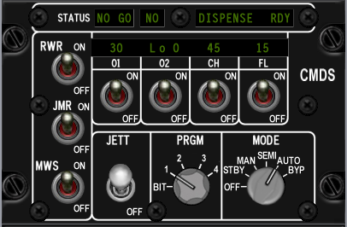

|  |  |  |  |  |  |  |  |
| --- | --- | --- | --- | --- | --- | --- | --- |
| **Switch Name** | **Poles** | **Switch type** | **Positions** | **Position names** | **Notes** | **Callback** | |
|  |  |  |  |  |  |  | |
| RWR | 2 | toggle | off-on | off, on |  | SimEWSRWROn, SimEWSRWROff | |
| JMR | 2 | toggle | off-on | off, on |  | SimEWSJammerOn, SimEWSJammerOff | |
| MWS | 2 | toggle | off-on | off, on |  |  | |
| 01 | 2 | toggle | off-on | off, on |  |  | |
| 02 | 2 | toggle | off-on | off, on |  |  | |
| CH | 2 | toggle | off-on | off, on |  | SimEWSChaffOff, SimEWSChaffOn | |
| FL | 2 | toggle | off-on | off, on |  | SimEWSFlareOff, SimEWSFlareOn | |
| JETT | 2 | locking toggle | off-on | off, JETT |  |  | |
| PRGM | 5 | rotary | on-on-on-on-on | bit, 1, 2, 3, 4, 5 | (5x36 deg) | SimEWSProgOne, SimEWSProgTwo, SimEWSProgThree, SimEWSProgFour | |
| MODE | 6 | rotary | on-on-on-on-on-on | off, stby, man, semi, auto, byp | (6x30 deg) | SimEWSModeOff, SimEWSModeStby, SimEWSModeMan, SimEWSModeSemi, SimEWSModeAuto, | |
| STATUS NO GO | 0 | green indicator light | n/a | NO GO (green lit legend) | |  | |
| STATUS GO | 0 | green indicator light | n/a | GO (green lit legend) | |  |
| STATUS READY | 0 | green indicator light | n/a | READY TO DISPENSE (green lit legend) | | | |

|  |  |
| --- | --- |
|  | J21 |
| 1 | BKLGT-V |
| 2 | BKLGT+V |
| 3 | +12V LEFT |
| 4 | +28V LEFT |
| 5 | GND LEFT |
| 6 | GO NET5\_2, |
| 7 | NO\_GO |
| 8 | RDY\_DISP |
| 9 | CHAFF\_LO |
| 10 | FLARE\_LO |

|  |  |
| --- | --- |
|  | J23 |
| 1 | BKLGT-V |
| 2 | BKLGT+V |
| 3 | +12V LEFT |
| 4 | +28V LEFT |
| 5 | GND LEFT |
| 6 | RWR\_ON |
| 7 | JMR\_ON |
| 8 | CHF\_ON |
| 9 | FLR\_ON |
| 10 | PRG\_BIT |
| 11 | PRG\_1 |
| 12 | PRG\_2 |
| 13 | PRG\_3 |
| 14 | PRG\_4 |
| 15 | MDEOFF |
| 16 | MDESTBY |
| 17 | MDEMAN |
| 18 | MDESEMI |
| 19 | MDEAUTO |
| 20 | MDEBYP |

## Gear Panel

|  |  |
| --- | --- |
| Build Status | |
| Panel Purchased |  |
| Back Panel Purchased |  |
| Mounted in Pit |  |
| Wired |  |
| Knobs mounted |  |
| Inputs Tested |  |
| Outputs Tested |  |

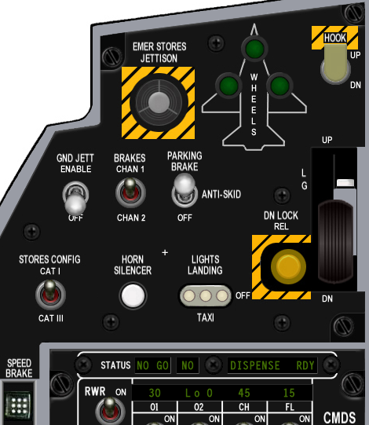

|  |  |  |  |  |  |  |  |  |  |
| --- | --- | --- | --- | --- | --- | --- | --- | --- | --- |
| **Switch Name** | **Poles** | **Switch type** | **Positions** | **Position names** | **Notes** | **Callback** | **Lightbits1** | **Lightbits2** | **Lightbits3** |
|  |  |  |  |  |  |  |  |  |  |
| Emergency jettison | 2 | guarded push | off-(on) | n/a | breakable cover over | SimEmergencyJettison | | |  |
| wheel lights | 0 | 3 x green lights | none | n/a |  |  |  |  | NoseGearDown = $10000,LeftGearDown = $20000,RightGearDown = $40000 |
| Hook | 2 | lever locking toggle | [off]-[on] | dn, up |  | SimHookUp,SimHookDown | | |  |
| Ground jettison | 2 | locking toggle | [off]-[on] | off, enable |  | SimGndJettOn, SimGndJettOff | | |  |
| Brakes | 2 | toggle | off-on | chan 2, chan 1 |  |  |  |  |  |
| Parking brake | 3 | locking toggle | [off]-[on]-[on] | off, anti skid, brake |  | SimParkingBrakeOff, ,SimParkingBrakeOn | | | |
| Stores | 2 | toggle | off-on | cat III, cat I |  | SimCATIII,SimCATI | |  |  |
| Horn silencer | 2 | push | off-(on) | n/a |  | SimSilenceHorn | |  |  |
| Landing lights | 3 | locking t handle toggle | [on]-[off]-[on] | taxi, off, landing |  | SimLandingLightOn, SimLandingLightOff | | | |
| Down lock release | 2 | push | off-(on) | n/a |  |  |  |  |  |
| Gear down enable | 2 | push | off-(on) | n/a | mounted on the arm of the gear handle | | | |  |
| Gear handle | 2 | lollipop lever | off-on | (down and up) |  | AFGeapUp, AFGearDown | | |  |
| Gear warning light | 0 | yellow light | none | n/a | mounted in lollipop end of the gear handle | | | GEARHANDLE = $40000000 | |

|  |  |
| --- | --- |
|  | J29 |
| 1 | BKLGT-V |
| 2 | BKLGT+V |
| 3 | +12V LEFT |
| 4 | +28V LEFT |
| 5 | GND LEFT |
| 6 | N\_GEAR |
| 7 | L\_GEAR |
| 8 | R\_GEAR |
| 9 | G\_HNDLE |
| 10 | PK\_SOLND |
| 11 | HOOK |
| 12 | GNDJETT |
| 13 | PARKBRK |
| 14 | EMG\_JET |
| 15 | CAT\_III |
| 16 | L\_TAXI |
| 17 | L\_LAND |
| 18 | L\_GEAR |
| 19 | HRN\_SIL |
| 20 | 20 OPEN |

## MISC

|  |  |
| --- | --- |
| Build Status | |
| Panel Purchased |  |
| Back Panel Purchased |  |
| Mounted in Pit |  |
| Wired |  |
| Knobs mounted |  |
| Inputs Tested |  |
| Outputs Tested |  |

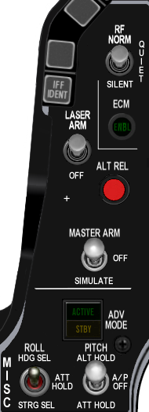

|  |  |  |  |  |  |  |  |  |
| --- | --- | --- | --- | --- | --- | --- | --- | --- |
| **Switch Name** | **Poles** | **Switch type** | **Positions** | **Position names** | **Notes** | **Callback** | **Lightbits1** | **Lightbits2** |
|  |  |  |  |  |  |  |  |  |
| RF quiet[[3]](#footnote-3) | 3 | locking toggle | [on[-[off]-[on] | silent, rf norm |  | SimRFNorm, SimRFQuiet, SimRFSilent | | |
| ECM light | 0 | green light | none | n/a |  |  |  | EcmPwr = $10000? |
| Laser arm | 2 | locking toggle | [off]-[on] | off, arm |  | SimLaserArmOn, SimLaserArmOff | | |
| Alternate release | 2 | push | off-(on) | n/a |  | SimPickle |  |  |
| Master arm | 3 | locking toggle | [on]-[off]-[on] | simulate, off, arm |  | SimSimMasterArm, SimSafeMasterArm, SimArmMasterArm | | |
| ADV mode | 0 | indicator light tile | none | active/standby |  |  |  |  |
| Autopilot pitch | 3 | locking toggle | [on]-[off]-[on] | att hold, a-p off, alt hold |  | SimRightAPDown, SimRightAPMid, SimRightAPUp | | |
| Autopilot roll | 3 | toggle | on-off-on | strg sel, att hold, hdg sel |  | SimLeftAPDown, SimLeftAPMid, SimLeftAPUp | | |

|  |  |
| --- | --- |
|  | J17 |
| 1 | BKLGT-V |
| 2 | BKLGT+V |
| 3 | +12V |
| 4 | +28V |
| 5 | GND , |
| 6 | ECM\_PWR |
| 7 | AP\_ON |
| 8 | TFR\_STDBY |
| 9 | ECM\_PWR |
| 0 | TFR\_ENGAGED |
| 1 | RF\_NRM |
| 2 | RF\_SILNT |
| 3 | LSR\_ON |
| 4 | S\_PICKLE |
| 5 | MST\_ARM |
| 6 | MST\_SIM |
| 7 | RAP\_DWN |
| 8 | RAP\_UP |
| 9 | LAP\_DWN |
| 10 | LAP\_UP |

## Threat Warn Prim

|  |  |
| --- | --- |
| Build Status | |
| Panel Purchased |  |
| Back Panel Purchased |  |
| Mounted in Pit |  |
| Wired |  |
| Knobs mounted |  |
| Inputs Tested |  |
| Outputs Tested |  |

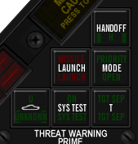

|  |  |  |  |  |  |  |  |
| --- | --- | --- | --- | --- | --- | --- | --- |
| **Switch Name** | **Poles** | **Switch type** | **Positions** | **Notes** | **Callback** | **Lightbits1** | **Lightbits2** |
|  |  |  |  |  |  |  |  |
| Handoff | 2 | push | off-(on) | Green illumination on push to select handoff mode | SimRWRHandoff |  | HandOff = $1 |
| Priority | 2 | push | off-(on) | Green illumination on push to select priority threat mode | SimRWRSetPriority |  | PriMode = $4 |
| Target separate | 2 | push | off-(on) | Green illumination on push to separate target symbols | SimRWRSetTargetSep |  | TgtSep = $20 |
| Missile Launch | 0 | indicator light tile | none | Red light |  |  | Launch = $2 |
| system test | 2 | push | off-(on) | Green light on push | |  |  |
| Unknown/naval | 2 | push | off-(on) | Green light on push | SimRWRSetNaval, SimRWRSetUnknowns | | Naval = $8,Unk = $10 |

|  |  |
| --- | --- |
|  | 19 |
| 1 | BKLGT-V |
| 2 | BKLGT+V |
| 3 | +12V |
| 4 | +28V |
| 5 | GND , |
| 6 | HANDOFF |
| 7 | PRIMODE |
| 8 | TGTSEP |
| 9 | LAUNCH |
| 10 | NAVAL |
| 11 | UKNOWN |
| 12 | RHANDOFF |
| 13 | RSETPRI |
| 14 | RSETTGT |
| 15 | RSETNVL |
| 16 | RSETUN |

## Eyebrow Lights L

|  |  |
| --- | --- |
| Build Status | |
| Panel Purchased |  |
| Back Panel Purchased |  |
| Mounted in Pit |  |
| Wired |  |
| Knobs mounted |  |
| Inputs Tested |  |
| Outputs Tested |  |

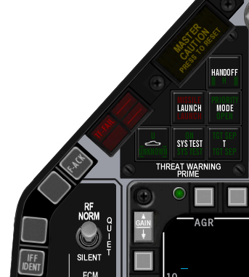

|  |  |  |  |  |  |  |  |
| --- | --- | --- | --- | --- | --- | --- | --- |
| **Switch Name** | **Poles** | **Switch type** | **Positions** | **Position names** | **Notes** | **Callback** | **Lightbits1** |
| **Left** |  |  |  |  |  |  |  |
| IFF | 2 | push | off-(on) | IFF IDENT |  |  |  |
| Blank 1 | 2 | push | off-(on) | (directly above IFF button) | |  |  |
| Blank 2 | 2 | push | off-(on) | (directly below TF-FAIL button) | |  |  |
| TF fail | 0 | red indicator light | none | TF-FAIL | Red illumination, normally off | | TF = $2 |
| F-ACK | 2 | push | off-(on) | F-ACK |  | SimICPFAck |  |
| Master Caution | 2 | push | off-(on) | Master Caution push to reset | | ExtinguishMasterCaution | MasterCaution = $1 |

|  |  |
| --- | --- |
|  | J16 |
| 1 | BKLGT-V |
| 2 | BKLGT+V |
| 3 | +12V |
| 4 | +28V |
| 5 | GND , |
| 6 | TFF |
| 7 | M\_CAUT |
| 8 | F\_ACK |
| 9 | EXT\_CTN |
| 10 | 10 OPEN |

## Eyebrow Lights R

|  |  |
| --- | --- |
| Build Status | |
| Panel Purchased |  |
| Back Panel Purchased |  |
| Mounted in Pit |  |
| Wired |  |
| Knobs mounted |  |
| Inputs Tested |  |
| Outputs Tested |  |

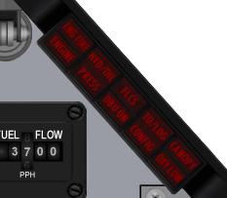

|  |  |  |  |  |  |  |  |
| --- | --- | --- | --- | --- | --- | --- | --- |
| **Switch Name** | **Poles** | **Switch type** | **Positions** | **Position names** | **Notes** | **Callback** | **Lightbits1** |
|  |  |  |  |  |  |  |  |
| **Right** |  |  |  |  |  |  |  |
| Engine fire | 2 | push | off-(on) | ENGFIRE ENGINE | Red illumination, normally off | | ENG\_FIRE = $20, ENGINE=80000000 |
| Fluid pressure warning | 2 | push | off-(on) | HYD/OIL PRESS | Red illumination, normally off | | HYD = $80,  OIL = $100 |
| Flight controls warning | 2 | push | off-(on) | FLCS DBU ON | Red illumination, normally off | |  |
| Landing configuration | 2 | push | off-(on) | TO/LDG CONFIG | Red illumination, normally off | | T\_L\_CFG = $800 |
| Canopy seal warning | 2 | push | off-(on) | CANOPY | Red illumination, normally off | | CAN = $400 |

|  |  |
| --- | --- |
|  | J11 |
| 1 | BKLGT-V |
| 2 | BKLGT+V |
| 3 | +12V |
| 4 | +28V |
| 5 | GND , |
| 6 | E\_FIRE |
| 7 | ENGINE |
| 8 | OIL |
| 9 | TL\_CFG |
| 10 | CANOPY |

A little challenge here as Leo provides support for more Light BITS, and Mike’s Right Eyebrow is different to what I’d been working off. Ended up using <http://www.scribd.com/doc/903695/F16MLU-Checklist> as a reference

|  |  |  |  |  |  |
| --- | --- | --- | --- | --- | --- |
|  | Original | Mike | F4IM | F4IM Comments |  |
| Engine | 7 | Engine |  | ENG\_FIRE | 6 |
| E\_Fire | 6 | Eng Fire |  | ENG\_FIRE | 6 |
| OIL | 8 | Press |  | OIL | 7 |
|  |  | HYD/OIL |  | HYD | 8 |
|  |  | FLCS |  | DUAL | 9 |
|  |  | DBO ON |  | DUAL | 9 |
| TL\_CFG | 9 | TO/LDG |  | T\_L\_CFG | 10 |
|  |  | CONFIG |  | CONFIG | 11 |
| Canopy | 10 | CANOPY |  | CAN | 12 |
|  |  | OXY LOW | N/A |  |  |

As Wired

|  |  |  |  |  |  |  |  |  |  |
| --- | --- | --- | --- | --- | --- | --- | --- | --- | --- |
|  |  | 1 | 2 | 3 | 4 | 5 | 6 | 7 | 8 |
| ENG FIRE | 1 | X |  |  |  |  |  |  |  |
| ENGINE | 2 |  | X |  |  |  |  |  |  |
| PRESS | 3 |  |  | X |  |  |  |  |  |
| CONFIG | 4 |  |  |  | X |  |  |  |  |
| CANOPY | 5 |  |  |  |  | X |  |  |  |
| HYD/OIL | 6 |  |  | X |  |  |  |  |  |
| DBU ON | 7 |  |  |  |  |  | X |  |  |
| FLCS | 8 |  |  |  |  |  |  | X |  |
| TO/LDG | 9 |  |  |  | X |  |  |  |  |
| OXY LOW | 10 |  |  |  |  |  |  |  | X |

|  |  |  |  |  |
| --- | --- | --- | --- | --- |
| ENG FIRE  1 | HYD/OIL  6 | FLCS  8 | TO/LDG  9 | CANOPY  5 |
| ENGINE  2 | PRESS  3 | DBU ON  7 | CONFIG  4 | OXY LOE  10 |

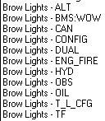

Final Wiring of Spare Connector

|  |  |
| --- | --- |
|  | J32 |
| 1 | BKLGT-V |
| 2 | BKLGT+V |
| 3 | +12V |
| 4 | +28V |
| 5 | GND , |
| 6 | E\_FIRE |
| 7 | ENGINE |
| 8 | OIL |
| 9 | TL\_CFG |
| 10 | CANOPY |
| 11 | FLCS |
| 12 | DBU ON |
| 13 | OXY LOW |
|  |  |

Indexer L

|  |  |
| --- | --- |
| Build Status | |
| Panel Purchased |  |
| Back Panel Purchased |  |
| Mounted in Pit |  |
| Wired |  |
| Knobs mounted |  |
| Inputs Tested |  |
| Outputs Tested |  |

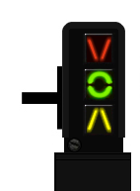

|  |  |  |  |  |  |  |  |
| --- | --- | --- | --- | --- | --- | --- | --- |
| **Switch Name** | **Poles** | **Switch type** | **Positions** | **Position names** | **Notes** | **Callback** | **Lightbits1** |
|  |  |  |  |  |  |  |  |
| **Left Indexer** |  |  |  |  |  |  |  |
|  |  |  |  |  |  |  | AOAAbove = $1000 |
|  |  |  |  |  |  |  | AOAOn = $2000 |
|  |  |  |  |  |  |  | AOABelow = $4000 |

|  |  |
| --- | --- |
|  | J8 |
| 1 | BKLGT-V |
| 2 | BKLGT+V |
| 3 | +12V |
| 4 | +28V |
| 5 | GND , |
| 6 | A\_ABVE |
| 7 | A\_ON |
| 8 | A\_BLOW |
| 9 | 9 OPEN, |
| 10 | 10 OPEN |

## Indexer R

|  |  |
| --- | --- |
| Build Status | |
| Panel Purchased |  |
| Back Panel Purchased |  |
| Mounted in Pit |  |
| Wired |  |
| Knobs mounted |  |
| Inputs Tested |  |
| Outputs Tested |  |

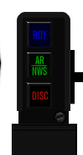

|  |  |  |  |  |  |  |  |
| --- | --- | --- | --- | --- | --- | --- | --- |
| **Switch Name** | **Poles** | **Switch type** | **Positions** | **Position names** | **Notes** | **Callback** | **Lightbits1** |
|  |  |  |  |  |  |  |  |
| **Right Indexer** |  |  |  |  |  |  |  |
|  |  |  |  |  |  |  | RefuelRDY = $8000 |
|  |  |  |  |  |  |  | RefuelAR = $10000 |
|  |  |  |  |  |  |  | RefuelDSC = $20000 |

|  |  |
| --- | --- |
|  | J9 |
| 1 | BKLGT-V |
| 2 | BKLGT+V |
| 3 | +12V |
| 4 | +28V |
| 5 | GND , |
| 6 | R\_RDY NET41\_2, |
| 7 | R\_AR NET40\_2, |
| 8 | R\_DSC NET39\_2, |
| 9 | 9 OPEN, |
| 10 | 10 OPEN |

## ICP

|  |  |
| --- | --- |
| Build Status | |
| Panel Purchased |  |
| Back Panel Purchased |  |
| Mounted in Pit |  |
| Wired |  |
| Knobs mounted |  |
| Inputs Tested |  |
| Outputs Tested |  |

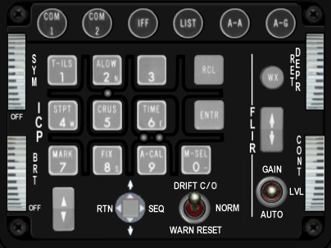

|  |  |  |  |  |  |  |
| --- | --- | --- | --- | --- | --- | --- |
| **Switch Name** | **# of poles** | **Switch type** | **Positions** | **Position names** | **Notes** | **Callback** |
|  |  |  |  |  |  |  |
| COM1 | 2 | push | off-(on) | n/a |  | SimICPCom1 |
| COM2 | 2 | push | off-(on) | n/a |  | SimICPCom2 |
| IFF | 2 | push | off-(on) | n/a |  | SimICPIFF |
| LIST | 2 | push | off-(on) | n/a |  | SimICPLIST |
| A-A | 2 | push | off-(on) | n/a |  | SimICPAA |
| A-G | 2 | push | off-(on) | n/a |  | SimICPAG |
| 1 key | 2 | push tile | off-(on) | n/a |  | SimICPTILS |
| 2 key | 2 | push tile | off-(on) | n/a |  | SimICPALOW |
| 3 key | 2 | push tile | off-(on) | n/a |  | SimICPTHREE |
| Recall key | 2 | push tile | off-(on) | n/a |  | SimICPCLEAR |
| 4 key | 2 | push tile | off-(on) | n/a |  | SimICPStpt |
| 5 key | 2 | push tile | off-(on) | n/a |  | SimICPCrus |
| 6 key | 2 | push tile | off-(on) | n/a |  | SimICPSIX |
| enter key | 2 | push tile | off-(on) | n/a |  | SimICPEnter |
| 7 key | 2 | push tile | off-(on) | n/a |  | SimICPMark |
| 8 key | 2 | push tile | off-(on) | n/a |  | SimICPEIGHT |
| 9 key | 2 | push tile | off-(on) | n/a |  | SimICPNINE |
| 0 key | 2 | push tile | off-(on) | n/a |  | SimICPZERO |
| WX | 2 | push | off-(on) | n/a |  |  |
| ICP inc/dec | 3 | rocker | (on)-off-(on) | down arrow, up arrow |  | SimICPNext, SimICPPrevious |
| display control switch | 4 | 4-way momentary bat | (on)-(on)-(on)-(on)-center off | down, rtn, up, seq (cw from bottom) | ? | SimICPDEDDOWN, SimICPResetDED ,SimICPDEDUP, SimICPDEDSEQ |
| Drift cutoff | 3 | toggle (momentary 1 side only) | (on)-off-on | warn reset, norm, drift c/o | | SimDriftCOOff, SimDriftCOOn |
| FLIR up/down | 3 | rocker | (on)-off-(on) | down arrow, up arrow |  |  |
| FLIR gain | 3 | toggle | on-off-on | auto, lvl, gain |  |  |
| SYM | 2 | 10k linear pot | off-increase clockwise | off |  | BMS analog axis or SimSymWheelD <SimSymWheelUp |
| BRT | 0 | 10k linear pot | off-increase clockwise | |  | BMS analog axis or SimHUDBrightnessDown, SimHUDBrightnessUp |
|  |  |  |  |  |  | SimHUDOn, SimHUDOff |
| RET DEPR | 0 | 10k linear pot | increase clockwise | |  | BMS analog axis or SimRetDn,SimRetUp |
| CONT | 0 | 10k linear pot | increase clockwise | |  |  |

## INSTR

|  |  |
| --- | --- |
| Build Status | |
| Panel Purchased |  |
| Back Panel Purchased |  |
| Mounted in Pit |  |
| Wired |  |
| Knobs mounted |  |
| Inputs Tested |  |
| Outputs Tested |  |

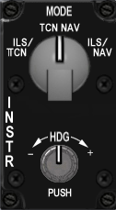

|  |  |  |  |  |  |  |
| --- | --- | --- | --- | --- | --- | --- |
| **Switch Name** | **# of poles** | **Switch type** | **Positions** | **Postion names** | **Notes** | **Callback** |
|  |  |  |  |  |  |  |
| mode | 4 | rotary | on-on-on-on | ils/tcn, tcn, nav, ils/nav | (4x30 deg) | SimHSIIlsTcn, SimHSITcn, SimHSINav, SimHSIIlsNav |
| heading | 0 | potentiometer | rotary | n/a | no EPIC connection |  |

|  | J4 | Implemented |
| --- | --- | --- |
| 1 | BKLGT-V | BKLGT-V |
| 2 | BKLGT+V | BKLGT+V |
| 3 | +12V | +12V |
| 4 | +28V | +28V |
| 5 | GND , | GND , |
| 6 | I\_TCN | I\_TCN |
| 7 | TCN | TCN |
| 8 | NAV | I\_NAV |
| 9 | I\_NAV | OPEN |
| 10 | 10 OPEN, | OPEN |
| 11 | R\_GND | R\_GND |
| 12 | R\_CRSE\_A | R\_CRSE\_HEAD\_A[[4]](#footnote-4) |
| 13 | R\_CRSE\_B | R\_CRSE\_HEAD\_A |
| 14 | R\_HEAD\_A | R\_Pushed[[5]](#footnote-5) |
| 15 | R\_HEAD\_B |  |
| 16 | 16 OPEN |  |

## HIS – Not used

|  |  |
| --- | --- |
| Build Status - not used | |
| Panel Purchased |  |
| Back Panel Purchased |  |
| Mounted in Pit |  |
| Wired |  |
| Knobs mounted |  |
| Inputs Tested |  |
| Outputs Tested |  |

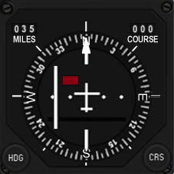

|  |  |  |  |  |  |  |
| --- | --- | --- | --- | --- | --- | --- |
| **Switch Name** | **# of poles** | **Switch type** | **Positions** | **Postion names** | **Notes** | **Callback** |
| course | 360 | encoder | rotary | n/a |  | SimHsiCourseDec, SimHsiCourseInc |
| heading | 360 | encoder | rotary | n/a |  | SimHsiHeadingDec, SimHsiHeadingInc |

The Course and Heading input is mapped to a single rotary on the INSTR panel, with the role changing if the rotary is pushed while rotating.

## Fuel Qty Select

|  |  |
| --- | --- |
| Build Status | |
| Panel Purchased |  |
| Back Panel Purchased |  |
| Mounted in Pit |  |
| Wired |  |
| Knobs mounted |  |
| Inputs Tested |  |
| Outputs Tested |  |

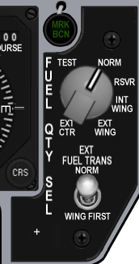

|  |  |  |  |  |  |  |
| --- | --- | --- | --- | --- | --- | --- |
| **Switch Name** | **# of poles** | **Switch type** | **Positions** | **Postion names** | **Notes** | **Callback** |
|  |  |  |  |  |  |  |
| source | 6 | rotary | on-on-on-on-on-on | ext ctr, ext wing, int wing, rsvr, norm, test | (6x45 deg) | SimFuelSwitchCenterExt, SimFuelSwitchWingExt, SimFuelSwitchWingInt, SimFuelSwitchResv, SimFuelSwitchNorm, SimFuelSwitchTest |
| Fuel transfer | 2 | locking toggle | [off]-[on] | wing first, norm |  | SimFuelTransWing,SimFuelTransNorm |

|  |  |
| --- | --- |
|  | J12 |
| 1 | BKLGT-V |
| 2 | BKLGT+V |
| 3 | +12V |
| 4 | +28V |
| 5 | GND , |
| 6 | MARKER |
| 7 | EXT\_WNG |
| 8 | INT\_WNG |
| 9 | RVSR |
| 10 | NORM |
| 11 | TEST |
| 12 | TRNSFR |
| 13 | EXT\_CTR |
| 14 | INST\_FLG1 |
| 15 | INST\_FLG2 |
| 16 | INST\_FLG3 |

## Caution Panel

|  |  |
| --- | --- |
| Build Status | |
| Panel Purchased |  |
| Back Panel Purchased |  |
| Mounted in Pit |  |
| Wired |  |
| Knobs mounted |  |
| Inputs Tested |  |
| Outputs Tested |  |

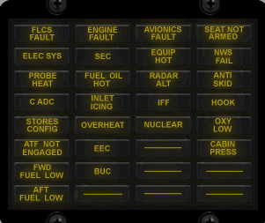

|  |  |  |
| --- | --- | --- |
| **Lightbits1** | **Lightbits2** | **Lightbits3** |
| CONFIG = $40 |  |  |
| DUAL = $200; |  |  |
| FltControlSys = $40000 |  |  |
| LEFlaps = $80000 |  |  |
| EngineFault = $100000 |  |  |
| Overheat = $200000 |  |  |
| FuelLow = $400000 |  |  |
| Avionics = $800000 |  |  |
| RadarAlt = $1000000 |  |  |
| IFF = $2000000 |  |  |
| ECM = $4000000 |  |  |
| Hook = $8000000 |  |  |
| NWSFail = $10000000 |  |  |
| CabinPress = $20000000 |  |  |
|  | FwdFuelLow = $40000 |  |
|  | AftFuelLow = $80000 |  |
|  | SEC = $400000 |  |
|  | OXY\_LOW = $800000 |  |
|  | PROBEHEAT = $1000000 |  |
|  | SEAT\_ARM = $2000000 |  |
|  | BUC = $4000000 |  |
|  | FUEL\_OIL\_HOT = $8000000 |  |
|  | ANTI\_SKID = $10000000 |  |
|  |  | Elec\_Fault = $400 |

## Sensor Power

|  |  |
| --- | --- |
| Build Status | |
| Panel Purchased |  |
| Back Panel Purchased |  |
| Mounted in Pit |  |
| Wired |  |
| Knobs mounted |  |
| Inputs Tested |  |
| Outputs Tested |  |

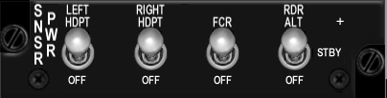

|  |  |  |  |  |  |
| --- | --- | --- | --- | --- | --- |
| **Switch Name** | **# of poles** | **Switch type** | **Positions** | **Postion names** | **Notes** |
|  |  |  |  |  |  |
| Left hardpoint | 2 | toggle | off-on | off, left hdpt | SimLeftHptOff, SimLeftHptOn |
| Right hardpoint | 2 | toggle | off-on | off, right hdpt | SimRightHptOff, SimRightHptOn |
| Fire control radar | 2 | toggle | off-on | off, fcr | SimFCROff, SimFCROn |
| Radar altimeter | 3 | toggle | off-on-on | off, stby, rdr alt | SimRALTOFF, SimRALTSTDBY, SimRALTOFF |

|  |  |
| --- | --- |
|  | J23 |
| 1 | BKLGT-V |
| 2 | BKLGT+V |
| 3 | +12V |
| 4 | +28V |
| 5 | GND , |
| 6 | L\_HPT |
| 7 | R\_HPT |
| 8 | FCR |
| 9 | RA\_STD |
| 10 | RA\_ON |

## HUD Control

|  |  |
| --- | --- |
| Build Status | |
| Panel Purchased |  |
| Back Panel Purchased |  |
| Mounted in Pit |  |
| Wired |  |
| Knobs mounted |  |
| Inputs Tested |  |
| Outputs Tested |  |

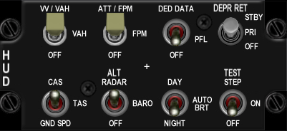

|  |  |  |  |  |  |  |
| --- | --- | --- | --- | --- | --- | --- |
| **Switch Name** | **# of poles** | **Switch type** | **Positions** | **Postion names** | **Notes** | **Callback** |
|  |  |  |  |  |  |  |
| Velocity scales | 3 | toggle | off-on-on | off, vah, vv/vah |  | SimScalesOff, SimScalesVAH, SimScalesVVVAH |
| Attitude scales | 3 | toggle | off-on-on | off, fpm, att/fpm |  | SimPitchLadderOff, SimPitchLadderFPM, SimPitchLadderATTFPM |
| Data Entry | 3 | toggle | off-on-on | off, pfl, ded data |  | SimHUDDEDOff, SimHUDDEDPFL, SimHUDDEDDED |
| DEPR reticle | 3 | toggle | [off]-[on]-[on] | off, pri, stby |  | SimReticleOff, SimReticlePri, SimReticleStby |
| Velocity | 3 | toggle | off-on-on | gnd spd, tas, cas |  | SimHUDVelocityGND, SimHUDVelocityTAS, SimHUDVelocityCAS |
| Altitude | 3 | toggle | off-on-on | auto, baro, alt radar |  | SimHUDAltAuto, SimHUDAltBaro, SimHUDAltRadar |
| Brightness | 3 | toggle | off-on-on | night, auto, day |  | SimHUDBrtNight, SimHUDBrtAuto, SimHUDBrtDay |
| Test | 3 | toggle | off-on-on | off, on, test step |  |  |

|  |  |
| --- | --- |
| 1 | BKLGT-V |
| 2 | BKLGT+V |
| 3 | +12V |
| 4 | +28V |
| 5 | GND , |
| 6 | S\_VA |
| 7 | S\_VV |
| 8 | FPM |
| 9 | AT\_FPM |
| 10 | PFL |
| 11 | DED |
| 12 | R\_PRI |
| 13 | R\_STD |
| 14 | A\_BARO |
| 15 | A\_RDR |
| 16 | NIGHT |
| 17 | DAY |
| 18 | CAS |
| 19 | GNDSPD |
| 20 | 20 OPEN |

## Nuclear consent

|  |  |
| --- | --- |
| Build Status | |
| Panel Purchased |  |
| Back Panel Purchased |  |
| Mounted in Pit |  |
| Wired |  |
| Knobs mounted |  |
| Inputs Tested |  |
| Outputs Tested |  |

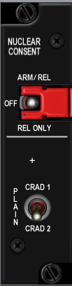

|  |  |  |  |  |
| --- | --- | --- | --- | --- |
| **Switch Name** | **# of poles** | **Switch type** | **Positions** | **Postion names** |
|  |  |  |  |  |
| plain | 2 | toggle | off-on | crad1, crad 2 |
| arm | 3 | guarded toggle | on-off-on | rel only, off, arm rel |

## Lighting

|  |  |
| --- | --- |
| Build Status | |
| Panel Purchased |  |
| Back Panel Purchased |  |
| Mounted in Pit |  |
| Wired |  |
| Knobs mounted |  |
| Inputs Tested |  |
| Outputs Tested |  |

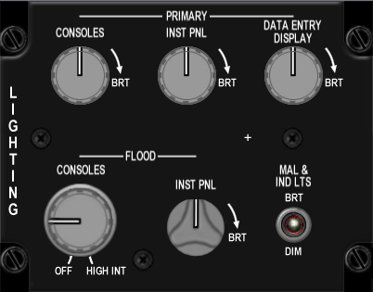

|  |  |  |  |  |
| --- | --- | --- | --- | --- |
| **Switch Name** | **# of poles** | **Switch type** | **Positions** | **Postion names** |
|  |  |  |  |  |
| Consoles (primary) | 0 | potentiometer | increase clockwise | |
| instrument panel (primary) | 0 | potentiometer | increase clockwise |  |
| Data entry display (primary) | 0 | potentiometer | increase clockwise |  |
| Consoles (flood) | 2 | off-potentiometer | increase clockwise |  |
| instrument panel (flood) | 0 | potentiometer | increase clockwise |  |
| malfunction lights | 2 | toggle | off-on | dim, brt |

|  |  |
| --- | --- |
|  | J27 |
| 1 | BKLGT-V |
| 2 | BKLGT+V |
| 3 | +12V |
| 4 | +28V |
| 5 | GND , |
| 6 | POT\_GND POT\_GROUND\_4, |
| 7 | POT\_+V POT\_+V\_4, |
| 8 | POT\_1 POT\_1\_4, |
| 9 | POT\_2 POT\_2\_4, |
| 10 | POT\_3 POT\_3\_4, |
| 11 | POT\_4 POT\_4\_4, |
| 12 | DIM\_BRIGHT DIM\_BRIGHT\_4, |
| 13 | 13 OPEN, |
| 14 | 14 OPEN, |
| 15 | 15 OPEN, |
| 16 | 16 OPEN |

## Master Zeroize

|  |  |
| --- | --- |
| Build Status | |
| Panel Purchased |  |
| Back Panel Purchased |  |
| Mounted in Pit |  |
| Wired |  |
| Knobs mounted |  |
| Inputs Tested |  |
| Outputs Tested |  |

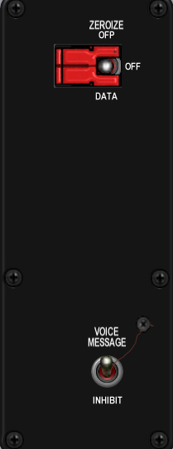

|  |  |  |  |  |  |  |
| --- | --- | --- | --- | --- | --- | --- |
| **Switch Name** | **# of poles** | **Switch type** | **Positions** | **Postion names** | **Notes** | **Callback** |
|  |  |  |  |  |  |  |
| voice message | 2 | toggle | off-on | inhibit, voice message |  | SimVMSOFF, SimVMSOn |
| zeroize | 3 | guarded toggle | on-off-on | data zeroize, blank, master zeroize | guarded in center off position | |

|  |  |
| --- | --- |
|  | J33 |
| 1 | BKLGT-V |
| 2 | BKLGT+V |
| 3 | +12V |
| 4 | +28V |
| 5 | GND , |
| 6 | V\_INHB NET5\_5, |
| 7 | 7 OPEN, |
| 8 | 8 OPEN, |
| 9 | 9 OPEN, |
| 10 | 10 OPEN |

## Air Cond

|  |  |
| --- | --- |
| Build Status | |
| Panel Purchased |  |
| Back Panel Purchased |  |
| Mounted in Pit |  |
| Wired |  |
| Knobs mounted |  |
| Inputs Tested |  |
| Outputs Tested |  |

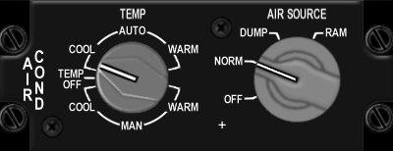

|  |  |  |  |  |  |  |
| --- | --- | --- | --- | --- | --- | --- |
| **Switch Name** | **# of poles** | **Switch type** | **Positions** | **Postion names** | **Notes** | **Callback** |
|  |  |  |  |  |  |  |
| air source | 4 | rotary | on-on-on-on | off, norm, dump, ram | (4x45 deg) | SimAirSourceOff, SimAirSourceNorm, SimAirSourceDump, SimAirSourceRam |
| temp | 7 | rotary | on-on-on-off-on-on-on |  | No EPIC connection |  |
|  |  |  |  |  |  |  |

|  |  |
| --- | --- |
|  | J34 |
| 1 | BKLGT-V |
| 2 | BKLGT+V |
| 3 | +12V |
| 4 | +28V |
| 5 | GND , |
| 6 | OFF |
| 7 | NORM |
| 8 | DUMP |
| 9 | RAM |
| 10 | 10 OPEN |

## KY-58

|  |  |
| --- | --- |
| Build Status | |
| Panel Purchased |  |
| Back Panel Purchased |  |
| Mounted in Pit |  |
| Wired |  |
| Knobs mounted |  |
| Inputs Tested |  |
| Outputs Tested |  |

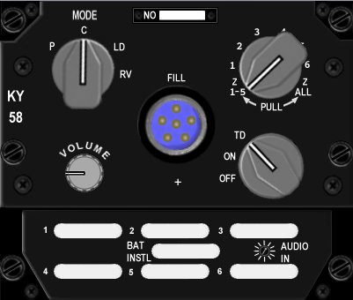

|  |  |  |  |  |  |
| --- | --- | --- | --- | --- | --- |
| **Switch Name** | **# of poles** | **Switch type** | **Positions** | **Postion names** | **Notes** |
|  |  |  |  |  |  |
| mode | 4 | rotary knob | on-on-on-on | p, c, ld, rv | (4x45 deg) |
| volume | 0 | 10k log potentiometer | clockwise to increase |  | no EPIC connection |
| number rotary | 8 | rotary knob | {on}-on-on-on-on-on-on-{on} | 215, 1, 2, 3, 4, 5, 6, 7 all | (8x30 deg) |
| on/off rotary | 3 | rotary knob | on-on-on | off, on, TD | (3x30 deg) |

## Avionics Power

|  |  |
| --- | --- |
| Build Status | |
| Panel Purchased |  |
| Back Panel Purchased |  |
| Mounted in Pit |  |
| Wired |  |
| Knobs mounted |  |
| Inputs Tested |  |
| Outputs Tested |  |

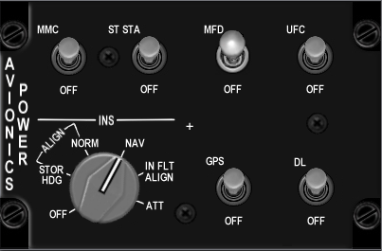

|  |  |  |  |  |  |  |
| --- | --- | --- | --- | --- | --- | --- |
| **Switch Name** | **# of poles** | **Switch type** | **Positions** | **Postion names** | **Notes** | **Callback** |
|  |  |  |  |  |  |  |
| FCC | 2 | Locking toggle | [off]-[on] | off, FCC |  | SimFCCOff, SimFCCOn |
| SMS | 2 | Locking toggle | [off]-[on] | off, SMS |  | SimSMSOff, SimSMSOn |
| MFD | 2 | Locking toggle | [off]-[on] | off, MFD |  | SimMFDOff, SimMFDOn |
| UFC | 2 | Locking toggle | [off]-[on] | off, UFC |  | SimUFCOff, SimUFCOn |
| INS | 7 | Rotary knob | on-on-on-on-on-on-on | off, stor hdg, norm, nav, cal, in flt align, att | (7x45deg) | SimINSOff, SimINSNorm, SimINSNav, SimINSInFlt |
| GPS | 2 | Locking toggle | [off]-[on] | off, GPS |  | SimGPSOff, SimGPSOn |
| DL | 2 | Locking toggle | [off]-[on] | off, DL |  | SimDLOff, SimDLOn |
| MAP | 2 | Locking toggle | [off]-[on] | off, MAP |  | SimMAPOff, SimMAPOn |

|  |  |
| --- | --- |
|  | J24 |
| 1 | BKLGT-V |
| 2 | BKLGT+V |
| 3 | +12V |
| 4 | +28V |
| 5 | GND , |
| 6 | FCC |
| 7 | SMS |
| 8 | MFD |
| 9 | UFC |
| 10 | I\_OFF |
| 11 | I\_HDG |
| 12 | I\_NRM |
| 13 | I\_NAV |
| 14 | I\_CAL |
| 15 | I\_ATT |
| 16 | GPS |
| 17 | TISL |
| 18 | MAP |
| 19 | P\_GND PHY\_MFD\_PWR\_4, |
| 20 | P\_MFD\_PWR PHY\_GND\_4 |

## Anti-Ice

|  |  |
| --- | --- |
| Build Status | |
| Panel Purchased |  |
| Back Panel Purchased |  |
| Mounted in Pit |  |
| Wired |  |
| Knobs mounted |  |
| Inputs Tested |  |
| Outputs Tested |  |

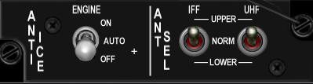

|  |  |  |  |  |  |  |
| --- | --- | --- | --- | --- | --- | --- |
| **Switch Name** | **# of poles** | **Switch type** | **Positions** | **Postion names** | **Notes** | **Callback** |
|  |  |  |  |  |  |  |
| engine anti ice | 3 | locking toggle | [off]-[on]-[on] | off, auto, on |  |  |
| IFF antenna select | 3 | toggle | on-off-on | lower, norm, upper |  |  |
| UHF antenna select | 3 | toggle | on-off-on | lower, norm, upper |  |  |

## Oxy Reg

|  |  |
| --- | --- |
| Build Status | |
| Panel Purchased |  |
| Back Panel Purchased |  |
| Mounted in Pit |  |
| Wired |  |
| Knobs mounted |  |
| Inputs Tested |  |
| Outputs Tested |  |

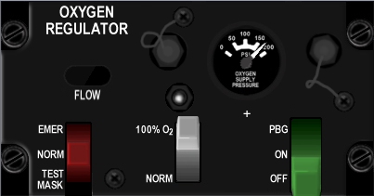

|  |  |  |  |  |
| --- | --- | --- | --- | --- |
| **Switch Name** | **# of poles** | **Switch type** | **Positions** | **Postion names** |
|  |  |  |  |  |
| Flow control (red) | 3 | lever | on-on-on | Test mask, norm, Emer |
| Oxygen content (green) | 2 | lever | on-on | Norm, 100% O2 |
| Pressure control (grey) | 3 | lever | off-on-on | off, on, PBG |

## DTU

|  |  |
| --- | --- |
| Build Status | |
| Panel Purchased |  |
| Back Panel Purchased |  |
| Mounted in Pit |  |
| Wired |  |
| Knobs mounted |  |
| Inputs Tested |  |
| Outputs Tested |  |

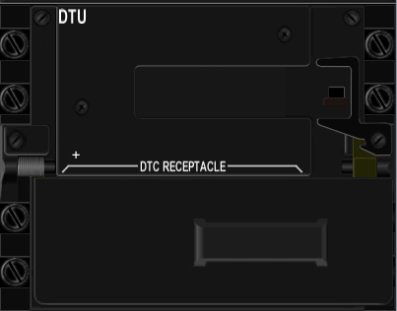

|  |  |  |  |
| --- | --- | --- | --- |
| **Switch Name** | **# of poles** | **Switch type** | **Positions** |
|  |  |  |  |
| DTU | 2 | toggle | off-on |

## Left MFD

|  |  |
| --- | --- |
| Build Status | |
| Panel Purchased |  |
| Back Panel Purchased |  |
| Mounted in Pit |  |
| Wired |  |
| Knobs mounted |  |
| Inputs Tested |  |
| Outputs Tested |  |

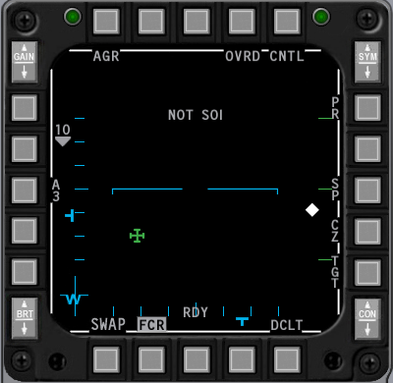

|  |  |  |  |  |  |
| --- | --- | --- | --- | --- | --- |
| **Switch Name** | **# of poles** | **Switch type** | **Positions** | **Notes** | **Callback** |
|  |  |  |  |  |  |
| OSB1 | 2 | push | off-(on) |  | SimCBEOSB\_1L |
| OSB2 | 2 | push | off-(on) |  | SimCBEOSB\_2L |
| OSB3 | 2 | push | off-(on) |  | SimCBEOSB\_3L |
| OSB4 | 2 | push | off-(on) |  | SimCBEOSB\_4L |
| OSB5 | 2 | push | off-(on) |  | SimCBEOSB\_5L |
| OSB6 | 2 | push | off-(on) |  | SimCBEOSB\_6L |
| OSB7 | 2 | push | off-(on) |  | SimCBEOSB\_7L |
| OSB8 | 2 | push | off-(on) |  | SimCBEOSB\_8L |
| OSB9 | 2 | push | off-(on) |  | SimCBEOSB\_9L |
| OSB10 | 2 | push | off-(on) |  | SimCBEOSB\_10L |
| OSB11 | 2 | push | off-(on) |  | SimCBEOSB\_11L |
| OSB12 | 2 | push | off-(on) |  | SimCBEOSB\_12L |
| OSB13 | 2 | push | off-(on) |  | SimCBEOSB\_13L |
| OSB14 | 2 | push | off-(on) |  | SimCBEOSB\_14L |
| OSB15 | 2 | push | off-(on) |  | SimCBEOSB\_15L |
| OSB16 | 2 | push | off-(on) |  | SimCBEOSB\_16L |
| OSB17 | 2 | push | off-(on) |  | SimCBEOSB\_17L |
| OSB18 | 2 | push | off-(on) |  | SimCBEOSB\_18L |
| OSB19 | 2 | push | off-(on) |  | SimCBEOSB\_19L |
| OSB20 | 2 | push | off-(on) |  | SimCBEOSB\_20L |
|  |  |  |  |  | SimCBEOSB\_GAINUP\_L |
| 30 |  |  |  |  | SimCBEOSB\_GAINDOWN\_L |

## Right MFD

|  |  |
| --- | --- |
| Build Status | |
| Panel Purchased |  |
| Back Panel Purchased |  |
| Mounted in Pit |  |
| Wired |  |
| Knobs mounted |  |
| Inputs Tested |  |
| Outputs Tested |  |

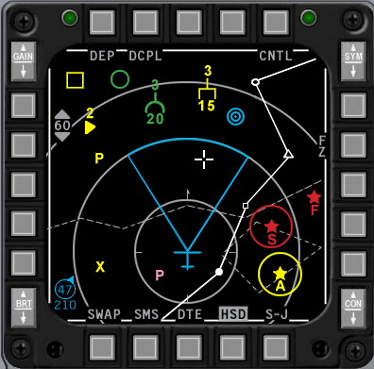

|  |  |  |  |  |  |
| --- | --- | --- | --- | --- | --- |
| **Switch Name** | **# of poles** | **Switch type** | **Positions** | **Notes** | **Callback** |
|  |  |  |  |  |  |
| OSB1 | 2 | push | off-(on) |  | SimCBEOSB\_1R |
| OSB2 | 2 | push | off-(on) |  | SimCBEOSB\_2R |
| OSB3 | 2 | push | off-(on) |  | SimCBEOSB\_3R |
| OSB4 | 2 | push | off-(on) |  | SimCBEOSB\_4R |
| OSB5 | 2 | push | off-(on) |  | SimCBEOSB\_5R |
| OSB6 | 2 | push | off-(on) |  | SimCBEOSB\_6R |
| OSB7 | 2 | push | off-(on) |  | SimCBEOSB\_7R |
| OSB8 | 2 | push | off-(on) |  | SimCBEOSB\_8R |
| OSB9 | 2 | push | off-(on) |  | SimCBEOSB\_9R |
| OSB10 | 2 | push | off-(on) |  | SimCBEOSB\_10R |
| OSB11 | 2 | push | off-(on) |  | SimCBEOSB\_11R |
| OSB12 | 2 | push | off-(on) |  | SimCBEOSB\_12R |
| OSB13 | 2 | push | off-(on) |  | SimCBEOSB\_13R |
| OSB14 | 2 | push | off-(on) |  | SimCBEOSB\_14R |
| OSB15 | 2 | push | off-(on) |  | SimCBEOSB\_15R |
| OSB16 | 2 | push | off-(on) |  | SimCBEOSB\_16R |
| OSB17 | 2 | push | off-(on) |  | SimCBEOSB\_17R |
| OSB18 | 2 | push | off-(on) |  | SimCBEOSB\_18R |
| OSB19 | 2 | push | off-(on) |  | SimCBEOSB\_19R |
| OSB20 | 2 | push | off-(on) |  | SimCBEOSB\_20R |
|  |  |  |  |  | SimCBEOSB\_GAINUP\_R |
|  |  |  |  |  | SimCBEOSB\_GAINDOWN\_R |

## Other

|  |  |
| --- | --- |
| Build Status | |
| Panel Purchased |  |
| Back Panel Purchased |  |
| Mounted in Pit |  |
| Wired |  |
| Knobs mounted |  |
| Inputs Tested |  |
| Outputs Tested |  |

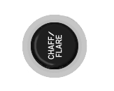

|  |  |  |  |  |  |  |
| --- | --- | --- | --- | --- | --- | --- |
| **Switch Name** | **# of poles** | **Switch type** | **Positions** | **Postion names** | **Notes** | **Callback** |
|  |  |  |  |  |  |  |
| Chaff/flare button | |  |  |  |  |  |
| Alt gear | 2 |  |  |  | ? | AFAlternateGear, AFAlternateGearReset |
| Canopy switch | 2 |  |  |  |  | AFCanopyToggle |
| pedal adj | 0 | T handle | mechanical | none |  |  |
| Mark beacon | 0 | green indicator light | none | mrk bcn |  |  |
|  |  |  |  |  |  |  |

## ACES-II

|  |  |
| --- | --- |
| Build Status | |
| Panel Purchased |  |
| Back Panel Purchased |  |
| Mounted in Pit |  |
| Wired |  |
| Knobs mounted |  |
| Inputs Tested |  |
| Outputs Tested |  |
|  |  |

|  |  |  |  |  |  |
| --- | --- | --- | --- | --- | --- |
| **Switch Name** | **# of poles** | **Positions** | **Postion names** | **Notes** | **Callback** |
|  |  |  |  |  |  |
| Eject grip | 2 |  |  |  | SimEject |
| Safety Lever | 2 |  |  |  | SimSeatOff, SimSeatOn |
| Manual release |  |  |  |  |  |

|  |  |
| --- | --- |
|  | J15 |
| 1 | BKLGT-V |
| 2 | BKLGT+V |
| 3 | +12V LEFT |
| 4 | +28V LEFT |
| 5 | GND LEFT |
| 6 | EJECT |
| 7 | SEAT\_ON |
| 8 | 8 OPEN, |
| 9 | 9 OPEN, |
| 10 | 10 OPEN |
|  |  |

## TQS

|  |  |  |  |  |  |  |
| --- | --- | --- | --- | --- | --- | --- |
| **Switch Name** | **# of poles** | **Switch type** | **Positions** | **Postion names** | **Notes** | **Callback** |
| DOGFIGHT | 3 |  | on-off-on | DDOGFIGHT, , |  | SimSelectMRMOverride, SimDeselectOverride, SimSelectSRMOverride |
| MAN RNG/UNCAGE | | Rotary knob |  | MAN RNG/UNCAGE |  | BMS alanog axis or SimRangeKnobDown, SimRangeKnobUp |
| ANT ELEV |  | Rotary knob | Detented center |  |  | BMS alanog axis or SimRadarElevationDown, SimRadarElevationCenter, SimRadarElevationUp |
| CURSOR |  | Joystick |  |  |  | BMS alanog axes or SimCursorDown ,SimCursorLeft ,SimCursorRight , SimCursorUp |
| ENABLE | 2 | push | off-(on) |  |  | SimCursorEnable |
| Speed Brake | 2 |  |  |  |  | AFBrakesIn, AFBrakesOut |
| PTT | 4 |  |  | VHF,UHF,IFF IN,IFF OUT |  | SimTransmitCom2,SimTransmitCom1 |
| Black-Out Switch | 2 |  |  |  |  |  |
|  |  |  |  |  |  |  |

## SSCG

|  |  |  |  |  |  |  |
| --- | --- | --- | --- | --- | --- | --- |
| **Switch Name** | **# of poles** | **Switch type** | **Positions** | **Postion names** | **Notes** | **Callback** |
| NWS-A/R DISC-MSL STEP | 2 |  | off,(on) |  |  | SimMissileStep |
| Trim | 5 |  |  | Off,Fwd,Aft,Left,Right | | AFElevatorTrimUp, AFElevatorTrimDown ,AFAileronTrimLeft, AFAileronTrimRight |
| Display Manag | 5 |  |  | Off,Fwd,Aft,Left,Right | | SimDMSUp, SimDMSDown, SimDMSLeft,SimDMSRight |
| Weapon Release | 2 |  | off,(on) |  |  | SimPickle |
| Paddle Switch | 2 |  |  |  |  | SimAPOverride |
| Trigger | 3 |  |  | Off,Detent1,Detent2 | | SimTriggerFirstDetent, SimTriggerSecondDetent |
| Pinky Switch | 2 |  |  |  |  | SimPinkySwitch |
| TMS | 5 |  |  | Off,Fwd,Aft,Left,Right | | SimTMSUp,SimTMSDown, SimTMSLeft,SimTMSRight |
| CMS | 5 |  |  | Off,Fwd,Aft,Left,Right | | SimDropProgrammed, SimECMConsent, ,SimECMStandby |

# Switch Mapping for non-Falcon

## Test

|  |  |  |  |
| --- | --- | --- | --- |
|  | **Lomac** | **Postion names** | **Keystroke** |
|  |  |  |  |
| EPU gen |  | off-epu gen |  |
| PROBE HEAT |  | test-off-probe heat |  |
| FIRE & OHEAT DETECT |  | n/a |  |
| OXY |  | off-QTY |  |
| MAL & IND LTS |  | n/a |  |
| A B C D |  |
| test maint |  | h |  |

## Anti-G

|  |  |  |  |
| --- | --- | --- | --- |
| **Switch Name** | **Lomac** | **Postion names** | **Keystroke** |
|  |  |  |  |
| Test |  | Test |  |

## Flt control

|  |  |  |  |
| --- | --- | --- | --- |
| **Switch Name** | **Lomac** | **Postion names** | **Keystroke** |
|  |  |  |  |
| DIGITAL |  | off-backup |  |
| ALT FALPS | Flaps Up | norm | LCtrl-F |
|  | Flaps Landing Position | extend | LShift-F |
| MANUAL TF FLYUP |  | disable-enable |  |
| LE FLAPS |  | auto-lock |  |
| FLCS |  | reset-off |  |
| BIT / OFF |  | OFF, BIT |  |
| RUN FAIL |  |

## Manual Trim

|  |  |  |  |
| --- | --- | --- | --- |
| **Switch Name** | **Lomac** | **Position names** | **Keystroke** |
|  |  |  |  |
| Pitch Trim |  |  |  |
| Roll Trim |  |  |  |
| Yaw Trim |  |  |  |
| Trim /AP DISC |  | norm, disc |  |

## Fuel

|  |  |  |  |
| --- | --- | --- | --- |
| **Switch Name** | **Lomac** | **Position names** | **Key Strokes** |
|  |  |  |  |
| MASTER | Engines Stop | OFF | RShift-End |
|  |  | MASTER |  |
| TANK INERTING | Fuel Dump | OFF-TANK INERTING | R |
| ENG FEED |  | OFF, NORM, AFT, FWD |  |
| AIR REFUEL | Refueling Bay | CLOSE, | LCtrl-R |
|  |  | OPEN | LCtrl-R |

## Aux Comm

|  |  |  |  |
| --- | --- | --- | --- |
| **Switch Name** | **Lomac** | **Position names** | **Keystroke** |
|  |  |  |  |
| MASTER |  | off, STBY, LOW, NORM, EMER |  |
| M-4 CODE |  | hold, a/b, zero |  |
| CNI |  | BACK UP, UFC |  |
| REPLY |  | OUT, A, B |  |
| MONITOR |  | OUT, AUDIO |  |
| TACAN |  | A/A TR-REC-T/R |  |
| CHANNEL 100's |  | 0-9 inclusive |  |
| CHANNEL 10's |  | 0-9 inclusive |  |
| CHANNEL 1's |  | 0-9 inclusive |  |
| channel x/y |  | x, y |  |

## Ext Lighting

|  |  |  |  |
| --- | --- | --- | --- |
| **Switch Name** | **Lomac** | **Position names** | **Keystrokes** |
|  |  |  |  |
| Form |  |  |  |
| Master | Illumination Cockpit | off | L |
|  |  | norm | L |
| Aerial Refueling |  |  |  |
| Anti Collision | Navigation lights | Off | RCtrl-L |
|  |  | anti collision | RCtrl-L |
| Flash Steady |  | flash, steady |  |
| Wing Trail | Smoke | dim, off, brt | T |
|  |  | off | T |
|  |  | brt | T |
| Fuselage |  | dim, off, brt |  |

## EPU

|  |  |  |  |
| --- | --- | --- | --- |
| **Switch Name** | **Lomac** | **Position names** | **Keystroke** |
|  |  |  |  |
| EPU | 3 | OFF-NORMAL-ON | Center guard on NORMAL |
| RUN light | 0 | green light |  |
| HYDRAZN-AIR | 0 | HYDRAZN-AIR |  |

## Elect

|  |  |  |  |
| --- | --- | --- | --- |
| **Switch Name** | **Lomac** | **Position names** | **Keystrokes** |
|  |  |  |  |
| MAIN PWR | Power Switch | OFF | Shift-P |
|  |  | BAT | Shift-P |
|  |  | MAIN PWR | Shift-P |
| CAUTION RESET |  |  |  |
| FLCS PMG-MAIN GEN |  | FLCS PMG-MAIN GEN |  |
| STBY GEN |  | STBY GEN |  |
| EPU GEN-EPU / PMG |  | EPU GEN-EPU / PMG |  |
| FAIL |  | FAIL |  |
| TO FLCS-FLCS RLY |  | TO FLCS-FLCS RLY |  |
|  |  |  |  |

## AVTR

|  |  |  |  |
| --- | --- | --- | --- |
| **Switch Name** | **Lomac** | **Position names** | **Keystroke** |
|  |  |  |  |
| AVTR |  | on, auto, off |  |

## ECM

|  |  |  |  |
| --- | --- | --- | --- |
| **Switch Name** | **Lomac** | **Position names** | **Keystroke** |
|  |  |  |  |
| OPR |  | OFF-STBY-OPR |  |
| DIM |  | 1, 2, 3 |  |
| XMIT |  | xmit, blank |  |
| RESET |  | reset, blank |  |
| BIT |  | bit, blank |  |
| 1 |  | S, A, F, T light in corners |  |
| 2 |  | S, A, F, T light in corners |  |
| 3 |  | S, A, F, T light in corners |  |
| 4 |  | S, A, F, T light in corners |  |
| 5 |  | S, A, F, T light in corners |  |
| ALT |  | S, A, F, T light in corners |  |
| FRM |  | S, A, F, T light in corners |  |
| SPL |  | S, A, F, T light in corners |  |

## Jet Start

|  |  |  |  |
| --- | --- | --- | --- |
| **Switch Name** | **Lomac** | **Position names** | **Keystroke** |
|  |  |  |  |
| JET FUEL | Engines Start | START2-OFF-START1 | RShift-Home |
| ENG CONT |  | SEC-PRI |  |
| AB RESET |  | ENG DATA-NORM-AB DATA |  |
| MAX POWER |  | OFF-MAX POWER |  |
| RUN |  | green light |  |

## Audio2

|  |  |  |  |
| --- | --- | --- | --- |
| **Switch Name** | **Lomac** | **Position names** | **Keystroke** |
|  |  |  |  |
| INTERCOM |  |  |  |
| TACAN |  |  |  |
| ILS |  |  |  |
| HOT MIC |  | CIPHER, OFF, HOT MIC | |

## Audio

|  |  |  |  |
| --- | --- | --- | --- |
| **Switch Name** | **Lomac** | **Position names** | **Keystroke** |
|  |  |  |  |
| COMM 1 volume |  |  |
| COMM 1 selector |  | OFF-SQL-GD |  |
| COMM 2 volume |  |  |  |
| COMM 2 selector |  | OFF-SQL-GD |  |
| SECURE VOICE |  |  |  |
| TF |  |  |  |
| MSL | 0 |  |  |
| THREAT | 0 |  |  |

## UHF

|  |  |  |  |
| --- | --- | --- | --- |
| **Switch Name** | **Lomac** | **Position names** | **Keystroke** |
|  |  |  |  |
| UHF |  | OFF-MAIN-BOTH-ADF | |
| TONE |  | tone |  |
| VOL |  |  |
| SQUELCH |  | OFF-ON |  |
| MANUAL |  | MANUAL-PRESET-GUARD |  |
| Freq 100's |  | A, 3, 2, T |  |
| Freq 10's |  | 0-9 inclusive |  |
| Freq 1's |  | 0-9 inclusive |  |
| Freq 1/10's |  | 0-9 inclusive |  |
| Freq 1/1000's |  | 00, 25, 50, 75 |  |
| CHAN |  | 1-19 inclusive |  |
| EMB |  | ?? |  |

## Manual Pitch

|  |  |  |  |
| --- | --- | --- | --- |
| **Switch Name** | **Lomac** | **Position names** | **Keystroke** |
|  |  |  |  |
| MANUAL PITCH |  | OVRD-NORM |  |

## Threat Warn Aux

|  |  |  |  |
| --- | --- | --- | --- |
| **Switch Name** | **Lomac** | **Position names** | **Keystroke** |
|  |  |  |  |
| Search |  | search |  |
| activity power |  | activity power |  |
| Low priority |  | low |  |
| system power |  | power |  |
| fuse |  | n/a |  |
| Dimmer |  | n/a |  |

## CMDS

|  |  |  |  |
| --- | --- | --- | --- |
| **Switch Name** | **Lomac** | **Position names** | **Keystroke** |
|  |  |  |  |
| RWR |  | off, on |  |
| JMR |  | off, on |  |
| MWS |  | off, on |  |
| 01 |  | off, on |  |
| 02 |  | off, on |  |
| CH |  | off, on |  |
| FL |  | off, on |  |
| JETT |  | off, JETT |  |
| PRGM |  | bit, 1, 2, 3, 4, 5 |  |
| MODE |  | off, stby, man, semi, auto, byp |  |
| STATUS NO GO |  | NO GO (green lit legend) | |
| STATUS GO | 0 | GO (green lit legend) | |
| STATUS READY | 0 |

## Gear Panel

|  |  |  |  |
| --- | --- | --- | --- |
| **Switch Name** | **Lomac** | **Position names** | **Keystrokes** |
|  |  |  |  |
| Emergency jettison | Weapons Jettison |  | LCtrl-W |
| wheel lights |  |  |  |
| Hook | Toggle Arrestor Hook |  | Ctl-G |
| Ground jettison |  |  |  |
| Brakes |  |  |  |
| Parking brake |  | off |  |
|  | Wheel Brake on | anti skid | W |
|  | Wheel Brake on | brake | W |
| Stores |  | cat III, cat I |  |
| Horn silencer | Audible Warning Reset | n/a | RShift-N |
| Landing lights | Gear Light Near/Far/Off | taxi | RAlt-L |
|  | Gear Light Near/Far/Off | off | RAlt-L |
|  | Gear Light Near/Far/Off | landing | RAlt-L |
| Down lock release |  | n/a |  |
| Gear down enable |  | n/a |  |
| Gear handle | Landing Gear Down | Down | LShift-G |
|  | Landing Gear Up | Up | LCtrl-G |
| Gear warning light |  | n/a |  |

## MISC

|  |  |  |  |
| --- | --- | --- | --- |
| **Switch Name** | **Lomac** | **Position names** | **Keystrokes** |
|  |  |  |  |
| RF quiet | Radar On/Off | silent | I |
|  |  | rf norm | I |
| ECM light |  | n/a |  |
| Laser arm |  | off, arm |  |
| Alternate release | Weapon Fire | n/a | Space |
| Master arm |  | simulate, off, arm |  |
| ADV mode |  | active/standby |  |
| Autopilot pitch |  | att hold, a-p off, alt hold |  |
| Autopilot roll |  | strg sel, att hold, hdg sel |  |

## Threat Warn Prime

|  |  |  |  |
| --- | --- | --- | --- |
| **Switch Name** | **Lomac** | **Positions** | **Notes** |
|  |  |  |  |
| Handoff |  | off-(on) |  |
| Priority |  | off-(on) |  |
| Target separate |  | off-(on) |  |
| Missile Launch |  | none |  |
| system test |  | off-(on) |
| Unknown/naval |  | off-(on) |  |

## Eyebrow Lights L

|  |  |  |  |
| --- | --- | --- | --- |
| **Switch Name** | **Lomac** | **Position names** | **Keystrokes** |
|  |  |  |  |
| IFF |  | IFF IDENT |  |
| Blank 1 |  | (directly above IFF button) |  |
| Blank 2 |  | (directly below TF-FAIL button) |  |
| TF fail |  | TF-FAIL |  |
| F-ACK |  | F-ACK | RShift-N |
| Master Caution |  | Master Caution push to reset | RShift-N |

## Eyebrow Lights R

|  |  |  |  |
| --- | --- | --- | --- |
| **Switch Name** | **Lomac** | **Position names** | **Keystroke** |
|  |  |  |  |
| **Right** |  |  |  |
| Engine fire |  | ENGFIRE ENGINE |  |
| Fluid pressure warning |  | HYD/OIL PRESS |  |
| Flight controls warning |  | FLCS DBU ON |  |
| Landing configuration |  | TO/LDG CONFIG |  |
| Canopy seal warning |  | CANOPY |  |

Indexer L

|  |  |  |  |
| --- | --- | --- | --- |
| **Switch Name** | **Lomac** | **Position names** | **Keystrok** |
|  |  |  |  |
| **Left Indexer** |  |  |  |
|  |  |  |  |
|  |  |  |  |
|  |  |  |  |

## Indexer R

|  |  |  |  |
| --- | --- | --- | --- |
| **Switch Name** | **Lomac** | **Position names** | **Keystroke** |
|  |  |  |  |
| **Right Indexer** |  |  |  |
|  |  |  |  |
|  |  |  |  |
|  |  |  |  |

## ICP

|  |  |  |  |
| --- | --- | --- | --- |
| **Switch Name** | **Lomac** | **Position names** | **Keystroke** |
|  |  |  |  |
| COM1 |  | n/a |  |
| COM2 |  | n/a |  |
| IFF |  | n/a |  |
| LIST |  | n/a |  |
| A-A |  | n/a |  |
| A-G |  | n/a |  |
| 1 key |  | n/a |  |
| 2 key |  | n/a |  |
| 3 key |  | n/a |  |
| Recall key |  | n/a |  |
| 4 key |  | n/a |  |
| 5 key |  | n/a |  |
| 6 key |  | n/a |  |
| enter key |  | n/a |  |
| 7 key |  | n/a |  |
| 8 key |  | n/a |  |
| 9 key |  | n/a |  |
| 0 key |  | n/a |  |
| WX |  | n/a |  |
| ICP inc/dec |  | down arrow, up arrow |  |
| display control switch |  | down, rtn, up, seq (cw from bottom) | ? |
| Drift cutoff |  | warn reset, norm, drift c/o | |
| FLIR up/down |  | down arrow, up arrow |  |
| FLIR gain |  | auto, lvl, gain |  |
| SYM |  | off |  |
| BRT |  |  |
|  |  |  |  |
| RET DEPR |  |  |
| CONT |  |  |

## INSTR

|  |  |  |  |
| --- | --- | --- | --- |
| **Switch Name** | **Lomac** | **Postion names** | **Keystroke** |
|  |  |  |  |
| mode |  | ils/tcn, tcn, nav, ils/nav |  |
| heading |  | n/a |  |

## HIS – Not used

|  |  |  |  |
| --- | --- | --- | --- |
| **Switch Name** | **Lomac** | **Postion names** | **Keystroke** |
| course |  | n/a |  |
| heading |  | n/a |  |

## Fuel Qty Select

|  |  |  |  |
| --- | --- | --- | --- |
| **Switch Name** | **Lomac** | **Postion names** | **Keystroke** |
|  |  |  |  |
| source |  | ext ctr, ext wing, int wing, rsvr, norm, test |  |
| Fuel transfer |  | wing first, norm |  |

## Sensor Power

|  |  |  |  |
| --- | --- | --- | --- |
| **Switch Name** | **Lomac** | **Postion names** | **Keystroke** |
|  |  |  |  |
| Left hardpoint |  | off, left hdpt |  |
| Right hardpoint |  | off, right hdpt |  |
| Fire control radar |  | off, fcr |  |
| Radar altimeter |  | off, stby, rdr alt |  |

## HUD Control

|  |  |  |  |
| --- | --- | --- | --- |
| **Switch Name** | **Lomac** | **Postion names** | **Keystrokes** |
|  |  |  |  |
| Velocity scales |  | off, vah, vv/vah |  |
| Attitude scales |  | off, fpm, att/fpm |  |
| Data Entry |  | off, pfl, ded data |  |
| DEPR reticle |  | off, pri, stby |  |
| Velocity |  | gnd spd, tas, cas |  |
| Altitude |  | auto, baro, alt radar |  |
| Brightness | HUD Colour | night | RCtrl-H |
|  |  | auto | RCtrl-H |
|  |  | day | RCtrl-H |
| Test |  | off, on, test step |  |

## Nuclear consent

|  |  |  |  |
| --- | --- | --- | --- |
| **Switch Name** | **Lomac** | **Positions** | **Keystroke** |
|  |  |  |  |
| plain |  | off-on |  |
| arm |  | on-off-on |  |

## Lighting

|  |  |  |  |
| --- | --- | --- | --- |
| **Switch Name** | **Lomac** | **Positions** | **Keystroke** |
|  |  |  |  |
| Consoles (primary) |  | increase clockwise | |
| instrument panel (primary) |  | increase clockwise |  |
| Data entry display (primary) |  | increase clockwise |  |
| Consoles (flood) |  | increase clockwise |  |
| instrument panel (flood) |  | increase clockwise |  |
| malfunction lights |  | off-on |  |

## Master Zeroize

|  |  |  |  |
| --- | --- | --- | --- |
| **Switch Name** | **Lomac** | **Postion names** | **Keystroke** |
|  |  |  |  |
| voice message |  | inhibit, voice message |  |
| zeroize |  | data zeroize, blank, master zeroize |  |

## Air Cond

|  |  |  |  |
| --- | --- | --- | --- |
| **Switch Name** | **Lomac** | **Postion names** | **Keystroke** |
|  |  |  |  |
| air source |  | off, norm, dump, ram |  |
| temp |  |  |  |
|  |  |  |  |

## KY-58

|  |  |  |  |
| --- | --- | --- | --- |
| **Switch Name** | **Lomac** | **Postion names** | **Keystroke** |
|  |  |  |  |
| mode |  | p, c, ld, rv |  |
| volume |  |  |  |
| number rotary |  | 215, 1, 2, 3, 4, 5, 6, 7 all |  |
| on/off rotary |  | off, on, TD |  |

## Avionics Power

|  |  |  |  |
| --- | --- | --- | --- |
| **Switch Name** | **Lomac** | **Postion names** | **Keystroke** |
|  |  |  |  |
| FCC |  | off, FCC |  |
| SMS |  | off, SMS |  |
| MFD |  | off, MFD |  |
| UFC |  | off, UFC |  |
| INS |  | off, stor hdg, norm, nav, cal, in flt align, att |  |
| GPS |  | off, GPS |  |
| DL |  | off, DL |  |
| MAP |  | off, MAP |  |

## Anti-Ice

|  |  |  |  |
| --- | --- | --- | --- |
| **Switch Name** | **Lomac** | **Postion names** | **Keystroke** |
|  |  |  |  |
| engine anti ice |  | off, auto, on |  |
| IFF antenna select |  | lower, norm, upper |  |
| UHF antenna select |  | lower, norm, upper |  |

## Oxy Reg

|  |  |  |  |
| --- | --- | --- | --- |
| **Switch Name** | **Lomac** | **Postion names** | **Keystroke** |
|  |  |  |  |
| Flow control (red) | 3 | Test mask, norm, Emer |  |
| Oxygen content (green) | 2 | Norm, 100% O2 |  |
| Pressure control (grey) | 3 | off, on, PBG |  |

## DTU

|  |  |  |  |
| --- | --- | --- | --- |
| **Switch Name** | **Lomac** | **Positions** | **Keystroke** |
|  |  |  |  |
| DTU |  | off-on |  |

## Left MFD

|  |  |  |  |
| --- | --- | --- | --- |
| **Switch Name** | **Lomac** | **Positions** | **Keystroke** |
|  |  |  |  |
| OSB1 |  | off-(on) |  |
| OSB2 |  | off-(on) |  |
| OSB3 |  | off-(on) |  |
| OSB4 |  | off-(on) |  |
| OSB5 |  | off-(on) |  |
| OSB6 |  | off-(on) |  |
| OSB7 |  | off-(on) |  |
| OSB8 |  | off-(on) |  |
| OSB9 |  | off-(on) |  |
| OSB10 |  | off-(on) |  |
| OSB11 |  | off-(on) |  |
| OSB12 |  | off-(on) |  |
| OSB13 |  | off-(on) |  |
| OSB14 |  | off-(on) |  |
| OSB15 |  | off-(on) |  |
| OSB16 |  | off-(on) |  |
| OSB17 |  | off-(on) |  |
| OSB18 |  | off-(on) |  |
| OSB19 |  | off-(on) |  |
| OSB20 |  | off-(on) |  |
|  |  |  |  |

## Right MFD

|  |  |  |  |
| --- | --- | --- | --- |
| **Switch Name** | **Lomac** | **Positions** | **Keystroke** |
|  |  |  |  |
| OSB1 |  | off-(on) |  |
| OSB2 |  | off-(on) |  |
| OSB3 |  | off-(on) |  |
| OSB4 |  | off-(on) |  |
| OSB5 |  | off-(on) |  |
| OSB6 |  | off-(on) |  |
| OSB7 |  | off-(on) |  |
| OSB8 |  | off-(on) |  |
| OSB9 |  | off-(on) |  |
| OSB10 |  | off-(on) |  |
| OSB11 |  | off-(on) |  |
| OSB12 |  | off-(on) |  |
| OSB13 |  | off-(on) |  |
| OSB14 |  | off-(on) |  |
| OSB15 |  | off-(on) |  |
| OSB16 |  | off-(on) |  |
| OSB17 |  | off-(on) |  |
| OSB18 |  | off-(on) |  |
| OSB19 |  | off-(on) |  |
| OSB20 |  | off-(on) |  |
|  |  |  |  |
|  |  |  |  |

## Other

|  |  |  |  |
| --- | --- | --- | --- |
| **Switch Name** | **Lomac** | **Positions** | **Keystrokes** |
|  |  |  |  |
| Chaff/flare button | |  |  |
| Alt gear |  |  |  |
| Canopy switch | Canopy Open/Close | Open | LCtrl-C |
|  | Canopy Open/Close | Close | LCtrl-C |
| pedal adj |  |  |  |
| Mark beacon |  |  |  |
|  |  |  |  |

## ACES-II

|  |  |  |  |
| --- | --- | --- | --- |
| **Switch Name** | **Lomac** | **Positions** | **Keystrokes** |
|  |  |  |  |
| Eject grip | Eject |  | LCtrl-E (3 times) |
| Safety Lever |  |  |  |
| Manual release |  |  |  |

## TQS

|  |  |  |  |
| --- | --- | --- | --- |
| **Switch Name** | **Lomac** | **Postion names** | **Keystroke** |
| DOGFIGHT |  | DDOGFIGHT, , |  |
| MAN RNG/UNCAGE |  | MAN RNG/UNCAGE |  |
| ANT ELEV |  |  |  |
| CURSOR |  |  |  |
| ENABLE |  |  |  |
| Speed Brake |  |  |  |
| PTT |  | VHF,UHF,IFF IN,IFF OUT |  |
| Black-Out Switch |  |  |  |
|  |  |  |  |

## SSCG

|  |  |  |  |
| --- | --- | --- | --- |
| **Switch Name** | **Lomac** | **Postion names** | **Keystroke** |
| NWS-A/R DISC-MSL STEP |  |  |  |
| Trim |  | Off,Fwd,Aft,Left,Right |  |
| Display Manag |  | Off,Fwd,Aft,Left,Right |  |
| Weapon Release |  |  |  |
| Paddle Switch |  |  |  |
| Trigger |  | Off,Detent1,Detent2 |  |
| Pinky Switch |  |  |  |
| TMS |  | Off,Fwd,Aft,Left,Right |  |
| CMS |  | Off,Fwd,Aft,Left,Right |  |

# Centre Console Maintenance

The centre console has a number of devices in a very compact space. Broadly speaking there is the base and the horizontal support.

|  |  |
| --- | --- |
| Component | Maintenance instructions |
|  |  |
| Entire CP | Removal - Remove Ejection Seat. Remove 4 bolts holding the base in place. Lift straight up |
| Installation - Carefully drop straight down, ensuring the LHS panel sits against support, and the RHS gauges support drops into its slot. |
| CP Back Panel | CP Back Panel can be removed only if CP Centre is firmly bolted to pit.  Assembly CP Rig to receive CP panel  Remove Ejection Seat as it is much easier to remove CP Back Panel from the front as opposed to the side.  Disconnect all leads from CP Back Panel  Remove RH Gauges.  Remove Top support bracket by removing bolt on CP end Fully disconnect top support bracket and reattach to front canopy support.  Unscrew bolt on top RH of centre console  Unscrew bolt on bottom RH of centre console  Check if screws are holding LH Misc Panel. |
| Glareshield |  |
| MFD Displays | MUST DISASSEMBLE CP, the screens are slotted in place and cannot be installed once CP is assembled. |
| Fuel Flow Display | Installation – Remove ICP assembly if installed. Install bolt and fix with nut. Slide LCD PCB in place and hold with nylon washer and nut. Once loosely tightened position such that tape on the base is just visible. Attach controller PCB, and affix using large spacers. |
| ICP | Unscrew two nuts holding the ICP assembly in place. |
| Threat Warn Prime | One of the switches if currently not wired, so care must be taken when disassembling. Push switches from the front.  Unscrew bezel.  Can be removed at any time. |
| RWR | Remove the two nuts from the rear, pull assembly from the front.  Can be removed at any time. |
| MFD Bezels | MUST REMOVE MFD DISPLAYS. MUST DISASSEMBLE CP.  Due to the tight clearance for the cable at the base of the display the displays have to be removed.  Use only suitable length countersunk bolts to hold Bezel as long bolts will damage display. |
| MISC Panel | Loosen 4 bolts holding panel in place. Carefully slide EL lead and panel cabling through the horizontal panel. |
| RH Gauges Support | Remove screw at top of panel, lift panel with gauges out and up. Careful as lower gauge faceplate sometimes falls off. |
| Upper Instruments | Removal – Ensure the rail attached to the back of the CP is bolted in place. Remove lower instrument Panel, and then lift Upper instrument panel outwards from the base. |
| Lower Instruments | Removal – Check upper panel is bolted in place. Unscrew 2 screws on RHS and 1 screw on LHS. |
| DED Case | Remove 4 countersunk screws attaching DED to glareshield. Remove 4 pan head screws from top panel, this allows the ld of the DED box to be removed. |

# Centre Console Base Maintenance

The base centre console can only be removed after the top centre console has been removed.

The centre console is held in place with 4 bolts attaching it ot the pit floor.

|  |  |
| --- | --- |
| Heading Indicator panel | Lay the Centre console base on its back  Remove the three screw to the left (one screw) and right (two screws). These are threaded into the rail. |
| Main Instrument Panel | Remove the heading indicator panel  Remove the LH bolt holding the front-back rail.  Lift the base of the main panel and slide the panel up and out towards you. |
|  |  |
| Assembly | Install Glareshield |
|  | Lay console on its back |
|  | Remove top left glareshield support bolt |
|  | Lay unit on its side (check surface is clear of debris) |
|  | Insert the top gauge panel |
|  | Sit console upright while supporting panel |
|  | Note the console now becomes top heavy. Take care not to knock it over. |
|  | Attach the top gauges panel using one bolt on the LHS, and the extended bracket at the back |
|  | Connect the flight illusions cable to the heading indicator on the bottom gauge panel |
|  | Drag the PCBs and coloured ribbon cable to the back. Check the coloured ribbon cable is sitting in the middle slot in the front. While lifting the RH side of the bottom gauge panel place a bolt in the bottom RHS. The unit is now very top heavy. A roll of solder helps keep it balanced. |
|  | Cable clamp the coloured USB lead in position |
|  | Mount the RHS PCB, only a single nut at the top is needed |
|  | Connect the three backlighting connectors to the LHS PCB. Note one of the connectors is green. |
|  | Install the top RHS bolt of the bottom gauge panel. |
|  |  |
|  |  |

# PFD Console Maintenance

Unplug cables

* Warning panel to EFlux
* Fuel gauge servo and backlight
* PFD to UCC
* Air core gauges

Remove right Hand Sill

Remove all Air-core gauges. This reduces the likelihood of a tragedy occurring and also makes it easier to get to the bottom nut.

Remove bolt on bottom LHS. Access to nut from outside pit

Remove two bolts on the top right hand side. Note, theare are four bolts holding a wooden rest, two of the bolts reamin (the front two), the other two are removed.

The bolts to be removed are on the inner sill, not the panel itself. The bracket on the TRHS (top right hand side) remains attached to the panel.

The panel lifts up from the bottom, around 2 cm, and then slides towards the seat.

When reinstalling the panel note there is a kayed slot to help position against the rib.

# Landing Gear Console Maintenance

Remove Seat and frame holding seat

Remove nuts and bolt in:

Mod-left on front of panel

Support bar the the base

Support bar at the top (may have to remove CP)

Place the panel on its side, landing gear towards the bottom

Remove the CMDs panel

Remove the Speedbrake Indicator

Unblot PCB support

Slide the Landing Gear Panel down towards the slot of the CMD panel

Unbolt landing gear panel itself.

Remove the bolts holding the angle support

Remove the two bolts holding the landing gear lever to the rail.

If the Front panel needs to be remove:

Unbolt the Push to Release button

Remove the Jewel from the Landing gear switch – careful not to loose the bolt holding it in place.

Gear-box maintenance – if the microswitch inside the gearbox needs replacing,:

Put the gear lever in the down position

Unscrew the 4 bolts in the base

Unscrew the one bolt holding the micro-switch plate in

Slide the plate towards the centre of the gearbox until the key-bolt clears the side

# High Level Module Assembly

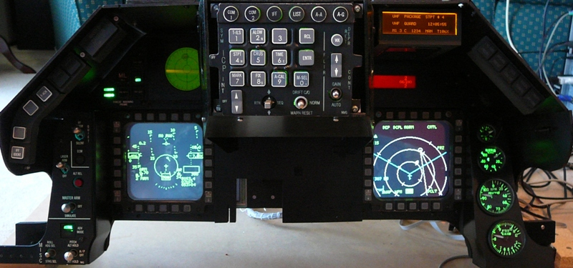

This instruction covers the assembly of the front sections of the pit. It includes the CP and Front panel as well as cables from the PFL and Gear Panel. It assumes the footwell panels are installed.

1. Remove the seat and front right canopy support to improve access to the back section of the pit

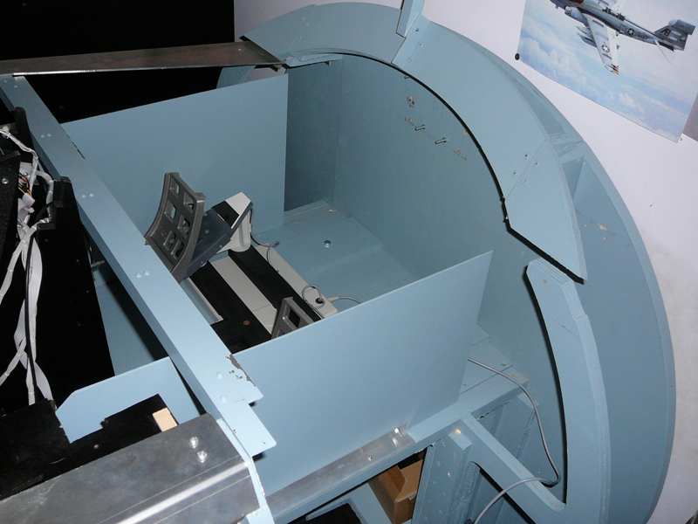

1. Install the CP with 4 bolts through the pit floor. Lay the cables towards the rear of the pit so they don’t tangle with the upper part of the front panel.

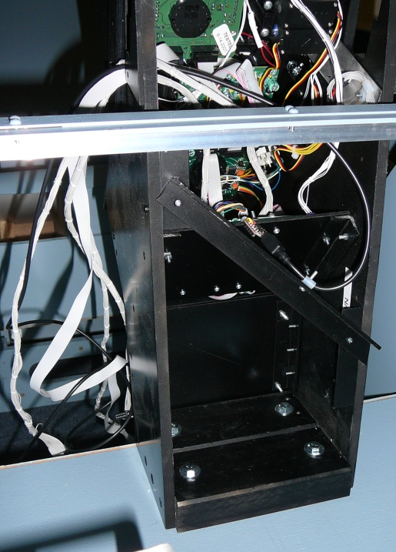

1. Install the floor that supports electronics bay. Bring the power distribution input to the top of the floor. Thread through the cables from the bottom section up to the electronics floor. Cables include:
   1. Instr (plug into Centre Distribution PCB)
   2. Fuel Qty Select (plug into Centre Distribution PCB)
   3. USB for OLED
   4. Servo Cables
   5. Flight Illusions

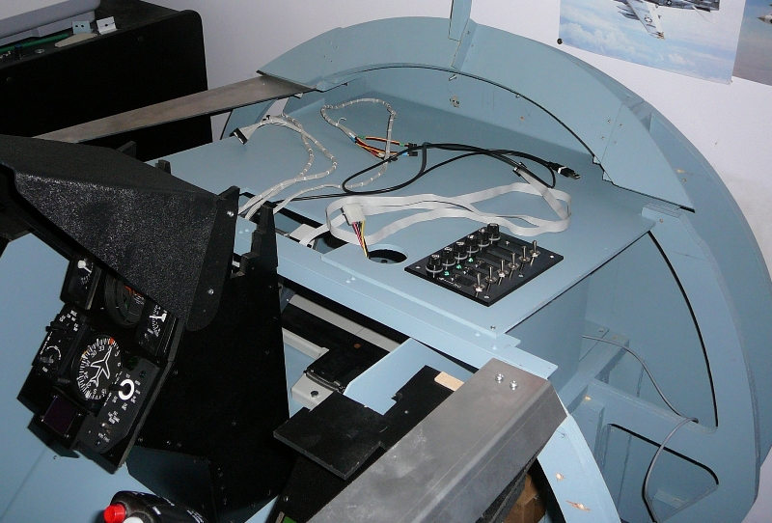

1. Install the top part of the console. This is a tight fit, and may require of rocking from the left and right. There is a guide on the RH of the CP that the top section slots into. As the LH of the top section holds the switches it needs to be strongly supported. This may mean the RH of the panel sits a couple of mm above the RH support, this doesn’t present a problem as there are no switches on the RH side. Attach the back top support to the top panel. 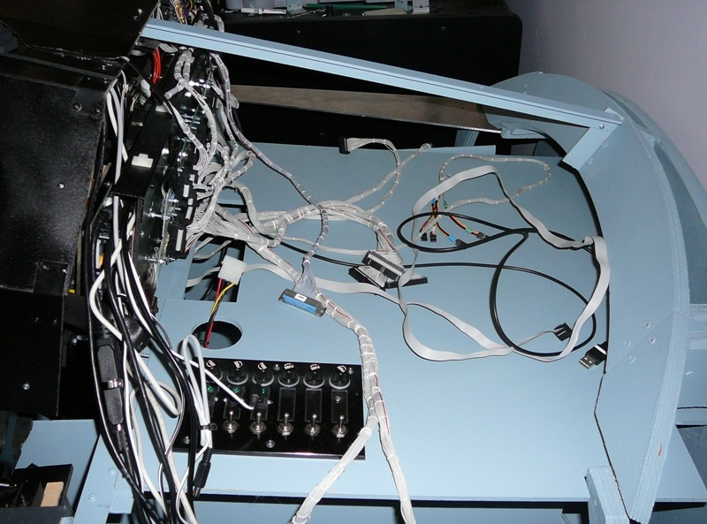
2. Connect the Inst and Fuel Qty Select leads from the Centre bottom panel to the Centre Distribution Panel. Note that Left and Right MFD and HIS connections are not used. The MFDs are now driven by a MM2 through Jays Matrix adaptor PCB. The INST lead connects to the Left, and Fuel Qty to the right when looking from the back.

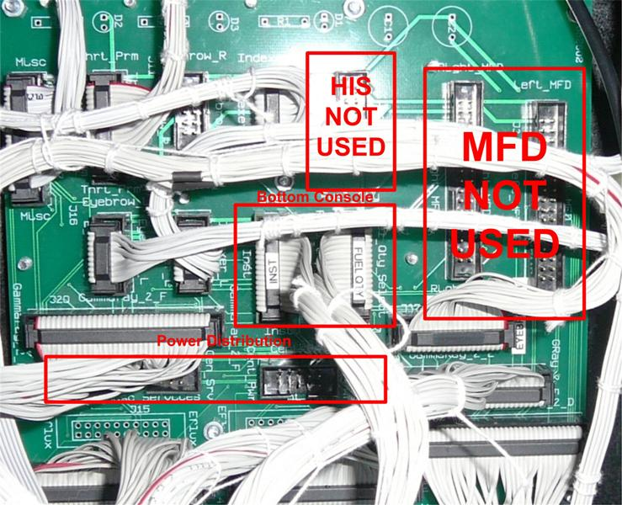

1. Thread the cables from the PFD panel through the Electronics bay floor. Cables include:
   1. PFD to UCC controller
   2. Servo lead
   3. Caution Panel to EFlux

# Test Server as Built Documentation

Update 26/1/09

Operating Systems Windows XP SP2

1 \* ATI PCI-Express Dual Head Card (Catalystr 8.12 8-12\_xp32\_dd\_ccc\_wdm\_enu\_72271.exe)

1 \* NVidia PCI Video Card FX 5200 128MB RAM (Geforce 175.19 175.19\_geforce\_winxp\_32bit\_english\_whql.exe)

Beta Innovations Device Manager 1.4.0.0

Beta Innovations F4IM 2.2.0.0

Beta Innovations Toolkit 1.4.0

PPJOY 0.83 (needed for Lightning’s S/W)

Parallax PSCI 0.9h Beta

Parallax Driver ?

UCC 1.8a

Flight Illusions G-Step Control 5.3

Logitech Game Panel Manager 2.02

MFD Extractor 2.0.3 (dependencies DX 9.0C, DotNet Framework 3.5)

G15 Viper 1.4.4.25

Touchbuddy 1.3.0.18-20070614-full

Falcon4 AF Patch 13, F4AF Hitiles

Open Falcon 4.5

Display Configuration

The screen resolutions are set for

Primary Screen 1024 \* 768

MFDs 800 \* 600

Note the colour depth is set to 16Bit, can’t remember whether it was MFD Extractor or Falcon 4 that failed to launch in windowed mode that forced me to change from32 bit colour depth to 16 bit.

The largest screen is positioned to the left, and assigned as the Primary screen as it makes co-ordinate position calculations easier.

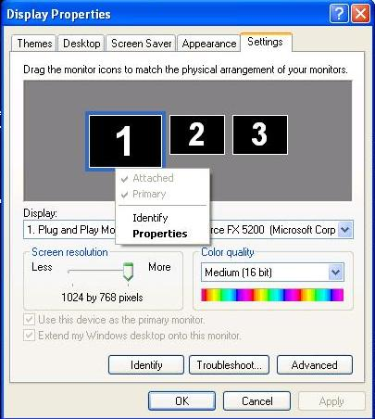

A print screen captures the whole view.

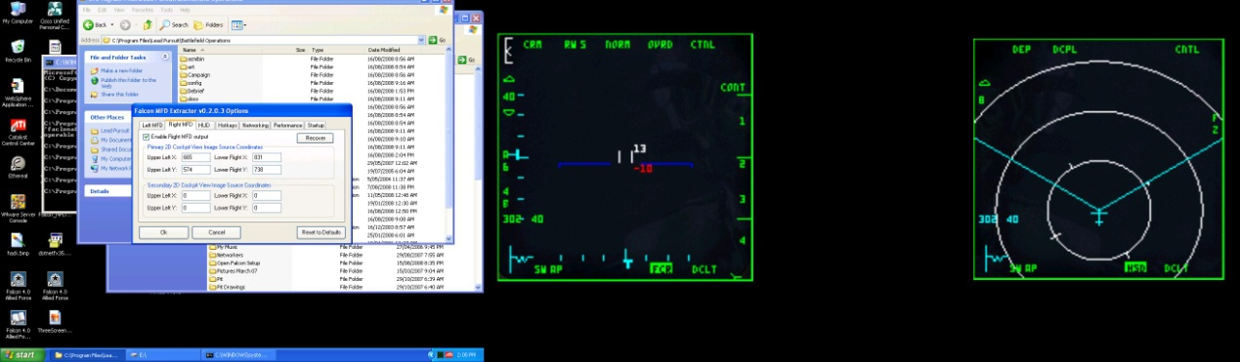

The co-ordinates for MFD Extractor are

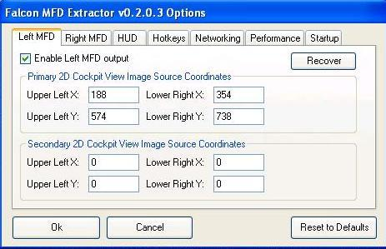

Right MFD

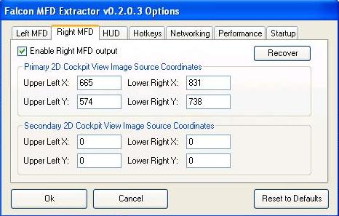

Com Port Allocation

Flight Illusion

UCC

Parallax

Beta Innovation Serial Numbers

Plasma-MM2 200 MFD (on back panel)

Plasma-MM2 201 ICP (in ICP assembly)

Electron-Flux DAC Outputs (Port A)

|  |  |  |
| --- | --- | --- |
| EF Port |  |  |
|  |  |  |
| 1 | Nozzle Position |  |
| 2 | FTIT |  |
| 3 | Engine RPM |  |
| 4 | Oil Pressure |  |
| 5 |  |  |
| 6 |  |  |
| 7 |  |  |
| 8 |  |  |

Electron-Flux Latched Output Port Usage (Port D)

| EF Port | Port Role |  |
| --- | --- | --- |
| 1 |  |  |
| 2 | TF-Fail (LH Eyebrow) |  |
| 3 |  |  |
| 4 | Master Caution (LH Eyebrow) |  |
| 5 |  |  |
| 6 | AA Defeat (TWP) |  |
| 7 |  |  |
| 8 | Naval/Unknown (currently labeled Record) (TWP) |  |
| 9 |  |  |
| 10 | Target Separate (TWP) |  |
| 11 |  |  |
| 12 | Missile Launch (TWP) |  |
| 13 | Engine Fire (RH Eyebrow) |  |
| 14 | Priority (TWP) |  |
| 15 | Engine (RH Eyebrow) |  |
| 16 | Open (TWP) |  |
| 17 | Hyd/Oil Pressure (RH Eyebrow) |  |
| 18 | ECM Enable (Misc) |  |
| 19 | TO/LDG Config (RH Eyebrow) |  |
| 20 |  |  |
| 21 | Canopy (RH Eyebrow) |  |
| 22 | Stand-by Adv Mode (Misc) |  |
| 23 | AOA High (LH Indexer) |  |
| 24 |  |  |
| 25 | AOA On (LH Indexer) |  |
| 26 | Active Adv Mode (Misc) |  |
| 27 | AOA Low (LH Indexer) |  |
| 28 | FLCS (RH Eyebrow) |  |
| 29 | Ready (RH Indexer) |  |
| 30 | Oxy Low (RH Eyebrow) |  |
| 31 | AR NWS (RH Indexer) |  |
| 32 | Disc (RH Indexer) | Refuel/NWS/ -RefuelDSC |
| 33 |  |  |
| 34 |  |  |
| 35 |  |  |
| 36 |  |  |
| 37 |  |  |
| 38 |  |  |
| 39 |  |  |
| 40 |  |  |
| 41 |  |  |
| 42 |  |  |
| 43 |  |  |
| 44 |  |  |
| 45 |  |  |
| 46 |  |  |
| 47 |  |  |
| 48 |  |  |
| 49 |  |  |
| 50 |  |  |
| 51 |  |  |
| 52 |  |  |
| 53 |  |  |
| 54 |  |  |
| 55 |  |  |
| 56 |  |  |
| 57 |  |  |
| 58 |  |  |
| 59 |  |  |
| 60 |  |  |
| 61 |  |  |
| 62 |  |  |
| 63 |  |  |
| 64 |  |  |
|  |  |  |

## PC Build Instructions

Install Software from As-built CDROM (note the Parallax servo driver is .rar’d, so need to extract using something other than WinZip. Using jZipV1c.exe

* Start install with minimum hardware, just using PCI Video card, no USB expansion cards.
* Install Windows XP Pro – No Service Pack
* Install Visual Studio 6.0
  + Installs Java VM – reboots
  + Custom Install
  + Select all and then unselect FoxPro, Interdev, SourceSafe
  + Register Environment Variables for Visual C
  + Ok re debug files, another reload
  + Install MSDN – custom select all – clear FoxPro and Interdev
  + Install Install-shield (back to disk 1
  + Extract Visual Studio SP 6 flies to folder and run SetupSP6 Restart windows)
  + Save Point VSInstall
  + Install XP SP1 (required for XP SP3 to install)
  + Install XP SP3 (after restart discovers audio devices but doesn’t have drivers, now knows about FX 5200 video card)
  + Increase screen resolution to 1024\*768
  + Directx 9C Redist – to c:\dx9c.
  + C:\DX9C\DXSETUP
  + Install DotNet Framework 3.5 SP1 (Needs XP SP2)
  + DotNetfx35 (using full redistributable). It displays that is downloading, but it is getting files locally. Then displays msg that you can disconnect from the internet, looks like it is hung, but CPUs are busy in background.
  + Save Point XP3
  + Installed Acrobat Reader 5.0
  + Install Beta Innovations Device Manager 1.4.0.0
  + Install Beta Innovations F4IM 2.2.0.0
  + Install Beta Innovations Toolkit 1.4.0
  + Install PPJOY 0.83 (PPJoySetup)
  + Install Parallax PSCI 0.9h Beta (387962\_SetupPSCI.rar, extract, setupPSCI.exe)
  + Install Parallax Driver (CDM\_Setup, installs FTDI CDM Drivers)
  + Copy UCC directory from install to Program\_Files
  + Install Flight Illusions G-Step Control 5.3 (from Full Install G-Step Control V5.3)
  + Install Logitech Game Panel Manager 2.02 (lgps202.exe)
  + Install MFD Extractor 2.0.3 (dependencies DX 9.0C, DotNet Framework 3.5), from Falcon\_MFD\_Extractor\_v0\_2\_0\_3\_\_x86
  + Install G15 Viper 1.4.4.25. Extract files from zip to Program\_files\g15Viper
  + Install Touch Screen drivers install\touchDrivers\4.3.0.2412. Need to extract to temp directory. (should have screen plugged in, if not plugged in don’t attempt calibration)
  + Install Touchbuddy 1.3.0.18-20070614-full. Extract files to program\_files\ Touchbuddy
  + Install cougar 2007 CDROM
  + SavePoint Utilities Installed
  + Install Falcon4 AF
  + Install Falcon4 AF Patch 13
  + Install Falcon4
  + Install AF Hitiles
  + SavePoint F4
  + Installed FS2004 and FSX. Added Aircraft, and Locations
  + Savepoint F4 FS2004
  + Now have 4 unknown devices in Device Manager
  + Installed Drivers from Gigabyte installation CDROM
  + After reboots No unknown devices in Device Manager.
  + Installed 2 \* 4 Port USB Cards
  + No unknown devise in Device Manager
  + Installed ATI Video Card and Drivers – No unknown devices in Device Manager – although ATI Manager is complaining as there are no monitors attached to the ATI card.
  + Installed NVIDA drivers (to replace existing Native MS Drivers)

1. Install all drivers from CDROM,
2. copied UCC files to UCC folder off the root directory,
3. Copied the G15 Viper files to a folder in Program Files

Connected USB Ports individually, waiting for ‘your new hardware is installed and ready for use message to appear.

Checks:

1. Z10 display may need to be touched underneath to light up
2. G15 Display starts without prompting
3. Launched UCC, changed RWR to not be reversed, play test display
4. Launched Beta Innovations Device Manager. Should see Gamma-Ray256, Plasma-MM2 (two of), Electron Flux, Gammatron

Beta Innovation Device Configuration

1. Both Plasmsa-MM2s Digital Inputs are configured in Scan Matrix Mode
2. Port D of the Electron Flux is Latched Output

Launch UCC and test RWR (don’t forget the contrast may need to be adjusted)

Launch F4 Interface Manager

1. The Configuration File (bif4.f4c) should be stored in C:\FSSERVER\DataFiles)
2. If the configuration file is not available,
   1. go to Port D Latched Outputs, Set Ports to invert for initial testing to light all lamps.
   2. Go to Port A DAC Outputs, Set Ports to F4 Shared Memory outputs, Add a section and press Test. Press the Cal button and set max position if needed.
   3. As the gauges as not all linear you’ll need to add sections. (currently a a little weirdness with the FTIT not displaying below 750 degrees.

Launch G15 Viper, create shortcut on desktop.

Launch Logitech Game Panel Manager, both the Z10 and G15 devices should be displayed in the LH panel. G15 Viper should have registered itself.

Clear all programs that are allowed to run on the Z10 and the G15 aside from G15 Viper. G15 Viper LCD1 for the Z10, and G15 Viper LCD2 for the Z10. These settings need to be matched on G15 Viper Logitech Game Panel Manager.

One the displays have been correctly set, run G15 and set the Fuel Flow to LCD 2, the X offset to 104, the Y offset to 16. Interesting Falcon 4 Allied forced now recognises the displays. Needed to clear them from Logitech Game Panel Manager.

Falcon4 setup

As there are a number of devices with analog inputs, F4 will probably select one of the MM2’s for throttle and control input, a bad thing. Go to F4 controllers and setup the joystick.

Checking MFD Extractor and output Values

1. Start Falcon4 in windowed mode
   1. Cd \program files\lead pursuit\battlefield operations
   2. Falconaf –window

# Miscellaneous Tidbits

Falcon Keystroke decoder

Source

http://forums.frugalsworld.com/vbb/showthread.php?t=99484

Well...  
  
it has been quite some time since somebody explained the inner working of the Falcon keyfiles to us. With the introduction of FalconAF and espacially the multi-controller-capability, the format has changed again (or at least it has been extended). So I thought it might be a good idea going through that file, its format and structure again. Perhaps somebody finds that information helpful.  
  
*1st Disclaimer:  
I am not the 1st one who's posting about the keyfile format, so the credit for finding out hardly belongs to me. Nevertheless, I'd like to make a summary that is valid for the current FalconAF version (patch 1.05).  
  
2nd Disclaimer:  
The name "secret decoder update" was choosen because 'Gorny asked me a long time ago what is the "secret decoder ring" for those keyfiles. Well, I was unable to answer that question satisfactorily.*  
  
So here we go...  
  
  
**Part 1: Where to find the file**  
  
Ok, as you all know, the FalconAF keyfiles define the binding between the functionallity you can trigger within the sim and the different input devices like keyboard and joysticks that you have available. You find your keyfiles in the "config" subfolder of your FalconAF installation directory, so the default location would be:  
  
"C:\Program Files\Lead Pursuit\Battlefield Operations\config\"  
The keyfiles available to the sim all end with "**.key**", LP provided backup copies of those files (in case you screw them up), ending in "**.orig**" for your reference.  
  
Let's have a look at the file - simply open it with a text editor. What you'll find are multiple lines, each line describing one particular binding. Let's pick out one line as an example...  
  
SimToggleAutopilot 1076 0 0X1E 0 0 0 1 "Ckpit-Autopilot"  
  
Basically, all lines look like this example line (well, more or less, details will follow). First part names an internal function name in the sim that is described by that line, then some code to which key/input device it is bound, and last not least (if we're lucky) some human-readable description of what that function really does. Let's get into the details...  
  
  
**Part 2: Keyboard bindings**  
  
The example line that we picked describes a keyboard binding. So let's have a deeper look (I use color coding to better distinguish between the different parts):  
  
SimToggleAutopilot 1076 0 0X1E 0 0 0 1 "Ckpit-Autopilot"  
  
  
The 1st part (SimToggleAutopilot) describes the sim function that is defined here. This is something what is defined by FalconAF and can not arbitrarily choosen by you. The most complete list of possible functions can be found in the cockpitbuilders.key file.  
  
  
The 2nd part (1076) defines an ID within the 2D cockpit that you see within the sim. Those IDs are basically used within the cockpit definitions (somewhere in the art/ckptart folders) and are NOT related to the keyboard binding that is done here. So why does it show up? It simply means that the same sim function described by the current line can be toggled when you click on the cockpit graphic (button or switch) that has that particular ID. Long speech, short sense: You should NOT adjust that number. Always leave it as it is, otherwise you may loose cockpit mouse functionality.  
  
If that number is "-1", it simply means that there is no 2D cockpit button/switch assigned to that function.  
  
Edit: because if some confusion regarding the cockpit mappings, I added the explanation that I gave in another post:  
  
the "-1" in the keystroke file does not mean that there is no clickable area in the cockpit available, it just means that the keystroke and the (possibly available) clickable area/button/whatever in the cockpit have not been mapped.  
  
So if you \*have\* a button that can change position, it has a control number assigned in the cockpit file that basically defines what has to happen with the cockpit graphics if you click on something. What the actual control number really does with the sim is hardcoded somewhere into Falcon.  
  
Now if that very control number shows up (instead the "-1") in the keystroke file next to a function entry, it simply means that if you press the key assigned to the function, the graphic change defined by the cockpit file will happen as well in the cockpit. However, there is no \*need\* that every clickable area in the cockpit has to be mapped to corresponding keystrokes.  
  
For buttons or lights that \*change\* status permanently, it makes of course sense that the keystroke changes the button position in the cockpit as well. But for things that are only "triggered" instantaniously and do not show a permanent change in the cockpit graphics, the mapping is not really needed (although it would be nice to have \*if\* there is a cockpit function available )  
  
And now for idle detent:  
  
In terms of the description above, the idle detent keystroke does \*not\* trigger the "finger"-graphic in the cockpit. However, it \*does\* trigger the idle detent function in Falcon.  
  
So for the idle detent to be effective, you need to have your RPM at 20% already and increased throttle...  
  
Of course you can click on the detent in the cockpit with the mouse and because of the cockpit file definition, you will see the finger move, but that does not guarantee that Falcon decides to actually execute the idle detent function.  
  
  
The 3rd part (0) seems not to be used anymore and is always "0" for keyboard bindings. Again, just leave it alone... (In the "old" Falcon days, here could have been used a "1" as well, which meant that ONLY the mouse cockpit input (2nd part) could be used to trigger the function and the keyboard binding was not used. Never saw this in FalconAF).  
  
  
With the 4th part (0X1E 0), the interesting things start to happen. Basically you see 2 numbers: "0X1E", which describes the keyboard button that is assigned, and "0", which describes the modifier that needs to be applied (Alt, Shift, Ctrl or combinations).  
  
Let's start with the modifier. This entry can have 8 different values:  
  
"0" = (no modifier)  
"1" = Shift  
"2" = Ctrl  
"3" = Shift+Ctrl  
"4" = Alt  
"5" = Shift+Alt  
"6" = Ctrl+Alt  
"7" = Shift+Ctrl+Alt  
  
So this is the key combination that you need to press together with the button defined before to trigger the function.  
  
Ok, so here's the big list of possible keys - for a US keybard layout (for those of you who \*really\* want to know it: those are costmized XT keycodes, not AT!):  
  
Edit: The "modifier keys" mentioned above (Shift, Ctrl, Alt) are NOT reckognized as individual keys in FalconAF. That's why they do not show up in that following list. And that's why you cannot distinguish between **left** Shift/Ctrl/Alt and **right** Shift/Ctrl/Alt.  
  
"0X1E" = "A"  
"0X30" = "B"  
"0X2E" = "C"  
"0X20" = "D"  
"0X12" = "E"  
"0X21" = "F"  
"0X22" = "G"  
"0X23" = "H"  
"0X17" = "I"  
"0X24" = "J"  
"0X25" = "K"  
"0X26" = "L"  
"0X32" = "M"  
"0X31" = "N"  
"0X18" = "O"  
"0X19" = "P"  
"0X10" = "Q"  
"0X13" = "R"  
"0X1F" = "S"  
"0X14" = "T"  
"0X16" = "U"  
"0X2F" = "V"  
"0X11" = "W"  
"0X2D" = "X"  
"0X15" = "Y"  
"0X2C" = "Z"  
"0X1" = "Escape"  
"0X3B" = "F1"  
"0X3C" = "F2"  
"0X3D" = "F3"  
"0X3E" = "F4"  
"0X3F" = "F5"  
"0X40" = "F6"  
"0X41" = "F7"  
"0X42" = "F8"  
"0X43" = "F9"  
"0X44" = "F10"  
"0X57" = "F11"  
"0X58" = "F12"  
"0XB7" = "PrintScreen"  
"0X46" = "ScrollLock"  
"0X29" = " ~ "  
"0X2" = "1"  
"0X3" = "2"  
"0X4" = "3"  
"0X5" = "4"  
"0X6" = "5"  
"0X7" = "6"  
"0X8" = "7"  
"0X9" = "8"  
"0XA" = "9"  
"0XB" = "0"  
"0XC" = " - "  
"0XD" = " = "  
"0XE" = "Backspace"  
"0XF" = "Tabulator"  
"0X1A" = " [ "  
"0X1B" = " ] "  
"0X2B" = " \ "  
"0X3A" = "CapsLock"  
"0X27" = " ; "  
"0X28" = " ' "  
"0X1C" = "Enter"  
"0X33" = " , "  
"0X34" = " . "  
"0X35" = " / "  
"0XDB" = "Win(left)"  
"0X39" = "Space"  
"0XDC" = "Win(right)"  
"0XDD" = "Menu"  
"0XD2" = "Insert"  
"0XD3" = "Delete"  
"0XC7" = "Home"  
"0XCF" = "End"  
"0XC9" = "PageUp"  
"0XD1" = "PageDown"  
"0XC8" = "CursorUp"  
"0XD0" = "CursorDown"  
"0XCB" = "CursorLeft"  
"0XCD" = "CursorRight"  
"0X45" = "NumLock"  
"0XB5" = "Num/"  
"0X37" = "Num\*"  
"0X4A" = "Num-"  
"0X4E" = "Num+"  
"0X52" = "Num0"  
"0X4F" = "Num1"  
"0X50" = "Num2"  
"0X51" = "Num3"  
"0X4B" = "Num4"  
"0X4C" = "Num5"  
"0X4D" = "Num6"  
"0X47" = "Num7"  
"0X48" = "Num8"  
"0X49" = "Num9"  
"0X53" = "NumDel"  
"0X9C" = "NumEnter"  
"0XFFFFFFFF" = "(Not assigned)"  
  
As you can see, a non-assignment (0XFFFFFFFF) is possible.  
  
Sorry for that looong list, I just wanted to be sure...   
  
  
Ok, the 5th part (0 0) basically works ***exactly*** the same as the 4th part. 1st number is a key, 2nd number is a modifier. So what's the deal here?  
  
Well, this is a key combination that you have to press ***before*** the key combination of defined in the 4th part. Huh? Let's pick an example, because the one we have used uses "0 0", which basically means there is no need for a 2nd keycombo... Alright, here's a better example (only highlighting the important things now):  
  
SaveCockpitDefaults -1 0 0X1F 0 0X2E 4 -1 "Sim-cockpit setup save"  
  
The first keycombo is "0X1F 0", which we can translate now to "no modifier" and "key S". Or simply "S". The second keycombo is "0X2E 4" which we can translate to "Alt" and "key C".  
  
So this means that for triggering the function, you have to press  
  
first **ALT+C** then **S**  
  
OK? Good.  
  
However, there is a restriction for this double-keycombo. You can not choose everything you want for that 5th part (ALT+C in our example). The available keycombos need to be defined as normal functions in the keyfile in order to use them. Here are the lines that are defined by default:  
  
CommandsSetKeyCombo -1 0 0X2C 2 0 0 -1 "Key-Combination Ctrl-Z"  
CommandsSetKeyCombo -1 0 0X2D 2 0 0 -1 "Key-Combination Ctrl-X"  
CommandsSetKeyCombo -1 0 0X2E 4 0 0 -1 "Key-Combination Alt-C"  
  
So that means that you can use those three combos (0X2C 2, 0X2D 2, 0X2E 4) as 5th part in your other function lines. I never tried defining different combos, but I guess it should be no problem  
  
  
The 6th part (1) defines wheter you can see and assign the function within the setup screen of FalconAF. The possible values are:  
  
"1" = You can see and change the assignment  
"-1" = You can see it, but not change it  
"-2" = You can neither see nor change it  
  
Have a look at the cockpitbuilders.key file, you'll see there are quite a bunch of "hidden" functions...  
  
  
And last not least, the 7th part ("Ckpit-Autopilot") simply holds the description that you see in the FalconAF setup screen for that function.  
  
That's it for the keyboard...  
  
  
**Part 3: DirectX bindings**  
  
Right, you do not need to use keyboard bindings only, you can also use DirectX button assignments to toggle a function. As you might have guessed already, the binding lines for DirectX look different then the ones that we have described so far. So let's pick **two** examples. Why two? Well, because there is a (minor) difference whether you have only one DirectX device connected to yout PC or multiple DirectX devices.  
  
First example line, only one DirectX device:  
SimTrigger 0 -1 -2 0 0x0 0  
  
Second example line, multiple DirectX devices:  
SimTrigger 0 -1 -2 0 0x0 0 {46D7A990-DCF4-11D9-8001-444553540000}  
  
As you can see, the only difference is a looooong identifier string in the end. Let's start with that identifier, because the rest of the line is the same for both examples. The long identifier simply identifies the DirectX device that is used to generate the input. Oh, you guessed already? Well, that's all there is to it...  
  
Now the question "How the hell do I know wich device is decribed with that identifier?" Honestly, I don't know where to find a definition. I've searched the registry as well as I made a dxdiag, msinfo... No luck. However, I only have TWO devices connected, so I just tried. The identifier above {46D7A990-DCF4-11D9-8001-444553540000} seems to be my Cougar. Just try, assign a function in the FalconAF setup screen with different controllers and take note for your individual controllers yourself.  
  
Edit: No need to search the registry or something else to get the controller ID. Just assign a DX button within the FalconAF setup screen, and FalconAF writes the ID to the keyfile. Open the file, look for the new entry, there you go!  
  
Before we explain the DirectX lines in detail, I want you make aware of the following:  
  
If you assign a DirectX button to a sim function that has already a keyboard input assigned, you will NOT overwrite thw keyboard input! Instead, both the keyboard input AND the DirectX input are functional now. And yes, that means that you may have two lines in your keyfile beginning with the same sim function name. That is completely OK!  
  
  
Now back to the details. I'll take the line without the identifier in the end for simplification:  
  
SimTrigger 0 -1 -2 0 0x0 0  
  
The 1st part ("SimTrigger") is the sim function that should be triggered. Nothing new here.  
  
Let me just jump to the 3rd part ("-1"), because we know this already as well. Like the 2nd part of the keyboard bindings, this 3rd part describes the 2D cockpit ID that can trigger the same function as well when clicked with the mouse. In our example, the "-1" simply means that there is no cokpit ID assigned.  
  
The 2nd part ("0") is the DirectX button of the device that is assigned to that function. Be aware that FalconAF starts to count the buttons up from "0", whereas most joystick start to count from "1". So if your stick has four buttons 1 2 3 4, FalconAF will identify them as 0 1 2 3.  
  
Edit: If you use more then one controller, every controller starts with the DX buttons from 0 again. FalconAF distinguished between different controllers just by the identifier/GUID at the end of the line mentioned above.  
  
However, this 2nd part ("0") is only relevant if the 4th part ("-2") is "-2", which means that the normal DirectX buttons of the device shoud be used. If the 4th part is not "-2", the 2nd part seems to be always "0". If the 4th part is "-2", the 5th part ("0") is always "0".  
  
The only only other value I have noticed for that 4th part is "-3". This means that your input device should NOT use the normal DirectX buttons, but directions of the POV/FieldOfView Hat switch. If that is the case, the 2nd part is not used and always "0", however, now the 5th part ("0") is used to determine the hat direction:  
  
"0" = Hat UP  
"2" = Hat RIGHT  
"4" = Hat DOWN  
"6" = Hat LEFT  
  
I assume that a value of "1" would lead to "Hat UP-RIGHT", a value of "3" would lead to "Hat RIGHT-DOWN" etc., but I haven't verified that yet.  
  
The 6th part ("0x0 0") seems to be always "0x0 0", I've never seen anything else.  
  
And last not least, if you have a 7th part, it is the identifier of your joystick.  
  
Confused? Well, it's not so hard if you see a complete example. Here's what my oooold Wingman is capable of (please ignore the actual sim functions that I have used, they make no sense at all, I just wanted to assign \*something\*):  
  
"Wingman Trigger (Button 1)"  
SimLeftHptOff 0 -1 -2 0 0x0 0 {CB7F0BB0-8F1F-11DA-8001-444553540000}  
  
"Wingman Button2"  
SimLeftHptOn 1 -1 -2 0 0x0 0 {CB7F0BB0-8F1F-11DA-8001-444553540000}  
  
"Wingman Button3"  
SimMAPOff 2 -1 -2 0 0x0 0 {CB7F0BB0-8F1F-11DA-8001-444553540000}  
  
"Wingman Button4"  
SimMAPOn 3 -1 -2 0 0x0 0 {CB7F0BB0-8F1F-11DA-8001-444553540000}  
  
"Wingman Button5"  
SimDLOff 4 -1 -2 0 0x0 0 {CB7F0BB0-8F1F-11DA-8001-444553540000}  
  
"Wingman Button6"  
SimDLOn 5 -1 -2 0 0x0 0 {CB7F0BB0-8F1F-11DA-8001-444553540000}  
  
"Wingman Button7"  
SimGPSOff 6 -1 -2 0 0x0 0 {CB7F0BB0-8F1F-11DA-8001-444553540000}  
  
"Wingman HatUP"  
SimUFCOff 0 -1 -3 0 0x0 0 {CB7F0BB0-8F1F-11DA-8001-444553540000}  
  
"Wingman HatRIGHT"  
SimMFDOn 0 -1 -3 2 0x0 0 {CB7F0BB0-8F1F-11DA-8001-444553540000}  
  
"Wingman HatDOWN"  
SimUFCOn 0 -1 -3 4 0x0 0 {CB7F0BB0-8F1F-11DA-8001-444553540000}  
  
"Wingman HatLEFT"  
SimMFDOff 0 -1 -3 6 0x0 0 {CB7F0BB0-8F1F-11DA-8001-444553540000}  
  
  
**Part 4: The best thing about multi-controller support**  
  
With the addition of the device identifier to the DirectX bindings, FalconAF is now capable of using 32 DirectX buttons for **every** DirectX device! So if you have 3 devices connected, you could assign up to 3x32 = 96 DirectX functions! This means a complete DirectX cockpit implementation is possible no

## Working with PICs

There are a couple of things not yet available ‘off the shelf’. After having a read of Mike Powell’s Building Simulated Aircraft Instrumentation it looked like building some custom instruments is a very doable thing. It was time to dig out some very old programming books and take a look at PICs.

First thing you’ll notice is the PIC architecture a different to the traditional microprocessor in the data and program space is not shared. Also it is RISC based, meaning you have only a small number of programming steps to learn (around 35).

I purchased a development board and programmer from Futurlec. Didn’t have a very happy experience with the parallel port programmer, so went and purchased a PIC programmer from Jaycar Electronics. Had another unhappy moment when the Jaycar PIC programmer refused to play nice. It is serial connected and would not recogise the programmer when using a USB-Serial adaptor. Fortunately I also had a docking station for the laptop which worked first time with the programmer.

The VELLEMAN Pic Programmer/Checker programmer costs around $120. It includes a PIC16F627A PIC with some demo code to verify the PIC is all well.

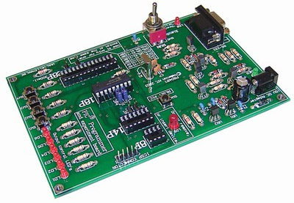

The controller board (PIC16F628CONT) from Futurlec (www.futurlec.com) is good value around $20.

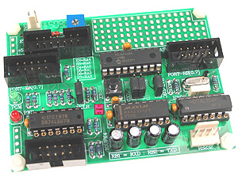

## Paint for Panels

String, go by the local model shop (not the hobby lobby, but a real dedicated model shop).  Ask for Tamiya model paints and get XF-1 (flat black) and XF-54 (Dark Sea Grey) paints.  These are a perfect match to the paint Mike uses.  I use them for touch up work when I'm building ICPs as they always get knicked.  They are acrylic based paints and clean up with water.  Very user friendly.

## Modifying a Logitech Z10 into a F16 DED.

From http://www.eaglevision.nu/z10\_ded.php

|  |  |
| --- | --- |
| z10_01 | 1. This is the z10 speakerset in its unmodified state. Please notice that turning it into a DED will make it absolutely worthless as a sound output device and that I accept no responsibility in any form for any damage caused by the modification. |
| z10_02 | 2. The most difficult part, removing the front-plate. The front-plate is mounted with double-sided tape. To remove the front, carefully place a fingernail between the front ant the frame. Now try to make a small opening by pulling on the front. When you have a small opening you can try to place more of your finger between the front and the housing. Keep pulling slowly and you will notice the front coming of. Be careful not to break the plastic, since you will need the buttons for the DED. |
| z10_03 | 3. Now remove the screws and remove the front bezel. You can cut the wires to the speakers. Please pay attention to the cable going from the LCD screen to the pcb. You can remove the cable by carefully pushing the brown locking plate on the pcb connector 1mm upwards. The LCD cable will then come free from its socket. Now you have to remove the LCD display and the keyboard by first removing the hotmelt. |
| z10_04 | 4. After removing the z10's guts this is what you need for the DED. The pcb, the LCD display and the touch-keyboard. Please make sure you do all the work with the mains disconnected. On my pictures I have the power connected for testing purposes. |
| z10_05 | 5. This is the main pcb. You can remove the amplifiers, the power-supply capacitor and the audio jack. Since you can best supply the DED with a separate 12V DC power-supply the capacitor can be safely removed. It is too high to fit the DED in its new housing. |
| z10_06 | 6. Here you see the pcb with the parts removed. The red and bleu wire go to the 12V DC power-supply connector, mounted in the DED box. |
| z10_07 | 7. |
| z10_08 | 8. Here all parts are connected for a final test. I have soldered a piece of USB wire (4 leads + shield) behind the USB connector on the pcb. The other side is connected to a USB-B pcb connector which is also mounted in the DED box. The cable is covered with hotmelt. Before you can solder the USB cable, you first have to remove the original sealing by pealing it of the pcb.  The touch-key keyboard is covered with the original keypad, which has been cut out of the frontpanel. |
| z10_09 | 9. This is the complete assembly that goes into the DED box. You can see the little pcb with DC- and USB connector. |
| z10_ded03 | 10. Here you can see everything mounted in the DED box. They keypad is mounted on the underside as the cover of an opening in the bottom of the box.  If everything still works this should be the result.  The layout of the DED box can be downloaded from this website in .dwg format. |
| z10_ded04 | 11. And here is your working DED. |

At the moment i am building the casing from 1mm aluminum

You can use the speakers, if you have an amplifier, because the audio IC's are on the PCB that drives the display. You even need to remove those IC's otherwise the PCB is too high. I also removed the condenser on the PCB, and now use a 12VDC power supply. Taking the speakers apart, and prepare the PCB for use as a DED was quite a job. You need to take great care removing the display and not damaging the flat-cable from the display and the flat-cable from the buttons.

Other Mods

Jason (aka Kill’n)

DED and PFLs

Copy all of the files to a directory otherwise the fonts will not fit properly on the LCD screen.

**\*\*\* How to install \*\*\***  
- download the latest GamePanel software from Logitech (you can get the 2.0+ version here: [http://www.logitech.com/index.cfm/434/3498&cl=gb,en?osid=1&file=](http://www.logitech.com/index.cfm/434/3498&cl=gb,en?osid=1&file=" \t "_blank)) and install it. Reboot your PC if needed.  
- Start the Logitech GamePanel Manager (Start -> Programs -> Logitech GamePanel Manager).  
- Once there, click on the Programs icon. This is more or less what you'll see:  
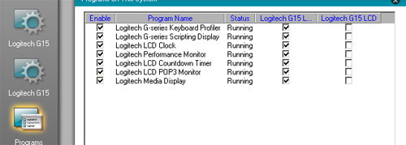  
  
- Next, start the G15viper.exe application by double clicking it. It should appear and it should also appear in the GamePanel Manager, like so:  
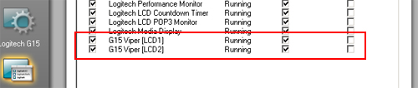  
  
- Now, correct the checkboxes so they look like this (VERY important !):  
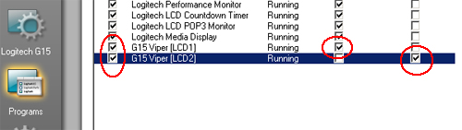  
  
- Finally, disable all the other programs in the list by unchecking the boxes:  
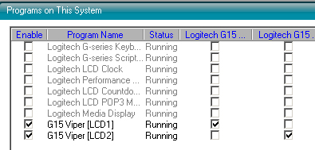  
Now start up Open Falcon or Falcon AF and get tinkering ! Click the DED and PFL previews in G15 Viper to identify your LCD displays, or click on 'About' to show a cool logo graphic on both screens. Play around with everything and get your feedback to me !

Opening the z10

Use an exacto knife to pry up a corner of the black face plate.  It's glued down with some crazy sticky glue.  Once you get it started, use a small screw driver to finish the job.  The hardest part is getting the lcd out.  You'll have to pick away at some at some adhesive in order to get the ribbon cable to move.  Just be careful and have patience, it will eventually come loose.  It's also a pain in the ass to get the circuit board out.  Again, you'll have to pick at some adhesive.  I also used pliers to break the plastic of the speaker housing to get to where I could get at the board.

Watch-out that the lcd cable lock doesn’t disappear.

Double sided tap holding keyboard and display down. Remove keyboard first. The hot melt glue seeps all the way through. Remove heat sink gunk.,

## Ribbstick Installation

This is pretty much straight copy of Dave’s Document.

IMPORTANT: GROUND THE STICK MOUNTING PLATE PRIOR TO OPERATION! FAILURE TO DO SO MAY RESULT IN STATIC DISCHARGE THAT CAN DAMAGE THE COUGAR ELECTRONICS!

WARNING: THE SENSOR TUBE PORTS ON THE PLASTIC TRANSDUCERS ARE VERY FRAGILE! AVOID EXERTING ANY UNDUE SIDE FORCES, EITHER DIRECTLY OR THROUGH THE SENSOR TUBES, AT THESE POINTS. THIS SHOULDN’T BE A PROBLEM UNDER NORMAL OPERATION, BUT CARE MUST BE TAKEN IF THE STICK IS PARTIALLY DISASSEMBLED FOR INSTALLATION.

## Installation Considerations

The design of the Ribbstick places the stick in the precise location of the real side-stick when the mounting plate is mounted on the inboard side of the interior right console wall (visible on the wall between the ACESII and right console). If you choose this installation, you will need to cut openings for the upper sensor housing and lower stick mount to pass through the interior console wall. You will also need to temporarily remove the stick shaft and possibly the upper sensor housing assembly as well. With any disassembly and reassembly, it is critical that the stick shaft be once again centered between all four tubes in the upper sensor assembly - more on this procedure later.

It is important to note that if your interior console wall is over ½” thick, you will need to remove additional material from the outboard side of the wall to provide clearance for the sensor tubes with the installation method described. If this is the case, you may seriously wish to consider the right- hand mounting plate option described below.

If you can live with a stick centerline that is 7/8” outboard of the real stick’s location (assuming you used a ½” thick console wall), you may wish to consider mounting the plate on the outboard side of the right console sidewall. This will result in a somewhat easier installation, as the need for cutting additional openings in the sidewall and partial disassembly of the stick can all be avoided.

Another option is to request at time of order that your stick be assembled with a right-hand mounting plate configuration. With a right-hand plate design you will mount the stick on a secondary sub-wall, or septum wall, located under the right console. With this design, the stick centerline can still be located at the precise location of the real side-stick without the need for stick disassembly or the need to modify the inside console wall.

If you already have a faux side-stick transducer housing and nose piece (the piece that attaches the transducer housing to the aux panel), preinstall these first, as an aid in locating the stick mounting plate.

|  |  |
| --- | --- |
| Plan view dimensions  Figure 1, Plan View of Ribbstick (not to scale) | The plate must be located at the proper height and fore/aft position, plus have the proper tilt, or inclination backwards, to properly position the stick shaft through the center of a faux transducer housing. Having the transducer housing prior to installation takes all the guesswork out of locating the plate!  If you are using a real right auxiliary panel and dimensionally correct faux transducer housing, you may also need to remove a small amount of material from the back of the aux panel pocket opening to provide enough operating clearance for the stick shaft.  With any of the installations described above, remember that the stick forces are transferred to the structure through the mounting plate and therefore the structure must be robust enough to accept these without deflecting.  A template is provided to assist you in preparing the mounting wall to accept the stick mounting plate. You will use the same template for all types of installation. |

## Design Concept

The stick shaft of the Ribbstick is rigidly mounted to the mounting plate assembly via a plate. When stick input forces are applied, the plate deforms, resulting in a stick displacement. The thickness of the plate determines the force vs. displacement characteristics of the Ribbstick. The Ribbstick currently ships with a 1/8” thick aluminum deflection plate. This plate results in a full-unmodified stick input (as seen by the PC) at approximately 20 lbs of force, and a resultant displacement of .235”. The exception to this is ‘nose down’, which is modified to require additional force, mimicking the F-16’s design. Through the use of the Cougar Control Panel applet (described later), the user can reduce the maximum required forces.

It is worth noting that force and displacement values referred to in this document are referring to forces and displacements applied or measured at the stick grip’s reference point – a point located where the middle of the user’s palm contacts the grip in normal use.

With stick displacement, the sensor tubes are compressed. The increase in internal tube pressure is sensed by the pressure transducer, which varies the input signal to the PC accordingly. The stick is designed with slight pre-loading on all tubes. This insures that any movement of the stick will result in a change of the input signal. It also means that the design’s very slight mechanical hysteresis (inability to repeatedly return to the exact same center resting point) is seen as an input change by software. If you see this hysteresis in your application, simply add enough software center ‘dead zone’ to negate it.

## Installation

Prior to disassembling your Cougar for conversion over to the Ribbstick installation, confirm that your Cougar is functioning properly.

Depending on the installation method you choose, you may need to partially disassemble the stick. If you do so, make certain that the stick shaft is re-centered between the sensor tubes – more on this below. Avoid removing or loosening the four screws holding the 1/8” thick aluminum plate to the mounting plate gussets (this is the most difficult point to realign). At worst, you should only need to remove the stick shaft and upper sensor housing.

Once you have secured the mounting plate in the cockpit and reassembled the stick components (if necessary), find a suitable location within reach of the Ribbstick’s cables to mount the Cougar’s printed circuit board (PCB). You may wish to leave the PCB in the Cougar base. While it may be more difficult to secure the Cougar base than the bare PCB, the advantage is that strain relief is provided for the USB cable, rudder, and throttle connectors.

|  |  |
| --- | --- |
| grounding strap  Figure 2, USB Cable Grounding Strap In Cougar Base (PCB removed) | Next, ground the mounting plate. This is an important step to reduce the chances of static discharge damaging the Cougar’s electronics. To do this, run a grounding wire from the stick mounting plate to the Cougar PCB or directly to the PC case. Most Cougars have a separate ground wire coming from the USB cable that terminates under one of the four screws holding the PCB in the Cougar base. Look under the screw closest to where the cable penetrates the casing to determine if you have a cable ground (see Figure 2). If your Cougar has this feature, run a ground wire from the stick mounting plate to the USB cable ground termination point. If you have an early version of the Cougar that lacks the USB cable ground wire, you must run the stick mounting plate ground wire back to the PC! Or even better, run the grounding wire to both the PC and one of the PCB mounting screws. Termination at the PC can be made using an alligator clip or similar fastener. |

You are now ready to make the cable connections to the PCB with the two 3-pin and the 5-pin female connectors coming from the Ribbstick. These connectors are polarized so you will only be able to seat them with the proper orientation. Also, you will note that one of the 3-pin connectors is tied to the 5-pin connector so there will be no confusing which of the 3-pin male headers to connect it to. Next, install your Cougar grip on the Ribbstick and make the final connections to the throttle and rudder.

Finally, plug the Cougar USB cord into the PC and confirm that the Cougar is again recognized by the Cougar Control Panel applet. Calibrate the stick as normal using the Cougar Control Panel.

## Force Adjustment

Using the Cougar Control Panel (CCP) applet, you are able to reduce the input forces required to produce maximum output (as seen by the software).

Open the CCP and click on the ‘Axis Shaping’ tab. Under ‘Axis Settings – Dead Zones’ you will note that you can adjust the upper and lower dead zones from a value of 0% to 100%. This is the setting you will change to adjust the maximum input force required. With a 0% dead zone setting, the full design force of 20 lbs (with 1/8” aluminum deflection plate) is required to generate a maximum output signal. At a 100% dead zone setting, the full design force is reduced by approximately 35%, to a value of 13 lbs. Worth noting, force and displacement are fixed in their relationship (In fact, this is close to a linear relationship and can be plotted as such). Therefore, lowering the force required to generate a maximum output signal also reduces the maximum displacement. You are in affect increasing the sensitivity of the stick.

As mentioned under DESIGN CONCEPT above, the Ribbstick is designed with a slight preloading of the sensor tubes to insure a change in output with any stick movement. You may wish to introduce a small amount of center dead zone if you are witnessing a slight hysteresis, or non-repeatability, at the center point.

Additionally, use the curve settings to customize the response of the stick for personal preference.

## Technical Issues

Shortly after initial use, and periodically thereafter, you will notice slight slop in the base of the Cougar grip. The higher forces of the Ribbstick work to loosen the threaded bottom adapter within the Cougar grip over time. When necessary, carefully open the Cougar grip and tighten the one remaining screw holding the adapter in the grip.

If you notice unbalanced operation in the roll axis, that is, the stick requires dissimilar forces in opposing directions to generate the same output signal; look for the following two issues.

1. Distorting force on sensor tubes; check to make sure that there is nothing coming in contact with the tubes that would distort them, generating a false input.
2. Misalignment of stick; this is most likely a result of partial disassembly during installation. Visually inspect the contact that the stick shaft makes with the sensor tubes. Do this by looking into the square sensor housing from above or below. The stick shaft should be making very slight but equal contact with all four sensor tubes. If this is not the case, follow the realignment procedure described below.

You may also notice that a slight left roll is induced during a hard ‘nose-up’ maneuver. Pulling your arm slightly towards your body, in addition to the intended backwards pull causes this. The installation of an elbow rest changes your arm mechanics and stops this unintended input.

## Realignment Of Stick

If your stick requires realignment, adjustment can be made in three places. (1) Four screws holding upper sensor housing to mounting plate adjusts the pitch axis only. (2) Four screws holding deflection plate to gussets adjust both pitch and roll axes. (3) Single bolt holding stick shaft to deflection plate adjusts to adjust both pitch and roll axes.

Realignment can be tedious, especially with the Ribbstick installed, and patience is required! If adjustment is needed in the pitch axis only, try making it with the upper sensor housing first. For small roll axis corrections, or a combination of roll axis and pitch axis corrections, try the single stick shaft bolt next.

The deflection plate is the most difficult point of adjustment and should be avoided. Anyway, you shouldn’t need to make changes here, as you wouldn’t normally be required to disassemble the deflection plate during stick installation.

## RWR

The RWR is driven by the UCC driver.

The UCC is driven by a 5V regulated supply. A challenge for my pit is the 5V connector on the UCC is the same connector that I standardized on for the rest of the pit. For that reason the adaptor lead will be hot-glued in place.

A second thing I’d forgotten about was the Contrast potentiometer. Without this potentiometer the RWR just glows bright green with nothing displayed. The potentiometer needs to be set to approximately 200 degrees.

Another piece of good luck is the backlight of UCC displays are controller by a switch off the back of the UCC. Given there is a spare pole on the Backlight Relay in the primary power module, its be use to control backlighting on the LCDs.

## Aircore Gauges

### Assembling the Tubes

Acknowledgement - this is pretty much a cut and paste from

http://www.viperpits.org/smf/index.php?topic=2698.15

When the tubes arrive from Jarrod they are partially assembled. They fit together exceptionally well, Initially I thought the end caps where a single unit, needless to say thet aren’t. Remove both end caps to start.

I know the tubes are pretty self explanatory, but I thought I would just put a little guide on here as to the order of some of the pieces.  
  
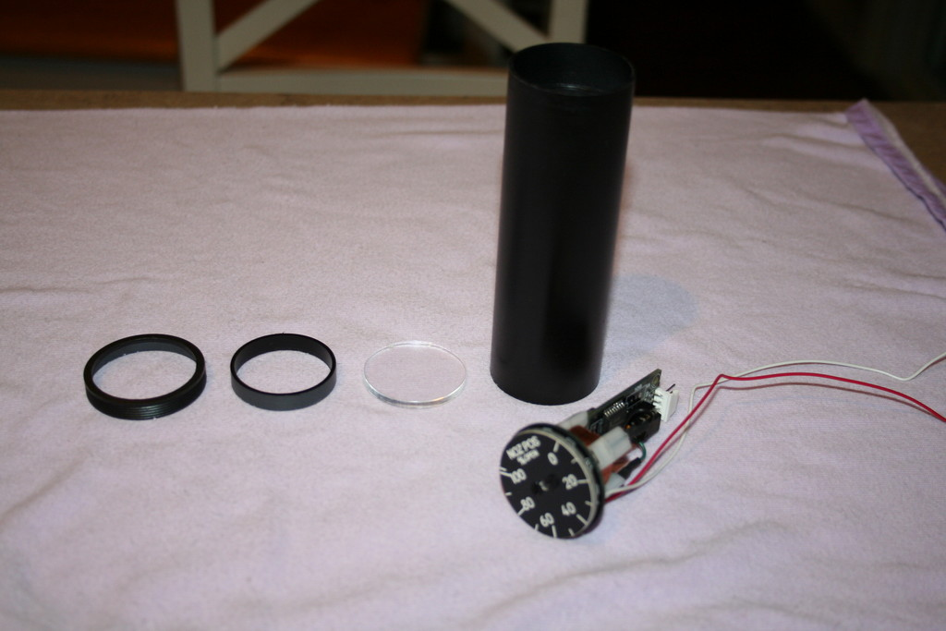  
  
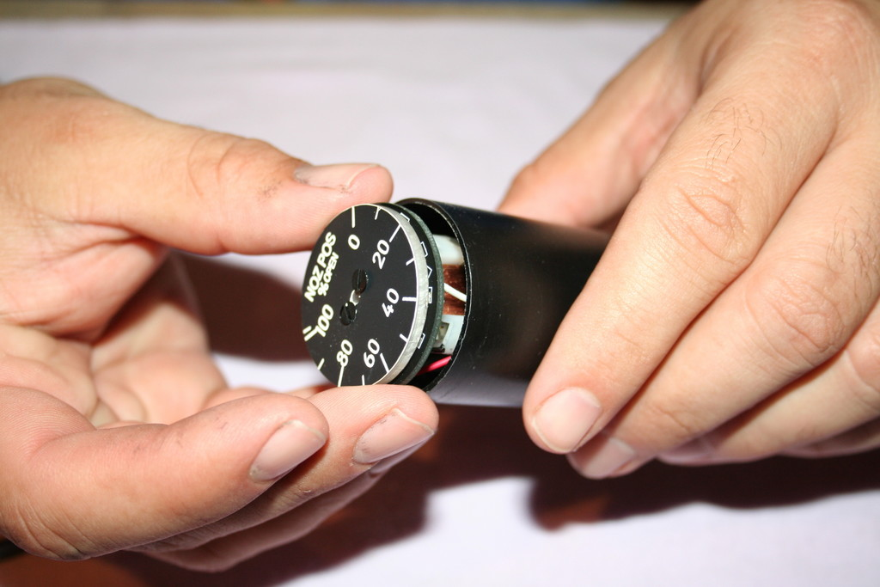  
  
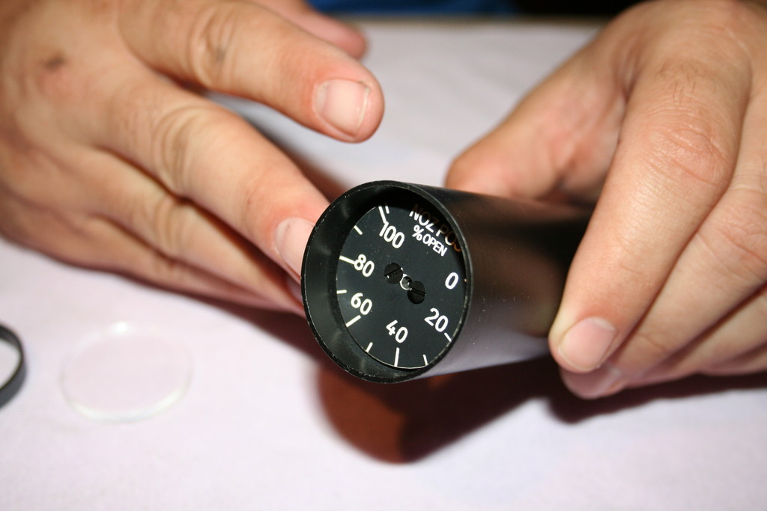  
  
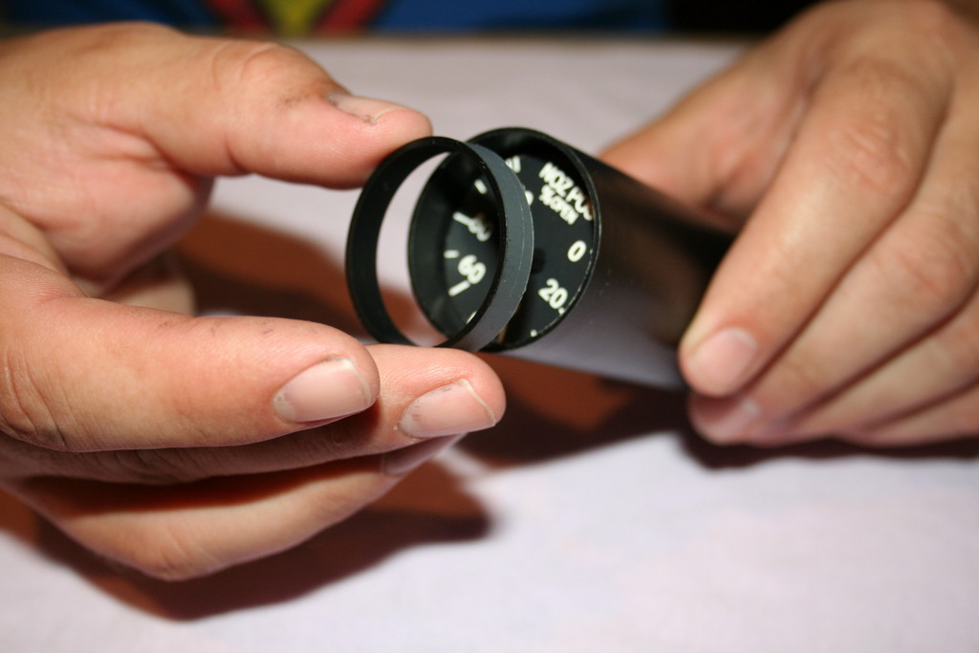  
  
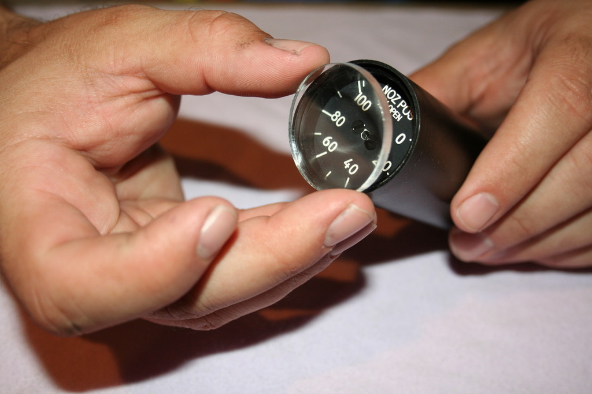  
  
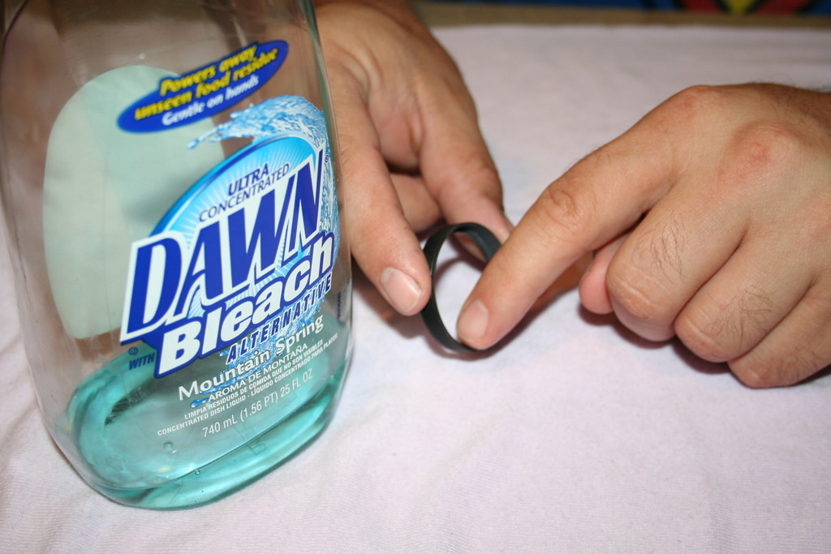  
  
All of the bezels and tailpieces are custom fit to each tube.  Be sure to keep them together.  As each piece is handmade, some pieces may fit a little tighter or looser than others.  Most of them should be plenty tight enough with just a dry interference fit.  However, if the bezel or tailpiece fits a little loose, add some dishwashing soap as a "glue". This will make it to where you can disassemble the unit if ever necessary.  I would recommend doing your gauge calibration of the needle before ever putting the glass and bezel in place.  
  
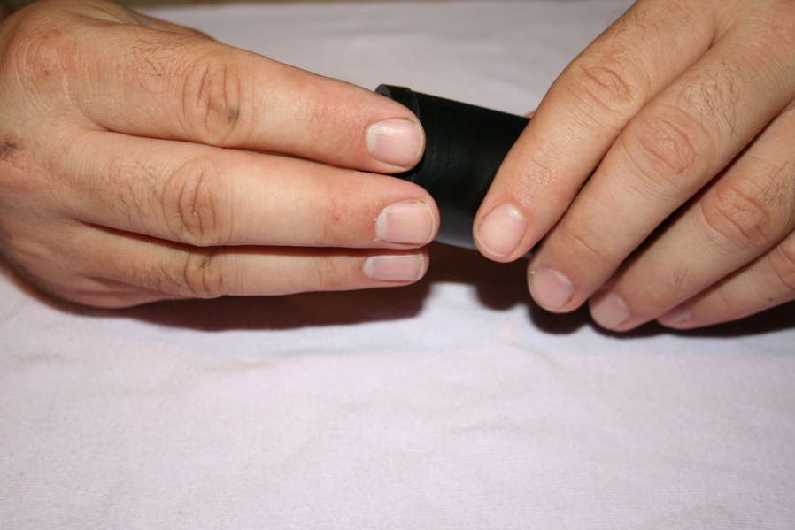  
  
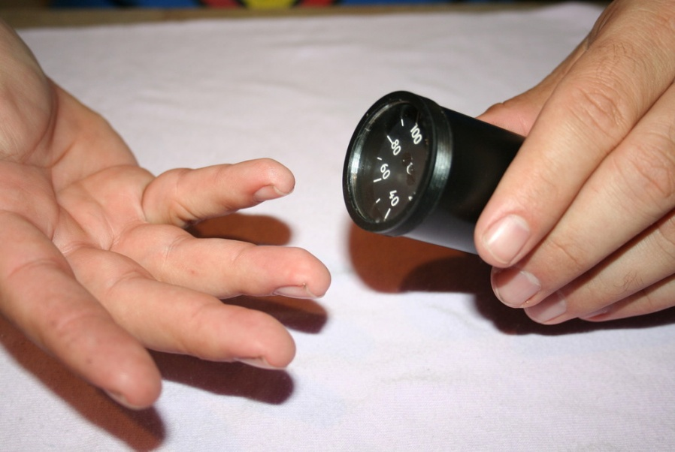  
  
There you have it.  The tailpieces are pretty straightforward.  If anyone has any questions or anything....let me know...

Air Core Gauge Calibration Procedure:

Although the AC360 driver circuit does not require any hardware calibration, the pointer must be properly installed at the zero position on the gauge prior to use. Use the USBDACS.exe test utility for this purpose, which can be found in the USB toolkit.

Set the output to OV for analog gauges or 0 binary for digital gauges. Press the needle onto the Air Core Movement’s shaft at the minimum or zero position on the gauge.

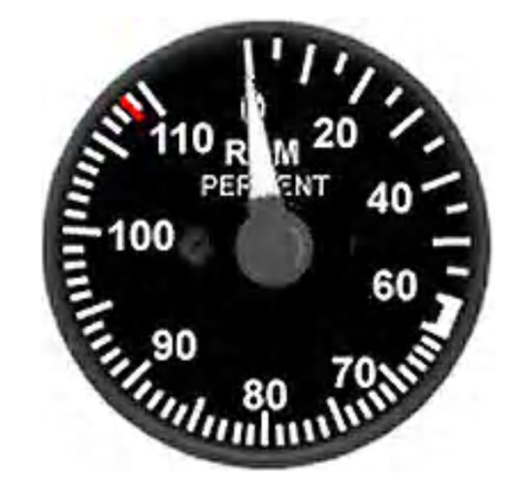

The Air Core driver circuit is now ready to use and will not need to be adjusted unless the physical range of the meter faceplate is changed. Additional in software calibration may be required depending on the intended application. Refer to the interface software help file for details.

Pin-outs for Analog type AC360X:

Connect JP1 of the AC360 driver to the expansion card using a maximum cable length of (22-24 AWG stranded wire). VIN: 0-5VDC analog input signal.

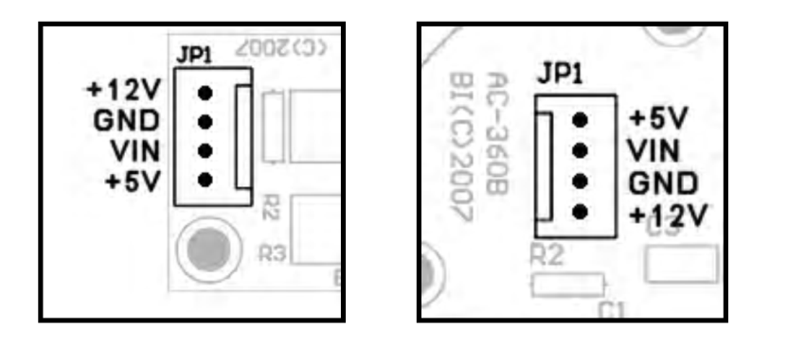

NOTE: When using the AC360 in conjunction with expansion cards, connect JP2 on the Dx10-8BIT card to an ATX PS or plug a 12-16VDC@1A AC adapter into the J1 power connector on the RXC or NITRO card. JP1 on AC360A & AC360B JP1 on AC360C

The Dx10 Expansion Module

It has 10 individually controlled voltage output channels through a single ElectronFlux port. 0 - 5VDC @ 8-bit resolution. 5V and 12V output pins for use with Air-Core movements.

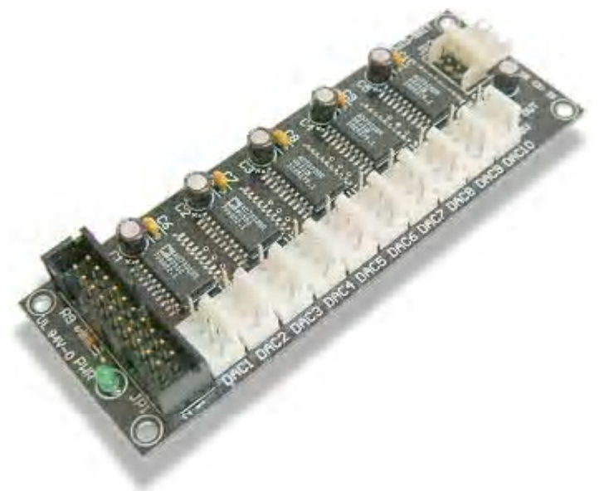

The Dx10-8BIT DAC output card is ideally suited for controlling up to 10 Air-Core Movement based gauges through the ElectronFlux module. The ElectronFlux port must be configured for 8- bit DACs mode (refer to user manual for details). When driving Air-Core movements requiring 12V power, the Dx10-8BIT can be connected to a standard ATX power supply reducing wiring complexity as each connector provides a 12V pin for this purpose. NOTE: unlike the 5V pins, the 12V source is not monitored nor protected against short circuits.

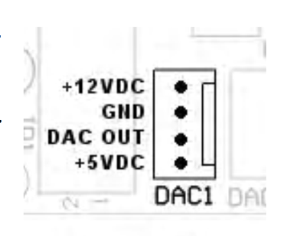

The Beta Innovations Test Bench

The test environment has:

* Plasma –lite
* Gammatron
* Electron-Flux
* 64-HV
* 64-Led
* DX-10
* DO10-RE5
* PBC-PWM

I did ask Leo about using the Nitro vs the 8 bit DAC, here’s the reply.

The Air-Core driver ICs I use are 10-bits. I found no difference between 8 and 10 bit resolution on gauges below 360 deg. I used the 12-bit ICs only because they had an SPI interface which made them convenient.

For continuous turn gauges that go beyond 360 deg, I would recommend using the full 10-bits. The next EF update will support 10-bits through SPI. Both DACs and AC driver ICs will be able to communicate directly with EF this way.

DAC

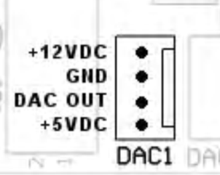

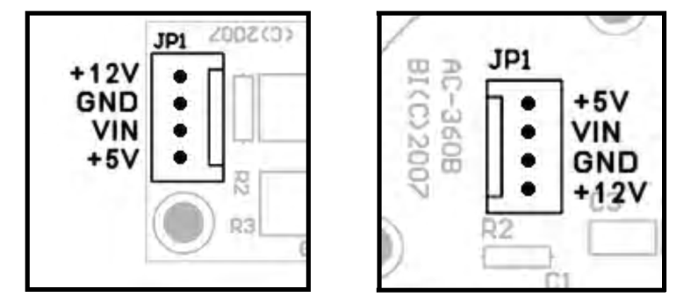

Whilst the simplest way to connect the Gauges to the DAC card would have been a straight through 4 way cable, its doesn’t include the two pins needed for backlighting.

An adapter card was added to take the PWM dimming and the DAC output and put it onto a single lead.

Outputs to Gauge Assembly (looking on lead side).



|  |  |
| --- | --- |
| Pin | Description |
| 1 | +12V |
| 2 | Gnd |
| 3 | DAC Out |
| 4 | +5V |
| 5 | Backlight Led +ve |
| 6 | Backlight Led Gnd |

## Which Version of Falcon

Post by Red Dog at <http://www.viperpits.org/smf/index.php?topic=3129.msg41043#msg41043>

Some examples:

UHF panel: Not fully integrated with OF, but quite more than with AF where nothing is active

TRIM panel: Trims can be assigned as analogue axis with OF, which is way better than digitally programmed with keystrokes

COM1 panel: Same is true here. COM 1 & 2 volume may be analogue assigned

TWP&TWA: many improvement there and specifically the handoff button will need to be interfaced differently in the two versions as in OF it makes the difference between a short and a long press

JET ENGINE PANEL: I think that OF has the code for the PRI/SEC switch. AF doesn't. So that's one switch that will be wired for OF use while it is not required for AF flying.

DTC: this has nothing to do with cockpit but as far as realism is concerned the DTC is a giant step. OF has it, AF doesn't

CMDS: improvement was done on the CMDS panel, mainly the modes. The BYP mode is also possible to use where in AF it's not. I also think that AF doesn't allow such a versatile combination on the CMS and gives access to the slap button above the throttle where OF does all that

IVC: we mentioned that before, but that will be for MP flight mainly - but you flip many more buttons using the IVC than with any app as RW or Teamspeak. IMHO it adds a lot of realism to the intraflight comms, especially at ramp-start where too little knowledge of the system will let you communicate with hand-signs only (and hand signs are not easy over the internet... it usually ends like this... Sting 2.2, Sting 2.1 open your canopy if you can hear me Smiley Smiley )

TGP: the targeting pod is way better than in AF. Few influences on the cockpit building side except that the RIGHT HDPT power switch has to be wired now and has a realistic meaning where it doesn't in AF

IDM: datalink is active in OF. It doesn't really influence the cockpit building but it does influence the Hotas programming as you then need the radioswitch on the TQS

The store management is also quite closer to the real system, but those are mainly through MFDs

Try Air refuelling to see the difference between the two flavors,

AR checks works only with OF, so AP DISC switch and AR door switches works better with OF

As far as radionavigation is concerned, OF allows ILS with specific frequencies untied fromt the tacan station. You get middle marker and inner marker that you don't get in AF That's yet another light to interface in the cockpit.

It also means you have to press more buttons while setting the ILS through the UFC (and that's the essence of using a pit isn't it) Smiley

I am not sure the VMS is active in AF. It is in OF and the VMS switch can be wired

And I would add that beside wiring panels, the very essence of pit building is to throw switches in position. With OF you will be much busier in the UFC system and with the MFDs. So the overall realism feeling in our cockpit is quite increased, because a lot more actions (and understanding) is required to set the systems correctly which AF lacks

Furthermore I haven't been flying for the past three months

## MFD Export from Lighting

<http://www.viperpits.org/smf/index.php?topic=3376.30>

Whilst this may not be the most recommended way to do this here’s what I’ve done.

1. I didn’t have any computers lying around that had more than one PCI-E slot. So went out and brought a PCI video card (yeap not the highest performance but I wanted something to test against).
2. After plugging the video card in, and getting no video, went to the desktop, properties, and enabled the monitor.
3. Spun up Falcon, and of course it didn’t appear on the correct video screen, was running on one of the MFDs.
4. Before fixing up the wrong screen issue installed MFD Extractor. Did a brief test to make sure it worked
5. Went back to desktop properties and dragged the screens to the correct order
6. On the screen that is to the be primary screen, right-click properties on it and set as primary display.
7. Restarted computer.
8. Rearranged outputs on MFD Extractor to fit
9. Spun up Falcon4, got black screens on MFDs. After trying both OF4.5 and Falcon4 AF, guessed problem was with my setup.
10. Punchline is MFD Extractor uses co-ordinates to determine where to grab screen information from, the primary screen was initially on the right hand side, so MFD had quite correctly used those as a reference point. As the primary screen had been relocated, there was no video to catch.
11. went back into MFD Extractor and set co-ordinates to 0,0 400,400, now getting video, just the wrong information but that’s easily solved.
12. Set the Desktop background to black with no pictures to tidy-up MFD output.
13. The test rig had an ATI and NVidia card (primary display), so I was getting the horrid flicker issue.
14. Copied the DLL Fix zip and extracted to the Falcon install directory. Still had flicker.
15. Then read the instructions and started Falcon 4 in the windows mode, NO FLICKER!!! (falconaf –window)
16. Went back into MFD Extractor and Reset to defaults
17. Relaid out the screens.
18. To get things sitting in the right place, ran Falcon in Windowed mode, paused, alt-tabed to a folder window (windows showing a list of files) and then iteratively changed the co-ordinated in for the Left hand MFD. With it paused, I could still see the MFD on screen so MFD Extractr was still displaying the MFd.
19. when determining the co-ordinates display a radar view as it has green lines on the outside that can be used to determine the edges of the capture area.

To find the input coordinates, you can just start up Falcon, go into Instant Action, get into your #1 cockpit view, then hit PrintScreen, and then exit Falcon.  Then go to your Windows Start menu and click Start/Programs/Accessories/Paint (or if you don't see Paint on the menu, then select Start/Run, then type "pbrush" (no quotes) and click Ok).  Once Paint is launched, select Edit/Paste. Now you'll have a copy of the Falcon screenshot sitting inside of Paint.  Now as you move around the image in Paint, if you hover your mouse over something, down in the lower right corner of the Paint window is a status bar that tells you the X,Y coordinates of where your mouse is hovering, relative to the entire image.  Those are the coordinates you'll use for the inputs.    
  
For the output coordinates, trial and error is probably best...or there are some simple tools out there that will show you the current x/y coordinates of wherever the mouse cursor happens to be...I'll see if I can dig one up for you...if not, I'll write one real quick.  
  
Another thing you can do for the output coordinates, if you have a flat-panel screen, is just measure with a measuring tape or ruler, since you know the resolution of your screen, and you can measure the screen's width, then you can pretty much calculate how many pixels are between any given two points on the screen.    
  
For example, if you have a 1680x1050 screen with a 22" diagonal measurement (and assuming the pixel groupings are square, which is a safe bet), then by the Pythagorean Theorem, we know that there will be 1981 pixels along the diagonal (1680^2 + 1050^2=c^2).  If 1981 pixels=22", then each inch = approximately 90 pixels.  So if you wanted an output window that appears, for example, 2 inches from the top and 2 inches from the left border of the screen, you would have an X/Y coordinate of 180, 180 for the upper left window coordinate.  For the lower right window bound, if, say, you wanted a 2" window, you'd again just add 180 pixels to the upper left's X and Ys, so your lower right bound coordinates would be 360,360 in this example...

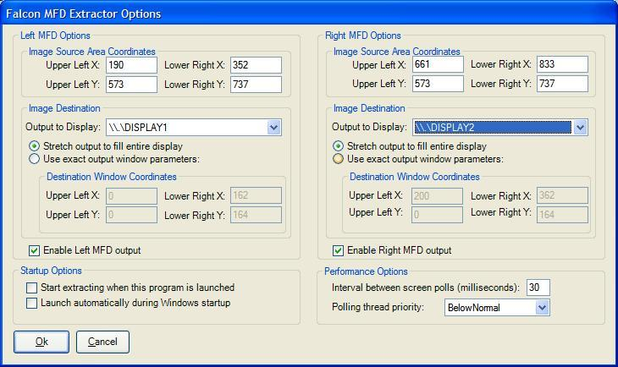

What about networking?

I'd originally written it as a client/server application where you passed a command-line argument into the program to tell it if it should send or receive data and to which IP address...but the performance sucks that way.    
  
Now what I am doing is I am using MaxiVista to test with, and so what happens there is the remote machine is running the MaxiVista client and the Falcon machine is running the MaxiVista server.  The remote (client) machine shows up like it's a second monitor.  Then all you do is tell Falcon MFD Extractor to write to that "virtual" monitor and voila, you're streaming MFD data across the network.  Performance is actually quite good that way.  
  
I will keep looking into ways to reimplement the networking functionality now that the core functionality is in place, but I am pretty impressed with MaxiVista and I think that's probably going to be the way to go in the short term.

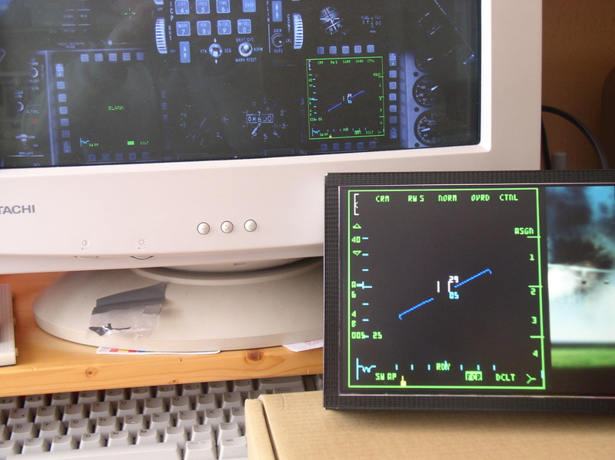

For today, the easiest way will be to set the input data coordinates for one of the MFDs to scrape from a single black pixel, and then output that pixel to an absolute coordinate output, say, the 0,0,1,1 coordinate (the upper left pixel) or alternatively the n-1,n-1,n,n coordinate (the lower right pixel).  
  
With the technique described above you can send either or both of the MFDs to a single screen or to two separate screens...at any size and at any position...so if you output to the smallest possible size window (1 pixel square), and you scrape only a single black input pixel, effectively, you've hidden the output.  
  
I should add a "none" option to the output display drop-down, though...just hadn't gotten to it yet.  I also want to add a couple performance tweaking options like the ability to set the polling interval and the thread priority as well...

Right on!  I spent the most time working on that little part.  I deliberately crippled my installation by running as much crap in the background as possible and by not actually having a second monitor physically attached -- using MaxiVista incurs a performance penalty because the screen data has to be sent across the network, but I figured if I could get the refresh rate high enough over the network then it would look great when run purely locally. In the latest update you have full control over how often the screen refreshes take place...The tradeoff is, more refreshes per second means more CPU cycles are stolen away from Falcon...That's why you also have the ability to adjust the thread priority. When the priority is "BelowNormal" or lower, just about any other program on the system can steal cycles from the MFD extractor, but the MFD extractor won't be stealing cycles from those programs.  If you set the thread priority higher than "BelowNormal" to just "Normal", then the MFD extractor will compete more for cycles with other programs, including Falcon (and you'll see that in the Task Manager if you look at the CPU utilization for the MFD Extractor).    
  
Now one interesting combo you could use is to have a very short polling period (many polls per second) and a low thread priority...then you'll be able to use as much CPU time as happens to be free at the moment but whenever some other program like Falcon needs those spare compute cycles, it will get priority over the MFD extractor...  
  
I set the default rate as 30ms between polls (which works out to ~33 polls/second, ideally) and I set the ThreadPriority to "BelowNormal" by default...but feel free to play around with that too, and see what happens!

Maxvista

<http://www.maxivista.com/download.htm>

Charos Led Modding tutorial:

If you are not into hacking bulbs and leds, the right mounting are available from

<http://www.trainaidsa.com/shop-leds.html>

<http://www.viperpits.org/smf/index.php?topic=3437.0>

Some folks wanted to know how to mod standard T1¾ bulbs to led, so here's a step-by-step tutorial:  
  
First of all get some burnt (preferably) T1¾ bulbs, some 5mm leds and decide if you're gonna wire the anode or cathode to the bulb case (it should be the same for all bulbs you mod, to save you from headaches.  
  
You can see the two solder points on the bulb, one on the side and one on the rear end.  
  
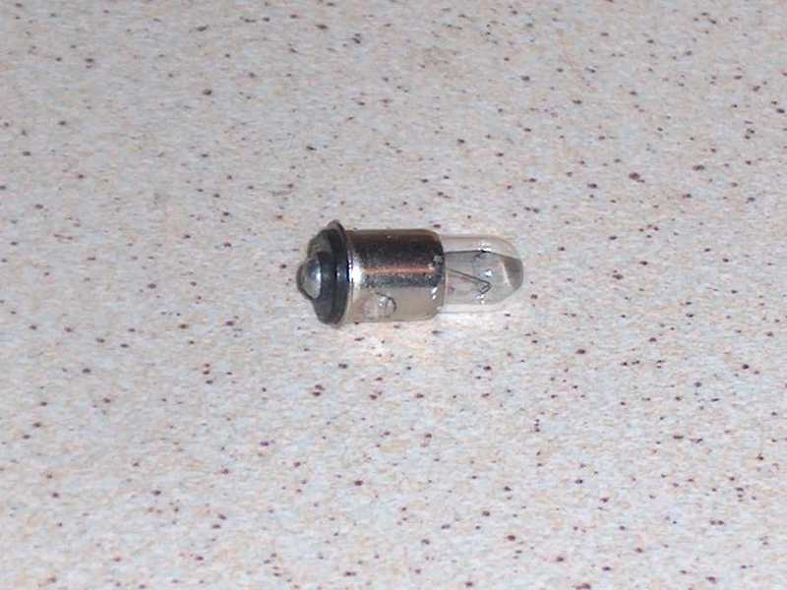  
  
Break the glass using pliers. It's advisable to do it in a plastic bag to keep glass fragments from flying away (you know they'll end up in your eye at the end...)  
  
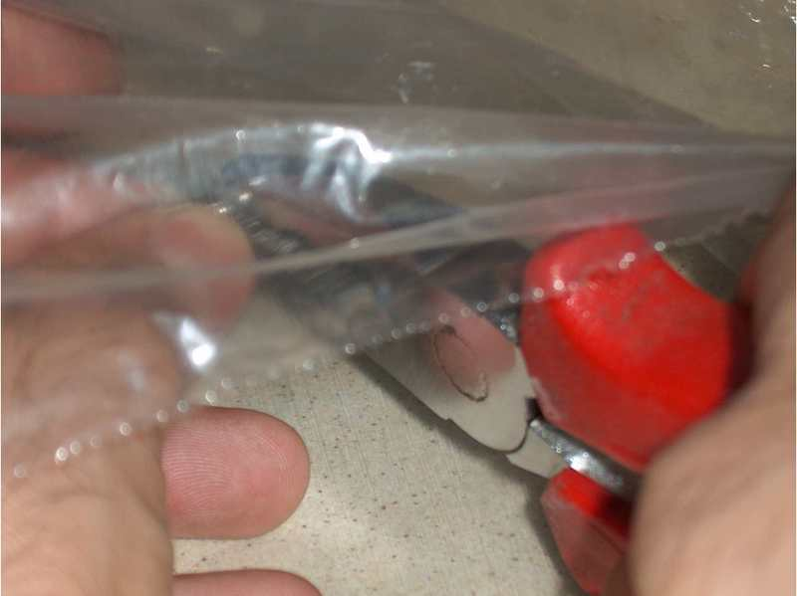  
  
The glue holding the glass on the metal case is brittle, so just scrape it away until there's nothing left but two small wires, soldered to the two points mentioned above.  
  
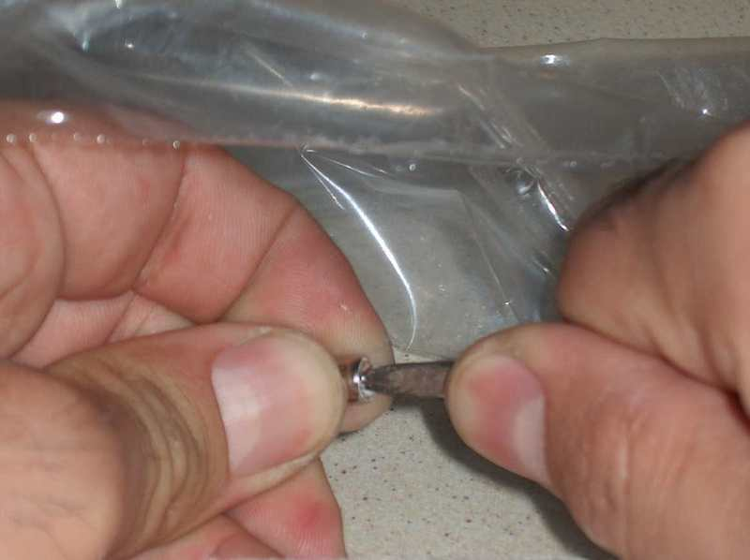  
  
Unsolder the two wires. Doing that on the rear end will leave a nice, clean hole. The one on the side is harder to unsolder completely clean, and the led lead going there will come at an angle, making things harder. So, just drill it out (1.5mm will do fine).  
  
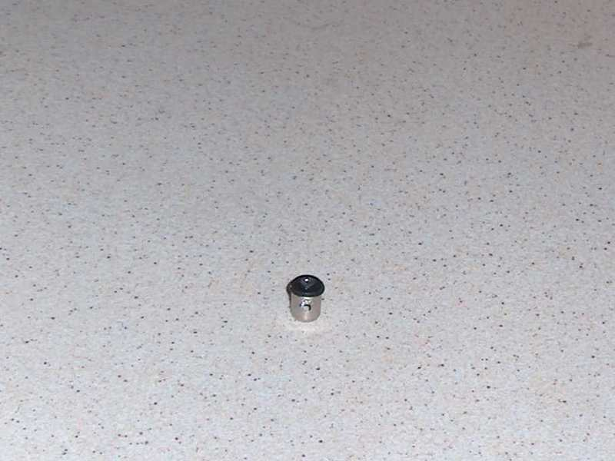  
  
File the rim on the led (almost) off. It won't fit in the case if you don't, and if you remove it completely the fit might be sloppy. So...   
  
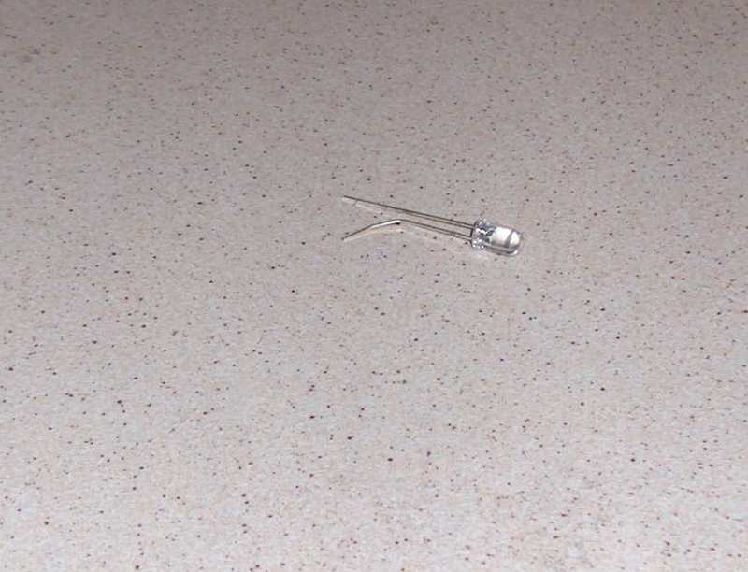  
  
...do a dry fit first.  
  
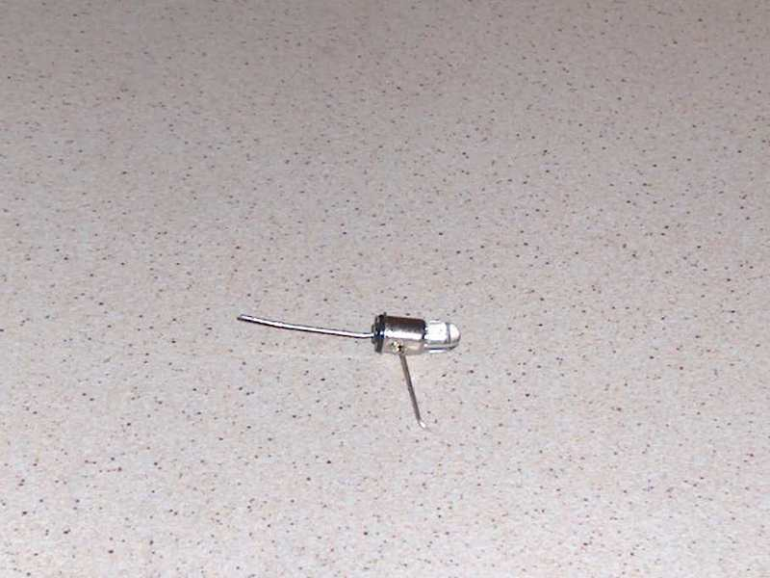  
  
Solder, clip the leads flush, file or dremmel till they don't stick out of the solder blob. Congratulate yourself, you're done.  
  
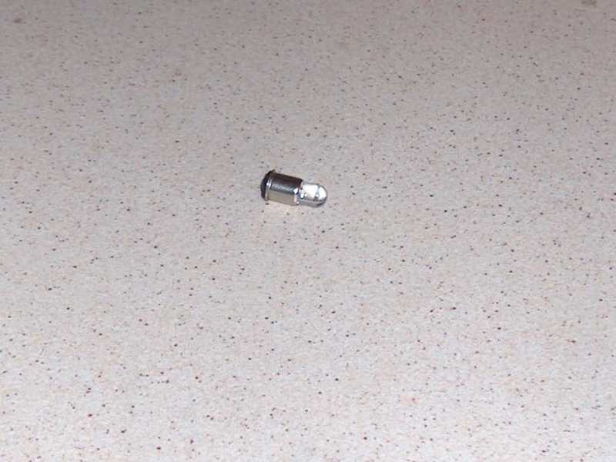  
  
If you ever bought an original gauge from ebay, you might have some of these red filters around. But then again you're making a b52 pit, so you don't care...  
  
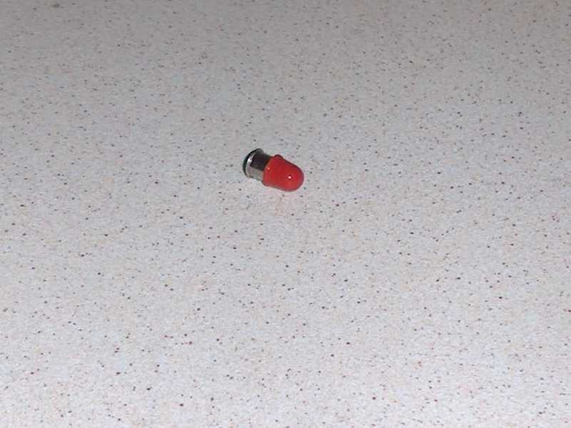  
  
Optionally you can file the lenses flat to diffuse the light and/or glue the led in the case. I find the latter unnecessary, the solder joins are strong enough and you're not gonna apply force to the lense (or take your pit in a 4g negative dive  ).  
  
You might use colored leds, but I prefer to just use colored film behind the indicator lenses for the following reasons:

* The bulbs will be interchangeable, I'll make as many as needed plus some spares which can be used anywhere
* Different colour leds have different voltage and amperage specs
* It's cheaper to buy a large quantity of white leds than smaller ones for each color

## Wiring Jays MFD Adaptors

WARNING – THE RIBBON CABLE’S FIRST COLOUR IS BLACK, SO COLOURS ARE OFFSET BY ONE – I.E. RED = PIN 3

The LDR output on pins 1 and 2 resistance ranges from 380K under a 60W bulb up to 6Meg in darkness.

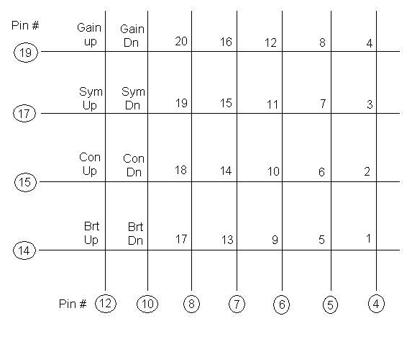

MFD Button Mappings

|  |  |  |  |  |  |  |
| --- | --- | --- | --- | --- | --- | --- |
|  | 1 | 2 | 3 | 4 | 5 |  |
| 20 |  |  |  |  |  | 6 |
| 19 |  |  |  |  |  | 7 |
| 18 |  |  |  |  |  | 8 |
| 17 |  |  |  |  |  | 9 |
| 16 |  |  |  |  |  | 10 |
|  | 15 | 14 | 13 | 12 | 11 |  |



Plasma MM2

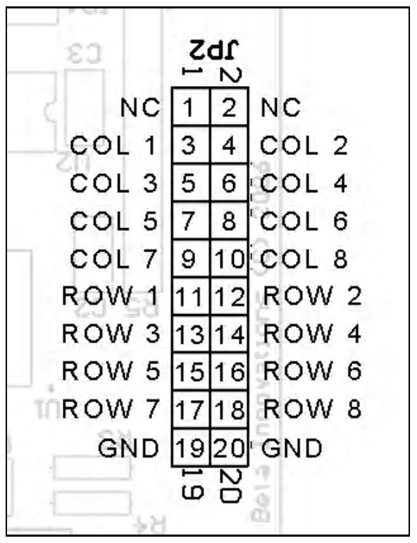

RIGHT MFD

Wire #4…..Pin #5…………………………………..Column 1

Wire #5…..Pin #4…………………………………..Column 2

Wire #6…..Pin #6…………………………………..Column 3

Wire #7…..Pin #7…………………………………..Column 4

Wire #8…..Pin #8…………………………………..Column 5

Wire #10…Pin #10…………………………………Column 6

Wire #12…Pin #12…………………………………Column 7

Wire #14…Pin #3…………………………………..Row 1

Wire #15…Pin #2…………………………………..Row 2

Wire #16…Pin #14…………………………………Ground

Wire #17…Pin #1…………………………………..Row 3

Wire #18…Pin #15…………………………………+5v

Wire #19…Pin #11…………………………………Row 4

LEFT MFD

Wire #4…..Pin #5…………………………………..Column 1

Wire #5…..Pin #4…………………………………..Column 2

Wire #6…..Pin #6…………………………………..Column 3

Wire #7…..Pin #7…………………………………..Column 4

Wire #8…..Pin #8…………………………………..Column 5

Wire #10…Pin #10…………………………………Column 6

Wire #12…Pin #12…………………………………Column 7

Wire #14…Pin #13…………………………………Row 5

Wire #15…Pin #2…………………………………..Row 6

Wire #16…Pin #11…………………………………Ground

Wire #17…Pin #15…………………………………Row 7

Wire #18…Pin #1…………………………………..+5v

Wire #19…Pin #14…………………………………Row 8

## I/O Card Pinouts

Figure 28 Gammatron Input



Figure 29 Gammatron Rotary Push Mapping



Figure 30 GammaRay Inputs



Figure 31 GammaRay Rotary Inputs



Figure 32 LOLED64 Side A



Figure 33 LOLED64 Side B Pinout



Figure 34 Jay-EL Bulb Pinout

|  |  |
| --- | --- |
| Pin | Bulb Position |
|  | Jay-EL Light Pinouts |
| C | Common |
| 1 | Bottom Left |
| 2 | Top Left |
| 3 | Top Right |
| 4 | Bottom Right |

Figure 35 Comport Usage

|  |  |
| --- | --- |
| Controller | Com Port |
|  |  |
| Flight Illusions | Com6 |
| Parallax | Com4 |

From <http://www.viperpits.org/smf/index.php?topic=1942.0> (to be checked)

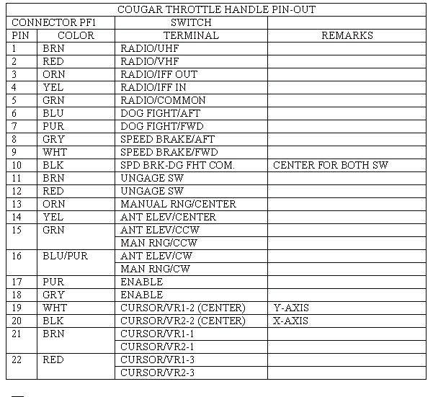

## ICP Layout

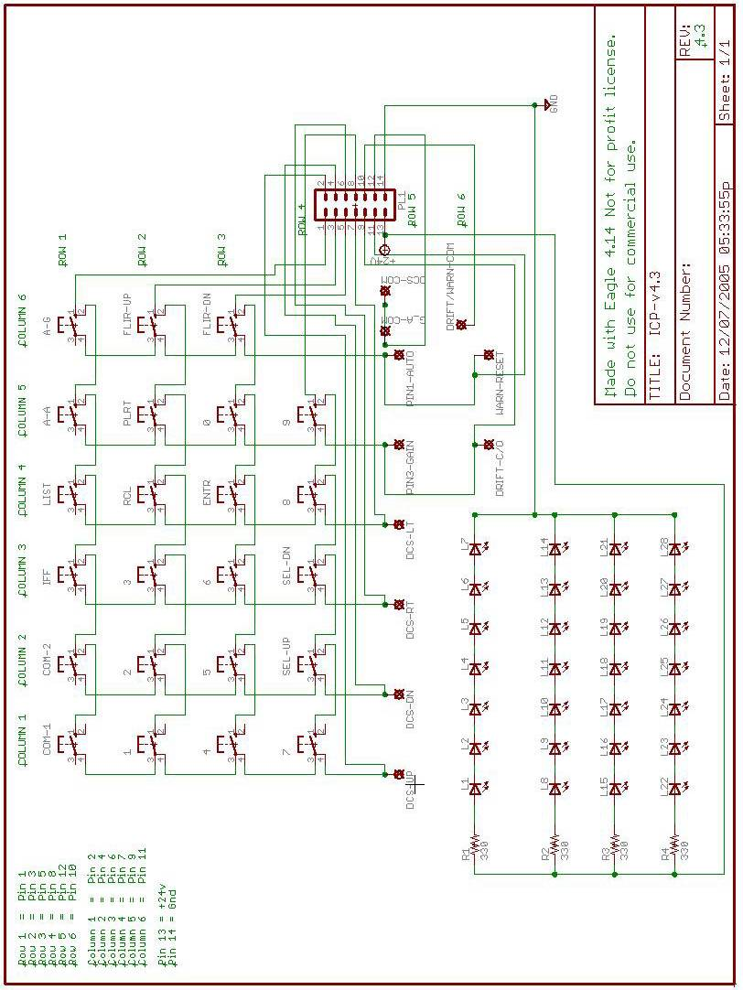

# Pinouts for the PCBs

Mid\_PCBs Bill of Material 23-May-07

----------------------------------------------------------------------------

Qty Product/Value Package Reference Designators

----------------------------------------------------------------------------

1 0.01uF 2PIN::H/200/200 C3

1 0.1uF 2PIN::H/200/200 C4

4 CAPACITOR 2PIN::V/200/400 C1-C2 C5-C6

----------------------------------------------------------------------------

2 DIODE 2PIN::H/400/100 D4-D5

1 LED 2PIN::H/200/100 D6

3 LED 2PIN::V/100/200 D1-D3

----------------------------------------------------------------------------

1 ACESII CON-HDR::2x5 J15

1 Analog\_In CON-HDR::2x5 J27

1 Anti-G CON-HDR::2x5 J5

1 Audio CON-HDR::2x10 J31

1 Audio\_2 CON-HDR::2x5 J11

1 Aux\_Comm CON-HDR::2x8 J7

1 Aux\_Comm\_Channel CON-HDR::2x8 J8

1 AVTR CON-HDR::2x5 J16

1 Cen\_Misc\_Services CON-HDR::2x10 J39

1 Center\_Pwr CON-HDR::2x5 J35

1 Centre\_Pwr CON-HDR::2x5 J2

1 CMDS CON-HDR::2x10 J23

1 CMDS\_Display CON-HDR::2x5 J21

1 ECM CON-HDR::2x5 J14

2 EFlux\_Out CON-HDR::2x10 J19 J33

1 Elect CON-HDR::2x8 J17

1 EPU CON-HDR::2x5 J10

1 Ext\_Light CON-HDR::2x8 J9

1 Flt\_Control CON-HDR::2x5 J4

1 Fuel CON-HDR::2x8 J6

1 Gamma\_Ray\_V2\_A CON-HDR::2x17 J18

1 Gamma\_Ray\_V2\_B CON-HDR::2x17 J32

1 Gamma\_Ray\_V2\_C CON-HDR::2x17 J40

1 Gear CON-HDR::2x10 J29

1 Guage\_In CON-HDR::2x5 J26

1 Jet\_Start CON-HDR::2x5 J13

1 Left\_Cabin CON-HDR::2x5 J28

2 Left\_Misc\_Services CON-HDR::2x17 J25 J41

1 Left\_Pwr CON-HDR::2x5 J34

1 Lighting\_Controller CON-HDR::2x8 J42

1 Man\_pitch CON-HDR::2x5 J3

1 Man\_Trim CON-HDR::2x10 J30

1 Right\_Misc\_Services CON-HDR::2x10 J38

1 Right\_Pwr CON-HDR::2x5 J36

2 Spare CON-HDR::2x10 J43-J44

1 Spare\_Pwr CON-HDR::2x5 J37

1 Test CON-HDR::2x5 J12

1 Threat\_Wrn\_Aux CON-HDR::2x8 J22

1 UCC\_Out\_1 CON-HDR::2x17 J1

1 UCC\_Out\_2 CON-HDR::2x17 J20

1 UHF CON-HDR::2x5 J24

----------------------------------------------------------------------------

1 MOSFET\_N TO::218 Q1

----------------------------------------------------------------------------

1 1K 2PIN::H/400/100 R5

1 47R 2PIN::H/400/100 R7

1 50K POT::TA\_Circ300 R4

1 120 2PIN::H/200/100 R6

1 R\_12V 2PIN::H/400/100 R2

1 R\_28V 2PIN::H/400/100 R3

1 R\_Bklight 2PIN::H/400/100 R1

----------------------------------------------------------------------------

1 LMC555 DIP::8D400Y300 U1

----------------------------------------------------------------------------

Totals: Elements=65 Pins=800 Nets=188

Right\_PCB Bill of Material 24-May-07

----------------------------------------------------------------------------

Qty Product/Value Package Reference Designators

----------------------------------------------------------------------------

4 CAPACITOR 2PIN::V/200/400 C1-C4

----------------------------------------------------------------------------

6 LED 2PIN::V/100/200 D1-D6

----------------------------------------------------------------------------

1 Air\_Cond CON-HDR::2x5 J34

1 Anti\_Ice CON-HDR::2x5 J31

1 Avoinic\_Pwr CON-HDR::2x10 J24

1 Cen\_Misc\_Services CON-HDR::2x10 J18

1 Center\_Pwr CON-HDR::2x5 J1

1 DTU CON-HDR::2x5 J25

2 EFlux\_Out CON-HDR::2x10 J10 J15

1 Eyebrow\_L CON-HDR::2x5 J16

1 Eyebrow\_R CON-HDR::2x5 J11

1 Fuel\_Qty\_Select CON-HDR::2x8 J12

1 Gamma\_Ray\_V2\_D CON-HDR::2x17 J2

1 Gamma\_Ray\_V2\_E CON-HDR::2x17 J13

1 Gamma\_Ray\_V2\_F CON-HDR::2x17 J20

1 Gamma\_Ray\_V2\_G CON-HDR::2x17 J22

1 Gamma\_Ray\_V2\_H CON-HDR::2x17 J36

1 HIS CON-HDR::2x5 J5

1 Hud\_Control CON-HDR::2x10 J29

1 Indexer\_L CON-HDR::2x5 J8

1 Indexer\_R CON-HDR::2x5 J9

1 Inst CON-HDR::2x8 J4

1 KY\_58 CON-HDR::2x5 J30

1 Left\_MFD CON-HDR::2x17 J3

1 Lighting CON-HDR::2x8 J27

1 Master\_Zeroise CON-HDR::2x5 J33

1 Misc CON-HDR::2x10 J17

1 Nuclear\_Consent CON-HDR::2x5 J28

1 OBOGS CON-HDR::2x5 J32

1 Ox\_Reg CON-HDR::2x5 J26

1 Right\_MFD CON-HDR::2x17 J6

1 Right\_Misc\_Services CON-HDR::2x10 J35

1 Right\_Pwr CON-HDR::2x5 J21

1 Sensor\_Pwr CON-HDR::2x5 J23

2 Spare CON-HDR::2x10 J37-J38

1 Threat\_Wrn\_Prime CON-HDR::2x8 J19

1 UCC\_Out\_3 CON-HDR::2x17 J7

1 UCC\_Out\_4 CON-HDR::2x17 J14

----------------------------------------------------------------------------

2 R\_12V 2PIN::H/400/100 R2 R5

2 R\_28V 2PIN::H/400/100 R3 R6

2 R\_Bklight 2PIN::H/400/100 R1 R4

----------------------------------------------------------------------------

Totals: Elements=54 Pins=742 Nets=169

## PCB Modifications

***The most important change is that the 28V rail plumbed to all PCBs is now a return (aka Ground) for the Led Latched-Outputs.***

Other Changes

* Ground added for GammaRay ports
* As Right Eyebrow uses more LEDs than original planned the spare port on the centre distribution PCB is now used to drive the Right Eyebrows. Used one for pins (so first part of pinout is the same, and then added new pins. DBU not wired end to end as out of ports of loled64.
* The Right and Left MFD connectors are not used on the Centre Distribution PCBs as an MM2 with Jays Adaptor PCB is used.
* The UCC connectors are used for driving Leds, even though UCC is not used for general outputs. The PCB had been designed to be driven either from the UCC or EFlux environment. This was before the LOLED64 had been released. To address this change in approach an Adaptor board is used to convert the LOLED64 outputs to pinout compatible with the UCC connectors.

# PCB Circuit Diagrams

Root_1_1

Root_1_2

Root_1_3

Root_1_1

Root_1_2

Root_1_3

Root_1_4

Root_1_5

Root_1_1TopPrintTopPrint

Capturing the PCB with multiple layers and colours. Tried MS Paint, Picssa2, and Office Picture editor, couldn’t find a way to chage the colour of the lines in the EMF file exported from WinQCad. Ultimately found by bringing all layers into PowerPoint the files stayed correctly overlaid.

Insert Picture from file (for Top, Bottom, and top Print) Then Right-click and edit picture, asked if you want to change to an Office Object, click yes. Can then select object – Right Click Format Object, select lines and then choose colour fro the layer. Then push modified layer ti back. Once the colours have been set you can then group them together. Colours used: Dark Blue for top layer, Dark Green for Bottom, and Red for Top print.

Then copy and paste directly into Word, it will paste as an Office Drawing Object.

There are two Cen\_Misc\_Services, Left\_Misc\_Services, Right\_Misc\_Services, Right\_Pwr, three Centre\_Pwr– to be investigated

Connector Totals:

|  |  |
| --- | --- |
| Connector Size | Quantity |
| 10 Pin | 36 |
| 16 Pin | 11 |
| 20 Pin | 19 |
| 34 Pin | 16 |
|  |  |
| Total Connectors | 82 |

|  |  |  |
| --- | --- | --- |
| Connector | Type | Location |
|  |  |  |
| Audio | CON-HDR::2x10 | J31 |
| Avoinic\_Pwr | CON-HDR::2x10 | J24 |
| Cen\_Misc\_Services | CON-HDR::2x10 | J18 |
| Cen\_Misc\_Services | CON-HDR::2x10 | J39 |
| CMDS | CON-HDR::2x10 | J23 |
| EFlux\_Out | CON-HDR::2x10 | J10 |
| EFlux\_Out | CON-HDR::2x10 | J15 |
| EFlux\_Out | CON-HDR::2x10 | J19 |
| EFlux\_Out | CON-HDR::2x10 | J33 |
| Gear | CON-HDR::2x10 | J29 |
| Hud\_Control | CON-HDR::2x10 | J29 |
| Man\_Trim | CON-HDR::2x10 | J30 |
| Misc | CON-HDR::2x10 | J17 |
| Right\_Misc\_Services | CON-HDR::2x10 | J35 |
| Right\_Misc\_Services | CON-HDR::2x10 | J38 |
| Spare | CON-HDR::2x10 | J37 |
| Spare | CON-HDR::2x10 | J38 |
| Spare | CON-HDR::2x10 | J43 |
| Spare | CON-HDR::2x10 | J44 |
| 19 | 19 |  |
| Gamma\_Ray\_V2\_A | CON-HDR::2x17 | J18 |
| Gamma\_Ray\_V2\_B | CON-HDR::2x17 | J32 |
| Gamma\_Ray\_V2\_C | CON-HDR::2x17 | J40 |
| Gamma\_Ray\_V2\_D | CON-HDR::2x17 | J2 |
| Gamma\_Ray\_V2\_E | CON-HDR::2x17 | J13 |
| Gamma\_Ray\_V2\_F | CON-HDR::2x17 | J20 |
| Gamma\_Ray\_V2\_G | CON-HDR::2x17 | J22 |
| Gamma\_Ray\_V2\_H | CON-HDR::2x17 | J36 |
| Left\_MFD | CON-HDR::2x17 | J3 |
| Left\_Misc\_Services | CON-HDR::2x17 | J25 |
| Left\_Misc\_Services | CON-HDR::2x17 | J41 |
| Right\_MFD | CON-HDR::2x17 | J6 |
| UCC\_Out\_1 | CON-HDR::2x17 | J1 |
| UCC\_Out\_2 | CON-HDR::2x17 | J20 |
| UCC\_Out\_3 | CON-HDR::2x17 | J7 |
| UCC\_Out\_4 | CON-HDR::2x17 | J14 |
| 16 | 16 |  |
| ACESII | CON-HDR::2x5 | J15 |
| Air\_Cond | CON-HDR::2x5 | J34 |
| Analog\_In | CON-HDR::2x5 | J27 |
| Anti\_Ice | CON-HDR::2x5 | J31 |
| Anti-G | CON-HDR::2x5 | J5 |
| Audio\_2 | CON-HDR::2x5 | J11 |
| AVTR | CON-HDR::2x5 | J16 |
| Center\_Pwr | CON-HDR::2x5 | J1 |
| Center\_Pwr | CON-HDR::2x5 | J35 |
| Centre\_Pwr | CON-HDR::2x5 | J2 |
| CMDS\_Display | CON-HDR::2x5 | J21 |
| DTU | CON-HDR::2x5 | J25 |
| ECM | CON-HDR::2x5 | J14 |
| EPU | CON-HDR::2x5 | J10 |
| Eyebrow\_L | CON-HDR::2x5 | J16 |
| Eyebrow\_R | CON-HDR::2x5 | J11 |
| Flt\_Control | CON-HDR::2x5 | J4 |
| Guage\_In | CON-HDR::2x5 | J26 |
| HIS | CON-HDR::2x5 | J5 |
| Indexer\_L | CON-HDR::2x5 | J8 |
| Indexer\_R | CON-HDR::2x5 | J9 |
| Jet\_Start | CON-HDR::2x5 | J13 |
| KY\_58 | CON-HDR::2x5 | J30 |
| Left\_Cabin | CON-HDR::2x5 | J28 |
| Left\_Pwr | CON-HDR::2x5 | J34 |
| Man\_pitch | CON-HDR::2x5 | J3 |
| Master\_Zeroise | CON-HDR::2x5 | J33 |
| Nuclear\_Consent | CON-HDR::2x5 | J28 |
| OBOGS | CON-HDR::2x5 | J32 |
| Ox\_Reg | CON-HDR::2x5 | J26 |
| Right\_Pwr | CON-HDR::2x5 | J21 |
| Right\_Pwr | CON-HDR::2x5 | J36 |
| Sensor\_Pwr | CON-HDR::2x5 | J23 |
| Spare\_Pwr | CON-HDR::2x5 | J37 |
| Test | CON-HDR::2x5 | J12 |
| UHF | CON-HDR::2x5 | J24 |
| 36 | 36 |  |
| Aux\_Comm | CON-HDR::2x8 | J7 |
| Aux\_Comm\_Channel | CON-HDR::2x8 | J8 |
| Elect | CON-HDR::2x8 | J17 |
| Ext\_Light | CON-HDR::2x8 | J9 |
| Fuel | CON-HDR::2x8 | J6 |
| Fuel\_Qty\_Select | CON-HDR::2x8 | J12 |
| Inst | CON-HDR::2x8 | J4 |
| Lighting | CON-HDR::2x8 | J27 |
| Lighting\_Controller | CON-HDR::2x8 | J42 |
| Threat\_Wrn\_Aux | CON-HDR::2x8 | J22 |
| Threat\_Wrn\_Prime | CON-HDR::2x8 | J19 |
| 11 | 11 |  |
| 82 | 82 |  |

## PCB Connectors Alphabetically Sorted

|  |  |  |
| --- | --- | --- |
| Connector | Type | Location |
| ACESII | CON-HDR::2x5 | J15 |
| Air\_Cond | CON-HDR::2x5 | J34 |
| Analog\_In | CON-HDR::2x5 | J27 |
| Anti\_Ice | CON-HDR::2x5 | J31 |
| Anti-G | CON-HDR::2x5 | J5 |
| Audio | CON-HDR::2x10 | J31 |
| Audio\_2 | CON-HDR::2x5 | J11 |
| Aux\_Comm | CON-HDR::2x8 | J7 |
| Aux\_Comm\_Channel | CON-HDR::2x8 | J8 |
| Avoinic\_Pwr | CON-HDR::2x10 | J24 |
| AVTR | CON-HDR::2x5 | J16 |
| Cen\_Misc\_Services | CON-HDR::2x10 | J18 |
| Cen\_Misc\_Services | CON-HDR::2x10 | J39 |
| Center\_Pwr | CON-HDR::2x5 | J1 |
| Center\_Pwr | CON-HDR::2x5 | J35 |
| Centre\_Pwr | CON-HDR::2x5 | J2 |
| CMDS | CON-HDR::2x10 | J23 |
| CMDS\_Display | CON-HDR::2x5 | J21 |
| DTU | CON-HDR::2x5 | J25 |
| ECM | CON-HDR::2x5 | J14 |
| EFlux\_Out | CON-HDR::2x10 | J10 |
| EFlux\_Out | CON-HDR::2x10 | J15 |
| EFlux\_Out | CON-HDR::2x10 | J19 |
| EFlux\_Out | CON-HDR::2x10 | J33 |
| Elect | CON-HDR::2x8 | J17 |
| EPU | CON-HDR::2x5 | J10 |
| Ext\_Light | CON-HDR::2x8 | J9 |
| Eyebrow\_L | CON-HDR::2x5 | J16 |
| Eyebrow\_R | CON-HDR::2x5 | J11 |
| Flt\_Control | CON-HDR::2x5 | J4 |
| Fuel | CON-HDR::2x8 | J6 |
| Fuel\_Qty\_Select | CON-HDR::2x8 | J12 |
| Gamma\_Ray\_V2\_A | CON-HDR::2x17 | J18 |
| Gamma\_Ray\_V2\_B | CON-HDR::2x17 | J32 |
| Gamma\_Ray\_V2\_C | CON-HDR::2x17 | J40 |
| Gamma\_Ray\_V2\_D | CON-HDR::2x17 | J2 |
| Gamma\_Ray\_V2\_E | CON-HDR::2x17 | J13 |
| Gamma\_Ray\_V2\_F | CON-HDR::2x17 | J20 |
| Gamma\_Ray\_V2\_G | CON-HDR::2x17 | J22 |
| Gamma\_Ray\_V2\_H | CON-HDR::2x17 | J36 |
| Gear | CON-HDR::2x10 | J29 |
| Guage\_In | CON-HDR::2x5 | J26 |
| HIS | CON-HDR::2x5 | J5 |
| Hud\_Control | CON-HDR::2x10 | J29 |
| Indexer\_L | CON-HDR::2x5 | J8 |
| Indexer\_R | CON-HDR::2x5 | J9 |
| Inst | CON-HDR::2x8 | J4 |
| Jet\_Start | CON-HDR::2x5 | J13 |
| KY\_58 | CON-HDR::2x5 | J30 |
| Left\_Cabin | CON-HDR::2x5 | J28 |
| Left\_MFD | CON-HDR::2x17 | J3 |
| Left\_Misc\_Services | CON-HDR::2x17 | J25 |
| Left\_Misc\_Services | CON-HDR::2x17 | J41 |
| Left\_Pwr | CON-HDR::2x5 | J34 |
| Lighting | CON-HDR::2x8 | J27 |
| Lighting\_Controller | CON-HDR::2x8 | J42 |
| Man\_pitch | CON-HDR::2x5 | J3 |
| Man\_Trim | CON-HDR::2x10 | J30 |
| Master\_Zeroise | CON-HDR::2x5 | J33 |
| Misc | CON-HDR::2x10 | J17 |
| Nuclear\_Consent | CON-HDR::2x5 | J28 |
| OBOGS | CON-HDR::2x5 | J32 |
| Ox\_Reg | CON-HDR::2x5 | J26 |
| Right\_MFD | CON-HDR::2x17 | J6 |
| Right\_Misc\_Services | CON-HDR::2x10 | J35 |
| Right\_Misc\_Services | CON-HDR::2x10 | J38 |
| Right\_Pwr | CON-HDR::2x5 | J21 |
| Right\_Pwr | CON-HDR::2x5 | J36 |
| Sensor\_Pwr | CON-HDR::2x5 | J23 |
| Spare | CON-HDR::2x10 | J37 |
| Spare | CON-HDR::2x10 | J38 |
| Spare | CON-HDR::2x10 | J43 |
| Spare | CON-HDR::2x10 | J44 |
| Spare\_Pwr | CON-HDR::2x5 | J37 |
| Test | CON-HDR::2x5 | J12 |
| Threat\_Wrn\_Aux | CON-HDR::2x8 | J22 |
| Threat\_Wrn\_Prime | CON-HDR::2x8 | J19 |
| UCC\_Out\_1 | CON-HDR::2x17 | J1 |
| UCC\_Out\_2 | CON-HDR::2x17 | J20 |
| UCC\_Out\_3 | CON-HDR::2x17 | J7 |
| UCC\_Out\_4 | CON-HDR::2x17 | J14 |
| UHF | CON-HDR::2x5 | J24 |

# PCB Connector Pinouts

**LEFT PCB**

J2

BACKLIGHT-V

BACKLIGHT-V

BACKLIGHT+V

BACKLIGHT+V

+12V LEFT

+12V LEFT

+28V LEFT

+28V LEFT

GROUND

GROUND

J3

BKLGT-V

BKLGT+V

+12V LEFT

+28V LEFT,

GND LEFT

MPTCHO NET49\_1,

7 OPEN,

8 OPEN,

9 OPEN,

10 OPEN

J4

BKLGT-V

BKLGT+V

+12V LEFT

+28V LEFT

GND LEFT

L\_FLT

FLP\_EXT

LEF\_LCK

9 OPEN

10 OPEN

J5

BKLGT-V

BKLGT+V

+12V LEFT

+28V LEFT

GND LEFT

6 OPEN,

7 OPEN,

8 OPEN,

9 OPEN,

10 OPEN

);

J6

BKLGT-V

BKLGT+V

+12V LEFT

+28V LEFT

GND LEFT

FUEL\_ON

PMP\_OFF

PMP\_NRM

PMP\_AFT

PMP\_FWD

FUL\_DOR

12 OPEN,

13 OPEN,

14 OPEN,

15 OPEN,

16 OPEN

J7

BKLGT-V

BKLGT+V

+12V LEFT

+28V LEFT

GND LEFT

COM\_OFF

COM\_STB

COM\_LOW

COM\_NO

COM\_BCK

COM\_UFC

TCN\_ATR

TCN\_NTR

14 OPEN,

15 OPEN,

16 OPEN

J8

BKLGT-V

BKLGT+V

+12V LEFT

+28V LEFT

GND LEFT

R\_GND

INC\_LFT

DEC\_LFT

INC\_CEN

DEC\_CEN

INC\_RGHT

DEC\_RGHT

INC\_BND

DEC\_BND

15 OPEN,

16 OPEN

J9

BKLGT-V

BKLGT+V

+12V LEFT

+28V LEFT

GND LEFT

EXTM\_ON

ACOL\_ON

FLSH\_ON

WNG\_DM

WNG\_BRT

P\_MSTR

P\_DIM

P\_CMN

14 OPEN,

15 OPEN,

16 OPEN

J10

BKLGT-V

BKLGT+V

+12V LEFT

+28V LEFT

GND LEFT

EPU\_ON

HYDRA

AIR

EPU\_OF

EPU\_ON

J11

BKLGT-V

BKLGT+V

+12V LEFT

+28V LEFT

GND LEFT

6 OPEN,

7 OPEN,

8 OPEN,

9 OPEN,

10 OPEN

J12

BKLGT-V

BKLGT+V

+12V LEFT

+28V LEFT

GND LEFT

6 OPEN,

7 OPEN,

8 OPEN,

9 OPEN,

10 OPEN

J13

BKLGT-V

BKLGT+V

+12V LEFT

+28V LEFT

GND LEFT

JFS\_ON\_LGHT

JFS\_ON\_SOL

JFS\_ST

9 OPEN,

10 OPEN

J14

BKLGT-V

BKLGT+V

+12V LEFT

+28V LEFT

GND LEFT

6 OPEN,

7 OPEN,

8 OPEN,

9 OPEN,

10 OPEN

J15

BKLGT-V

BKLGT+V

+12V LEFT

+28V LEFT

GND LEFT

EJECT

SEAT\_ON

8 OPEN,

9 OPEN,

10 OPEN

J16

BKLGT-V

BKLGT+V

+12V LEFT

+28V LEFT

GND LEFT

AVTR

AVT\_OFF

AVT\_ON

9 OPEN

10 OPEN

J17

BKLGT-V

BKLGT+V

+12V LEFT

+28V LEFT

GND LEFT

FLCSPMG

MAINGEN

STBYGEN

EPUGEN

EPUPMG

BATFAIL

TOFLCS

FLCSRLY

PWR\_OFF

PWRMAIN

WRN\_RST

J21

BKLGT-V

BKLGT+V

+12V LEFT

+28V LEFT

GND LEFT

GO NET5\_2,

NO\_GO

RDY\_DISP

CHAFF\_LO

FLARE\_LO

J22

BKLGT-V

BKLGT+V

+12V LEFT

+28V LEFT

GND LEFT

AXSCH

AXACT

AXLOW

AXPWR

R\_SRCH

R\_GND

R\_PWR

13 OPEN,

14 OPEN,

15 OPEN,

16 OPEN

J23

BKLGT-V

BKLGT+V

+12V LEFT

+28V LEFT

GND LEFT

RWR\_ON

JMR\_ON

CHF\_ON

FLR\_ON

PRG\_BIT

PRG\_1

PRG\_2

PRG\_3

PRG\_4

MDEOFF

MDESTBY

MDEMAN

MDESEMI

MDEAUTO

MDEBYP

J24

BKLGT-V

BKLGT+V

+12V LEFT

+28V LEFT

GND LEFT

UCHN\_UP UHF\_CHAN\_UP\_2,

UCHN\_DWN UHF\_CHAN\_DWN\_2,

8 R\_GROUND\_1,

9 OPEN,

10 OPEN

J25

R\_GND

2 OPEN,

3 OPEN,

4 OPEN,

5 THREAT\_DOWN\_2,

U-THREAT-D THREAT\_UP\_2,

7 MISSLE\_DWN\_2,

U-MISSLE-D MISSLE\_UP\_2,

9 COMM1\_DWN\_2,

U-COM1-D COMM1\_UP\_2,

11 COMM2\_DWN\_2,

U-COM2-D COMM2\_UP\_2,

13 DEC\_LEFT\_1,

U-LEFT-D INC\_LEFT\_1,

15 DEC\_CENTRE\_1,

U-CNTER-D INC\_CENTRE\_1,

17 DEC\_RIGHT\_1,

U-RIGHT-D INC\_RIGHT\_1,

19 DEC\_BAND\_1,

U-BAND-D INC\_BAND\_1,

21 UHF\_CHAN\_DWN\_2,

U-UHF-D UHF\_CHAN\_UP\_2,

23 ROT\_YRIGHT\_2,

L-YAW-R ROT\_YLEFT\_2,

25 ROT\_RRIGHT\_2,

L-ROLL-R ROT\_RLEFT\_2,

27 ROT\_NOSEDOWN\_2,

U-NOSE-D ROT\_NOSEUP\_2,

29 OPEN,

30 OPEN,

P-DIM PHYSICAL\_LIGHT\_DIM\_1,

32 OPEN,

GND PHYSICAL\_GROUND\_1,

MSTR PHYSICAL\_LIGHT\_MASTER\_1

J26

1 NET54\_2,

2 NET55\_2,

3 OPEN,

4 OPEN,

5 OPEN,

6 OPEN,

7 OPEN,

8 OPEN,

9 OPEN,

10 OPEN

J27

ANA\_PWR NET50\_2,

ANA\_GND NET49\_2,

ANA\_1 NET53\_2,

ANA\_2 NET52\_2,

ANA\_3 NET51\_2,

ANA\_4 NET48\_2,

ANA\_5 NET47\_2,

ANA\_6 NET46\_2,

ANA\_7 NET45\_2,

10 OPEN

J28

BKLGT-V

BKLGT+V

+12V LEFT

+28V LEFT

GND LEFT

CANOPY

CHAFFFLARE

8 OPEN,

9 OPEN,

10 OPEN

);

J29

BKLGT-V

BKLGT+V

+12V LEFT

+28V LEFT

GND LEFT

N\_GEAR

L\_GEAR

R\_GEAR

G\_HNDLE

PK\_SOLND

HOOK

GNDJETT

PARKBRK

EMG\_JET

CAT\_III

L\_TAXI

L\_LAND

L\_GEAR

HRN\_SIL

20 OPEN

J30

BKLGT-V

BKLGT+V

+12V LEFT

+28V LEFT

GND LEFT

ROLL

PITCH

8 OPEN,

ANA\_PWR

ANA\_GND

APITCH

AROLL

AYAW

YLEFT

YRGHT

RLEFT

RRIGHT

NSEUP

NSEDWN

AP\_DISC

J31

BKLGT-V

BKLGT+V

+12V LEFT

+28V LEFT

GND LEFT

ANA\_PWR

ANA\_GND

ACM1\_V

ACM2\_V

AMSL\_V

ATHRT\_V

CM1\_UP

CM1\_DWN

CM2\_UP

CM2\_DWN

MSL\_UP

MSL\_DWN

THRT\_UP

THRT\_DWN

R\_GND);

J34

BACKLIGHT-V

BACKLIGHT-V

BACKLIGHT+V

BACKLIGHT+V

+12V

+12V

+28V

+28V

GROUND

GROUND

J35

BACKLIGHT-V

BACKLIGHT-V

BACKLIGHT+V

BACKLIGHT+V

+12V

+12V

+28V

+28V

GROUND

GROUND

J36

BACKLIGHT-V

BACKLIGHT-V

BACKLIGHT+V

BACKLIGHT+V

+12V

+12V

+28V

+28V

GROUND

GROUND

J37

BACKLIGHT-V

BACKLIGHT-V

BACKLIGHT+V

BACKLIGHT+V

+12V

+12V

+28V

+28V

GROUND

GROUND

);

J38

BKLGT-V

BKLGT-V

BKLGT+V

BKLGT+V

+12V

+12V

+28V

+28V

GND

GND,

P\_GND

P\_+V

P\_1 BACKLIGHT\_CTL\_3,

P\_2 NVG\_FLOOD\_CTL\_3,

P\_3 WHITE\_FLOOD\_CTL\_3,

P\_4

DIM\_

18 OPEN,

PHY\_GND OPEN,

PHY\_MFD OPEN

);

J39

BKLGT-V

BKLGT-V

BKLGT+V

BKLGT+V

+12V

+12V

+28V

+28V

GND

GND

11 OPEN,

12 OPEN,

R\_GND

R\_CRSE\_A

R\_CRSE\_B

R\_HEAD\_A

R\_HEAD\_B

18 OPEN,

FLG\_ENG OPEN,

FLG\_PWR OPEN

J41

R\_GND

2 OPEN,

3 OPEN,

4 OPEN,

5

U-THREAT-D

7

U-MISSLE-D

9

U-COM1-D

11

U-COM2-D

13

U-LEFT-D

15

U-CNTER-D

17

U-RIGHT-D

19

U-BAND-D

21

U-UHF-D

23

L-YAW-R

25,

L-ROLL-R

27

U-NOSE-D

29 OPEN,

30 OPEN,

P-DIM OPEN,

32 OPEN,

GND OPEN,

MSTR OPEN

);

J42 :

BKLGT-V

BKLGT-V

BKLGT+V

BKLGT+V

P\_GND

P\_+V

P\_1 BACKLIGHT\_CTL\_3,

P\_2 NVG\_FLOOD\_CTL\_3,

P\_3 WHITE\_FLOOD\_CTL\_3,

P\_4 NET38\_3,

DIM\_BRT

12 OPEN,

13 OPEN,

14 OPEN,

15 OPEN,

16 OPEN

\_\_\_\_\_\_\_\_\_\_\_\_\_\_\_\_\_\_\_\_\_\_\_\_\_

**RIGHT PCB**

J1 : CONNECTOR\_\_HEADER\_10 PORT MAP

(

BACKLIGHT-V

BACKLIGHT-V

BACKLIGHT+V

BACKLIGHT+V

+12V

+12V

+28V

+28V

GROUND

GROUND

J2

GND OPEN,

IN\_1 OPEN,

IN\_2 OPEN,

IN\_3 OPEN,

IN\_4 OPEN,

IN\_5 OPEN,

IN\_6 NET29\_1,

IN\_7 NET28\_1,

IN\_8 NET27\_1,

IN\_9 NET26\_1,

IN\_10 NET25\_1,

IN\_11 NET24\_1,

IN\_12 NET23\_1,

IN\_13 NET22\_1,

IN\_14 NET21\_1,

IN\_15 NET20\_1,

IN\_16 NET19\_1,

IN\_17 NET18\_1,

IN\_18 NET17\_1,

IN\_19 NET16\_1,

IN\_20 NET15\_1,

IN\_21 NET14\_1,

IN\_22 NET13\_1,

IN\_23 NET12\_1,

IN\_24 NET11\_1,

IN\_25 NET10\_1,

IN\_26 NET9\_1,

IN\_27 NET8\_1,

IN\_28 NET7\_1,

IN\_29 NET6\_1,

IN\_30 NET5\_1,

IN\_31 NET4\_1,

IN\_32 OPEN,

+VCC OPEN

J3

BKLGT-V

BKLGT+V

+12V

+28V

GND ,

O\_1L NET29\_1,

O\_2L NET28\_1,

O\_3L NET27\_1,

O\_4L NET26\_1,

O\_5L NET25\_1,

O\_6L NET24\_1,

O\_7L NET23\_1,

O\_8L NET22\_1,

O\_9L NET21\_1,

O\_10L NET20\_1,

O\_11L NET19\_1,

O\_12L NET18\_1,

O\_13L NET17\_1,

O\_14L NET16\_1,

O\_15L NET15\_1,

O\_16L NET14\_1,

O\_17L NET13\_1,

O\_18L NET12\_1,

O\_19L NET11\_1,

O\_20L NET10\_1,

LGNUP NET9\_1,

LGNDN NET8\_1,

28 OPEN

J4

BKLGT-V

BKLGT+V

+12V

+28V

GND ,

I\_TCN

TCN

NAV

I\_NAV

10 OPEN,

R\_GND

R\_CRSE\_A

R\_CRSE\_B

R\_HEAD\_A

R\_HEAD\_B

16 OPEN

J5

BKLGT-V

BKLGT+V

+12V

+28V

GND ,

6 OPEN,

7 OPEN,

8 OPEN,

9 OPEN,

10 OPEN

J6

BKLGT-V

BKLGT+V

+12V

+28V

GND ,

O\_1R NET29\_2,

O\_2R NET28\_2,

O\_3R NET27\_2,

O\_4R NET26\_2,

O\_5R NET25\_2,

O\_6R NET24\_2,

O\_7R NET23\_2,

O\_8R NET22\_2,

O\_9R NET21\_2,

O\_10R NET20\_2,

O\_11R NET19\_2,

O\_12R NET18\_2,

O\_13R NET17\_2,

O\_14R NET16\_2,

O\_15R NET15\_2,

O\_16R NET14\_2,

O\_17R NET13\_2,

O\_18R NET12\_2,

O\_19R NET11\_2,

O\_20R NET10\_2,

RGNUP NET9\_2,

RGNDN NET8\_2,

28 OPEN

J7

OUT\_1 PWR\_OFF\_FLAG\_2,

2 OPEN,

OUT\_2 ENG\_ON\_FLAG\_2,

4 OPEN,

OUT\_3 NET30\_2,

6 OPEN,

OUT\_4 NET31\_2,

8 OPEN,

OUT\_5 NET32\_2,

10 OPEN,

OUT\_6 NET33\_2,

12 OPEN,

OUT\_7 NET38\_2,

14 OPEN,

OUT\_8 NET37\_2,

16 OPEN,

OUT\_9 NET36\_2,

18 OPEN,

OUT\_10 NET35\_2,

20 OPEN,

OUT\_11 NET34\_2,

22 OPEN,

OUT\_12 NET44\_2,

24 OPEN,

OUT\_13 NET43\_2,

26 OPEN,

OUT\_14 NET42\_2,

28 OPEN,

OUT\_15 NET41\_2,

30 OPEN,

OUT\_16 NET40\_2,

32 OPEN,

OUT\_17 NET39\_2,

34 OPEN

J8

BKLGT-V

BKLGT+V

+12V

+28V

GND ,

A\_ABVE

A\_ON

A\_BLOW

9 OPEN,

10 OPEN

J9

BKLGT-V

BKLGT+V

+12V

+28V

GND ,

R\_RDY NET41\_2,

R\_AR NET40\_2,

R\_DSC NET39\_2,

9 OPEN,

10 OPEN

J10

GND ,

GND ,

OUT\_1 NET30\_2,

OUT\_2 NET31\_2,

OUT\_3 NET32\_2,

OUT\_4 NET33\_2,

OUT\_5 NET38\_2,

OUT\_6 NET37\_2,

OUT\_7 NET36\_2,

OUT\_8 NET35\_2,

OUT\_9 NET34\_2,

OUT\_10 NET44\_2,

OUT\_11 NET43\_2,

OUT\_12 NET42\_2,

OUT\_13 NET41\_2,

OUT\_14 NET40\_2,

OUT\_15 NET39\_2,

V-ADJ OPEN,

VCC OPEN,

VCC OPEN

J11

BKLGT-V

BKLGT+V

+12V

+28V

GND ,

E\_FIRE

ENGINE

OIL

TL\_CFG

CANOPY

J12

BKLGT-V

BKLGT+V

+12V

+28V

GND ,

MARKER

EXT\_WNG

INT\_WNG

RVSR

NORM

TEST

TRNSFR

EXT\_CTR

INST\_FLG1

INST\_FLG2

INST\_FLG3

J13

GND OPEN,

IN\_1 NET29\_2,

IN\_2 NET28\_2,

IN\_3 NET27\_2,

IN\_4 NET26\_2,

IN\_5 NET25\_2,

IN\_6 NET24\_2,

IN\_7 NET23\_2,

IN\_8 NET22\_2,

IN\_9 NET21\_2,

IN\_10 NET20\_2,

IN\_11 NET19\_2,

IN\_12 NET18\_2,

IN\_13 NET17\_2,

IN\_14 NET16\_2,

IN\_15 NET15\_2,

IN\_16 NET14\_2,

IN\_17 NET13\_2,

IN\_18 NET12\_2,

IN\_19 NET11\_2,

IN\_20 NET10\_2,

IN\_21 NET9\_2,

IN\_22 NET8\_2,

IN\_23 NET7\_2,

IN\_24 NET6\_2,

IN\_25 NET5\_2,

IN\_26 NET4\_2,

IN\_27 NET3\_2,

IN\_28 NET2\_2,

IN\_29 NET1\_2,

IN\_30 OPEN,

IN\_31 OPEN,

IN\_32 OPEN,

+VCC OPEN

J14

OUT\_1 NET30\_3,

2 OPEN,

OUT\_2 NET29\_3,

4 OPEN,

OUT\_3 NET23\_3,

6 OPEN,

OUT\_4 NET22\_3,

8 OPEN,

OUT\_5 NET21\_3,

10 OPEN,

OUT\_6 NET20\_3,

12 OPEN,

OUT\_7 NET19\_3,

14 OPEN,

OUT\_8 NET18\_3,

16 OPEN,

OUT\_9 NET28\_3,

18 OPEN,

OUT\_10 NET27\_3,

20 OPEN,

OUT\_11 NET26\_3,

22 OPEN,

OUT\_12 NET25\_3,

24 OPEN,

OUT\_13 NET24\_3,

26 OPEN,

OUT\_14 OPEN,

28 OPEN,

OUT\_15 OPEN,

30 OPEN,

OUT\_16 OPEN,

32 OPEN,

OUT\_17 OPEN,

34 OPEN

J15

GND ,

GND ,

OUT\_1 NET30\_3,

OUT\_2 NET29\_3,

OUT\_3 NET23\_3,

OUT\_4 NET22\_3,

OUT\_5 NET21\_3,

OUT\_6 NET20\_3,

OUT\_7 NET19\_3,

OUT\_8 NET18\_3,

OUT\_9 NET28\_3,

OUT\_10 NET27\_3,

OUT\_11 NET26\_3,

OUT\_12 NET25\_3,

OUT\_13 NET24\_3,

OUT\_14 OPEN,

OUT\_15 OPEN,

V-ADJ OPEN,

VCC OPEN,

VCC OPEN

J16

BKLGT-V

BKLGT+V

+12V

+28V

GND ,

TFF

M\_CAUT

F\_ACK

EXT\_CTN

10 OPEN

J17

BKLGT-V

BKLGT+V

+12V

+28V

GND ,

ECM\_PWR

AP\_ON

TFR\_STDBY

ECM\_PWR

TFR\_ENGAGED

RF\_NRM

RF\_SILNT

LSR\_ON

S\_PICKLE

MST\_ARM

MST\_SIM

RAP\_DWN

RAP\_UP

LAP\_DWN

LAP\_UP

J18

BKLGT-V

BKLGT-V

BKLGT+V

BKLGT+V

+12V

+12V

+28V

+28V

GND ,

GND ,

11 OPEN,

12 OPEN,

R\_GND

R\_CRSE\_A

R\_CRSE\_B

R\_HEAD\_A

R\_HEAD\_B

18 OPEN,

FLG\_ENG

FLG\_PWR

J19

BKLGT-V

BKLGT+V

+12V

+28V

GND ,

HANDOFF

PRIMODE

TGTSEP

LAUNCH

NAVAL

UKNOWN

RHANDOFF

RSETPRI

RSETTGT

RSETNVL

RSETUN

J20

GND OPEN,

IN\_1 NET17\_3,

IN\_2 NET16\_3,

IN\_3 NET15\_3,

IN\_4 NET14\_3,

IN\_5 NET13\_3,

IN\_6 NET12\_3,

IN\_7 NET11\_3,

IN\_8 NET10\_3,

IN\_9 NET9\_3,

IN\_10 NET8\_3,

J21

BACKLIGHT-V

BACKLIGHT-V

BACKLIGHT+V

BACKLIGHT+V

+12V

+12V

+28V

+28V

GROUND ,

GROUND

J23

BKLGT-V

BKLGT+V

+12V

+28V

GND ,

L\_HPT

R\_HPT

FCR

RA\_STD

RA\_ON

J24

BKLGT-V

BKLGT+V

+12V

+28V

GND ,

FCC

SMS

MFD

UFC

I\_OFF

I\_HDG

I\_NRM

I\_NAV

I\_CAL

I\_ATT

GPS

TISL

MAP

P\_GND PHY\_MFD\_PWR\_4,

P\_MFD\_PWR PHY\_GND\_4

);

J25

BKLGT-V

BKLGT+V

+12V

+28V

GND ,

6 OPEN,

7 OPEN,

8 OPEN,

9 OPEN,

10 OPEN;

J26 : CONNECTOR\_\_HEADER\_10 PORT MAP

(

BKLGT-V

BKLGT+V

+12V

+28V

GND ,

6 OPEN,

7 OPEN,

8 OPEN,

9 OPEN,

10 OPEN

J27

BKLGT-V

BKLGT+V

+12V

+28V

GND ,

POT\_GND POT\_GROUND\_4,

POT\_+V POT\_+V\_4,

POT\_1 POT\_1\_4,

POT\_2 POT\_2\_4,

POT\_3 POT\_3\_4,

POT\_4 POT\_4\_4,

DIM\_BRIGHT DIM\_BRIGHT\_4,

13 OPEN,

14 OPEN,

15 OPEN,

16 OPEN

J28

BKLGT-V

BKLGT+V

+12V

+28V

GND ,

6 OPEN,

7 OPEN,

8 OPEN,

9 OPEN,

10 OPEN

);

J29 : CONNECTOR\_\_HEADER\_20 PORT MAP

(

BKLGT-V

BKLGT+V

+12V

+28V

GND ,

S\_VA

S\_VV

FPM

AT\_FPM

PFL

DED

R\_PRI

R\_STD

A\_BARO

A\_RDR

NIGHT

DAY

CAS

GNDSPD

20 OPEN

J30

BKLGT-V

BKLGT+V

+12V

+28V

GND ,

6 OPEN,

7 OPEN,

8 OPEN,

9 OPEN,

10 OPEN

J31

BKLGT-V

BKLGT+V

+12V

+28V

GND ,

6 OPEN,

7 OPEN,

8 OPEN,

9 OPEN,

10 OPEN

J32

BKLGT-V

BKLGT+V

+12V

+28V

GND ,

6 OPEN,

7 OPEN,

8 OPEN,

9 OPEN,

10 OPEN

J33

BKLGT-V

BKLGT+V

+12V

+28V

GND ,

V\_INHB NET5\_5,

7 OPEN,

8 OPEN,

9 OPEN,

10 OPEN

J34

BKLGT-V

BKLGT+V

+12V

+28V

GND ,

OFF

NORM

DUMP

RAM

10 OPEN

J35

BKLGT-V

BKLGT-V

BKLGT+V

BKLGT+V

+12V

+12V

+28V

+28V

GND ,

GND ,

P\_GND POT\_GROUND\_4,

P\_+V POT\_+V\_4,

P\_1 POT\_1\_4,

P\_2 POT\_2\_4,

P\_3 POT\_3\_4,

P\_4 POT\_4\_4,

DIM\_BRT DIM\_BRIGHT\_4,

18 OPEN,

PHY\_GND PHY\_GND\_4,

PHY\_MFD PHY\_MFD\_PWR\_4

J36

GND OPEN,

IN\_1 NET5\_5,

IN\_2 NET4\_5,

IN\_3 NET3\_5,

IN\_4 NET2\_5,

IN\_5 NET1\_5,

IN\_6 OPEN,

IN\_7 OPEN,

IN\_8 OPEN,

IN\_9 OPEN,

IN\_10 OPEN,

IN\_11 OPEN,

IN\_12 OPEN,

IN\_13 OPEN,

IN\_14 OPEN,

IN\_15 OPEN,

IN\_16 OPEN,

IN\_17 OPEN,

IN\_18 OPEN,

IN\_19 OPEN,

IN\_20 OPEN,

IN\_21 OPEN,

IN\_22 OPEN,

IN\_23 OPEN,

IN\_24 OPEN,

IN\_25 OPEN,

IN\_26 OPEN,

IN\_27 OPEN,

IN\_28 OPEN,

IN\_29 OPEN,

IN\_30 OPEN,

IN\_31 OPEN,

IN\_32 OPEN,

+VCC OPEN

1. Now that I am using Mikes EL sheets, this is much less of an issue. [↑](#footnote-ref-1)
2. The EU661 also included PDF, DED LCDs and hardware to drive all Leds in cockpit. [↑](#footnote-ref-2)
3. The original table only had two poles, but this is a three position switch. So initially will only have RF Norm and RF Quiet. [↑](#footnote-ref-3)
4. This input is for the HSI, not the roatry on the INST panel. The roatry on the INST panel in the sim has no input. [↑](#footnote-ref-4)
5. A single rotary is dual roled, with role changing dependant on whether it is pushed or not. [↑](#footnote-ref-5)